Product List

Supplements………………………………………4-77

Wellness Products………………………………..78-86

Wild Essentials Pet Line…………………………87-90



We partner with Reliance Vitamins as our supplement manufacturer. They offer independent confirmation of the quality we have always maintained in the manufacturing of our products. Reliance meets not only current FDA regulations, but also the strict guidelines of the Natural Products Association and other industry-specific organizations.

**Facility Certifications:**

**1.NPA GMP Certification Program**

Reliance has been GMP certified by UL and the Natural Products Association for several years to independently confirm the quality of their manufacturing systems. NPA GMP Certification is awarded to companies that meet a high level of compliance to the NPA GMP Standard as verified through comprehensive third-party inspections of facilities and GMP-related documentation. 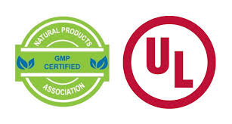

**2. NSF GMP Registered**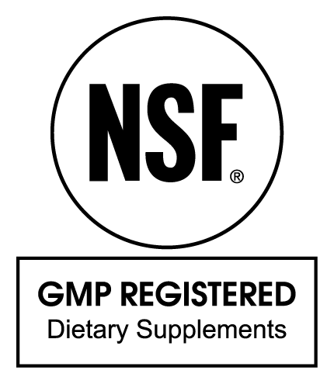

Reliance was the first GMP registered by NSF in 2012, the gold standard of GMP registration programs in the dietary supplement and functional foods categories. this certifies that we adhere to a system of processes, procedures and documentation to assure product has the identity, strength, composition, quality and purity that appear on its label.

**3. QAI’s USDA Certified Organic**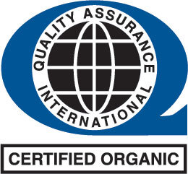

Reliance's manufacturing facility has been certified to handle organic ingredients for our supplements, assuring organic Integrity from Farm to retail shelf. QAI is a USDA accredited certifying agency approved to provide Organic certification in accordance with the USDA's national organic program.

**4. HALAL Certification**

Reliant supplements featuring Halal certification use ingredients and processes that meet the requirements of Islamic law. qualified experts from Islamic Services of America have verified our facility and products meet Halal requirements with regard to food composition handling and preparation. 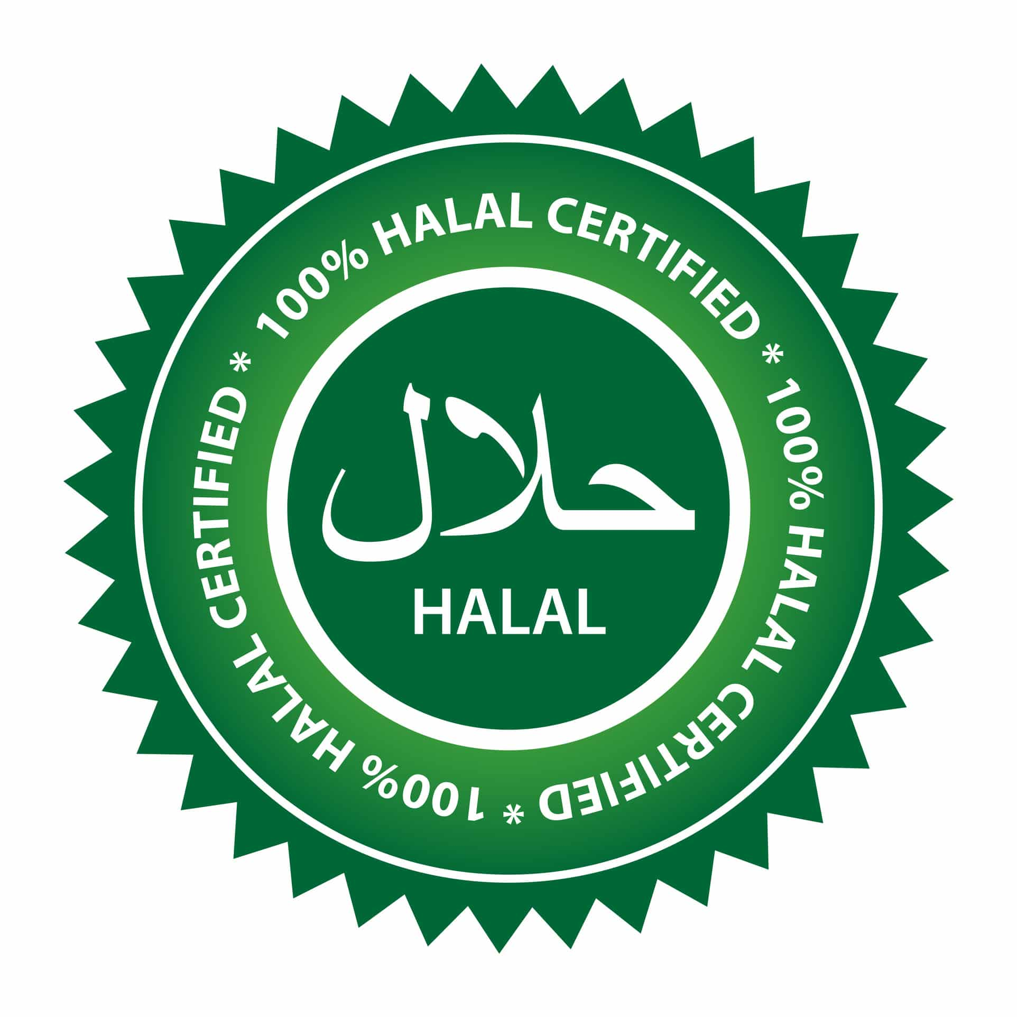

**5. Koshler Certification**

Reliance supplements that are Kosher certified adhere to all kosher law requirements for both the actual product and its production. This has been verified by a rabbinic agency who has checked the products, production facility and actual production to ensure all ingredients, derivatives, tools and Machinery have no trace of non kosher substances

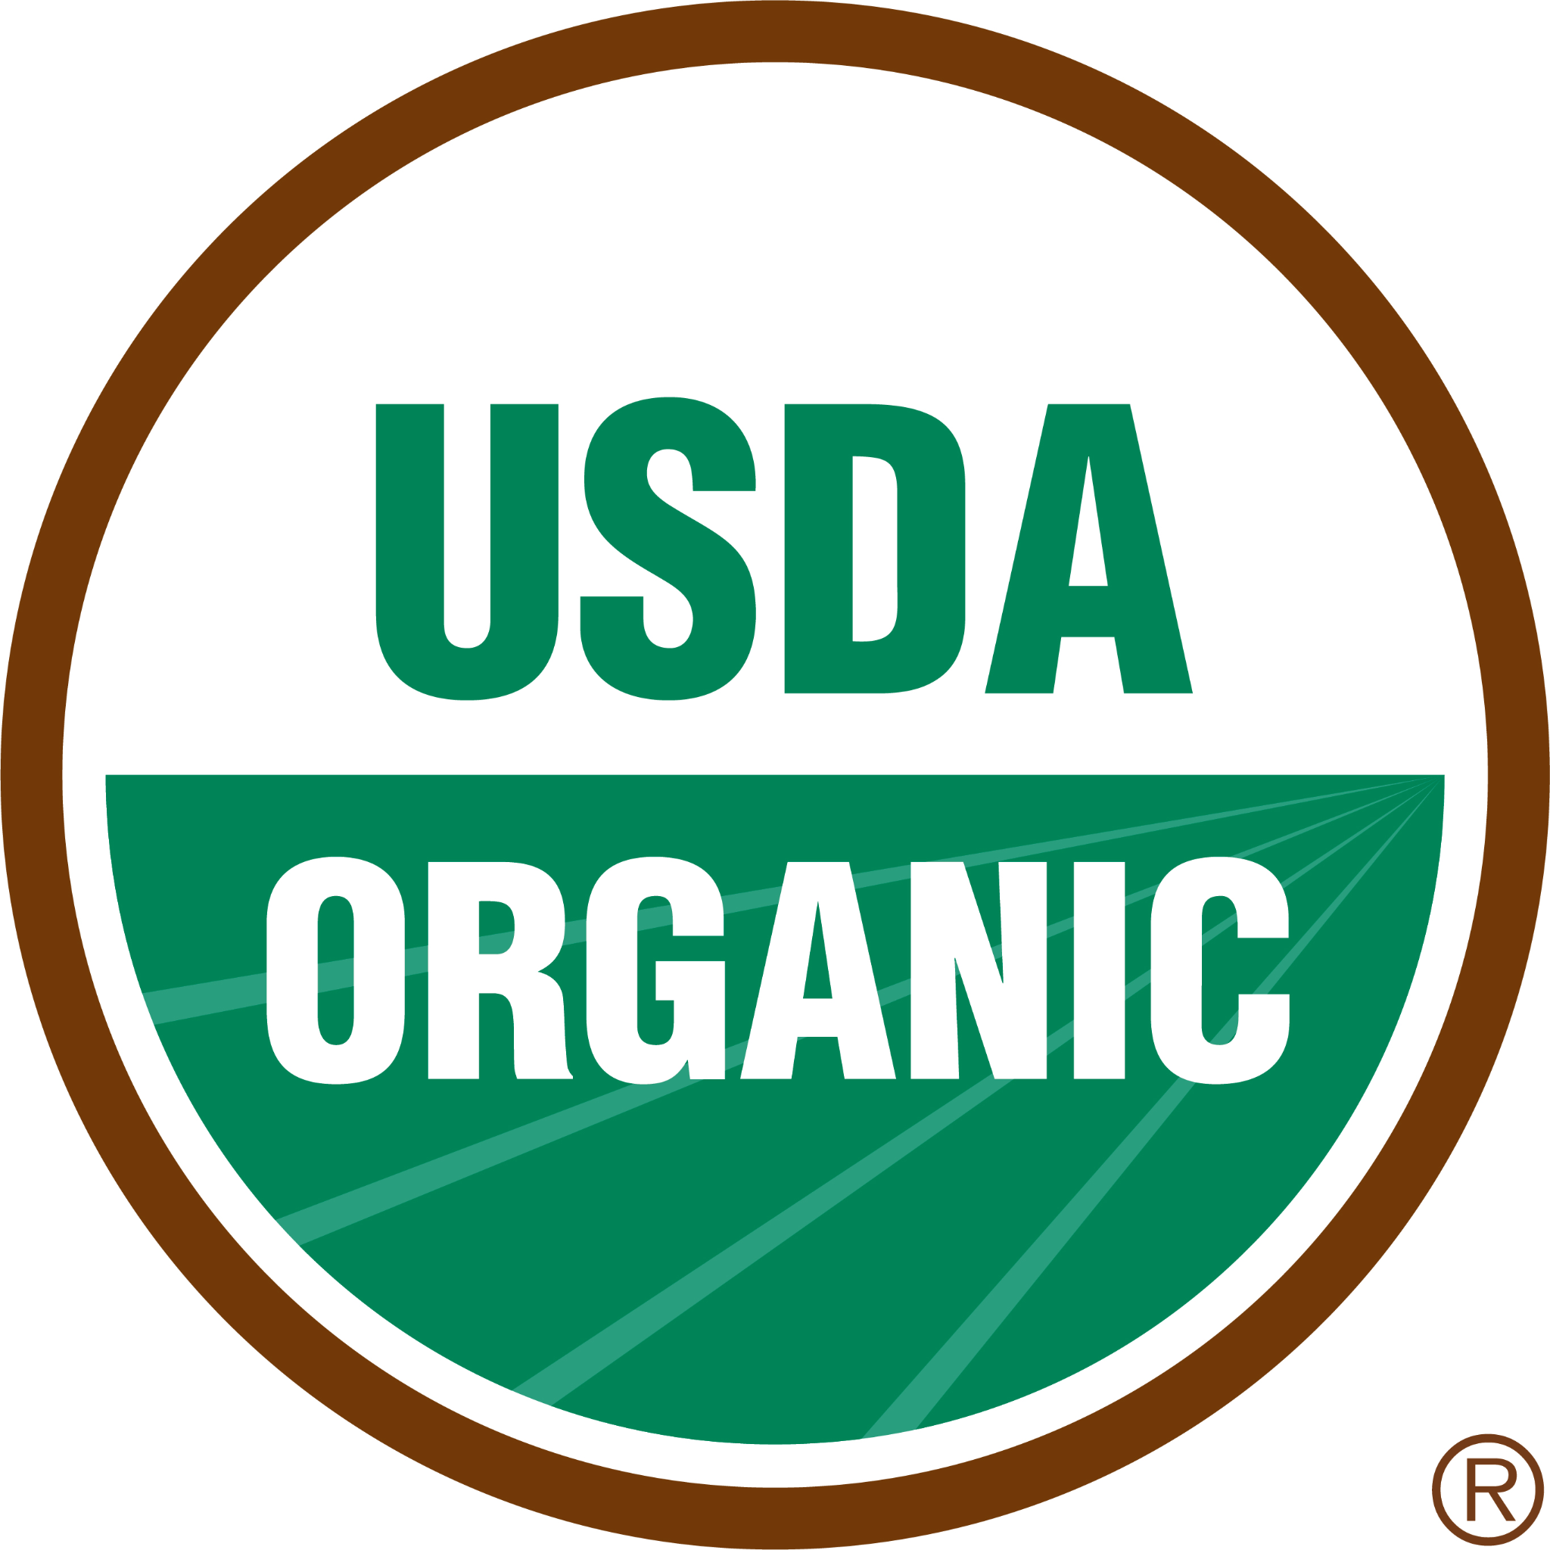

**Product Certifications:**

1. **USDA Organic**

Many of our products are USDA certified organic supplements.

**2.Non-GMO Project Verified**

We offer many supplements that have been verified As non-GMO by the non-GMO project product verification program - North America’s only third-party verification for non-GMO food and products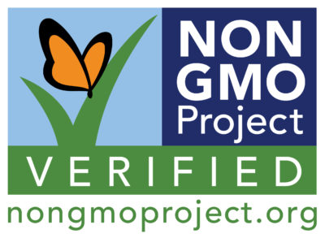

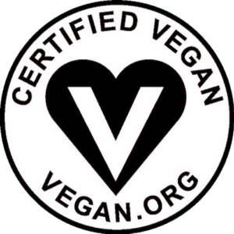

**3. Certified Vegan**

Our supplements with a certified vegan logo do not contain ingredients with animal products or byproducts, and have not been tested on animals.

**Pine Hill Farm Cultivating Wellness Supplement Product List**

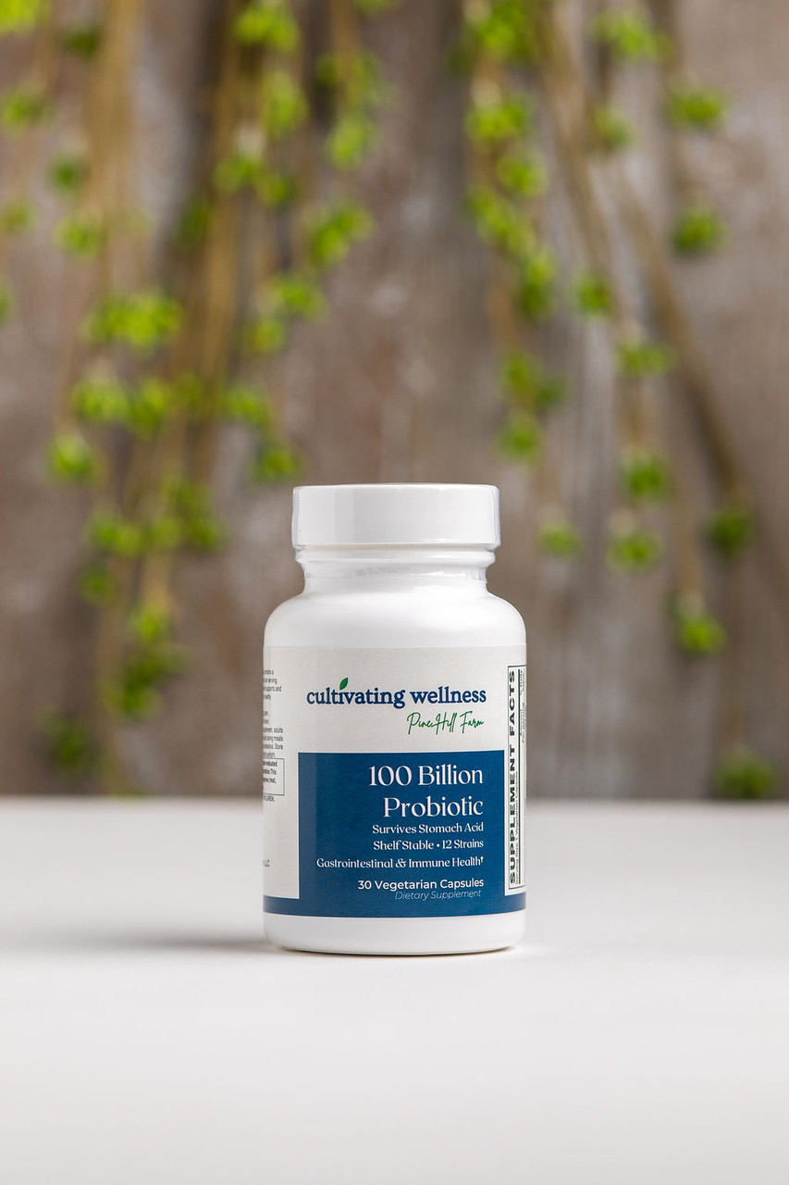

**100 Billion Probiotic**

**Dose:** 1 capsule daily

Our most potent probiotic delivers 100 Billion CFUs from 12 clinically studied strains to quickly restore healthy gut flora and support long-term digestive and immune health.

**Features**

* 12 probiotic strains from Danisco®
* 100 Billion CFUs guaranteed through expiration
* BEARS (Bio-Enhanced Acid Resistant Strains) for survival in stomach acid—no enteric coating needed
* Shelf-stable with patented poly-matrix preservation
* Includes FOS and FiberAid® prebiotics to nourish beneficial bacteria

**Benefits**

* Supports digestion, immunity, and gut balance
* Helps replenish microbiome after antibiotics
* Inhibits growth of harmful bacteria
* Promotes a resilient and diverse gut environment

**35 Billion Probiotic**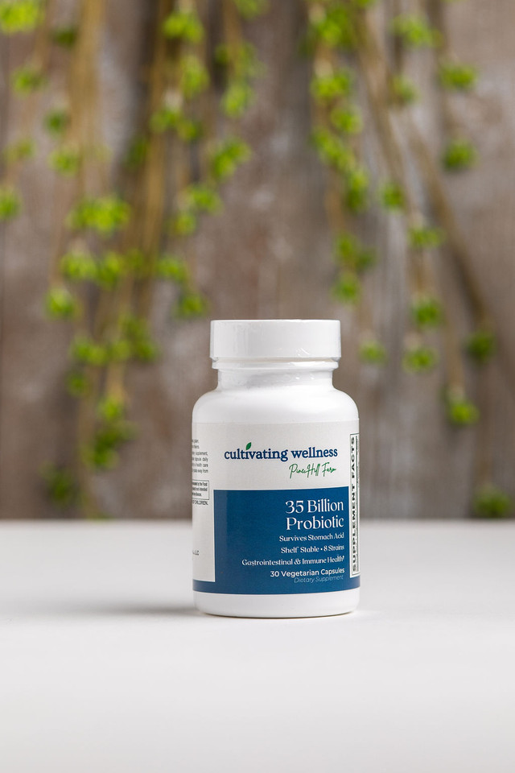

**Dose:** 1 capsule daily

A high-potency, shelf-stable formula delivering 35 Billion CFUs from 8 BEARS probiotic strains to support daily digestive and immune health.

**Features**

* 8 clinically studied strains from Danisco®, a leader in probiotic science
* BEARS (Bio-Enhanced Acid Resistant Strains) survive stomach acid—no enteric coating needed
* Shelf-stable with patented poly-matrix preservation (no refrigeration required)
* Includes prebiotics: FOS & FiberAid® to fuel probiotic growth

**Benefits**

* Supports healthy digestion, immune function, and gut balance
* Helps restore microbiome after antibiotic use
* Promotes long-term intestinal health by maintaining beneficial flora
* Creates an environment unfavorable to harmful bacteria

**Adrenal Support**

**Dose:** 2 capsules daily

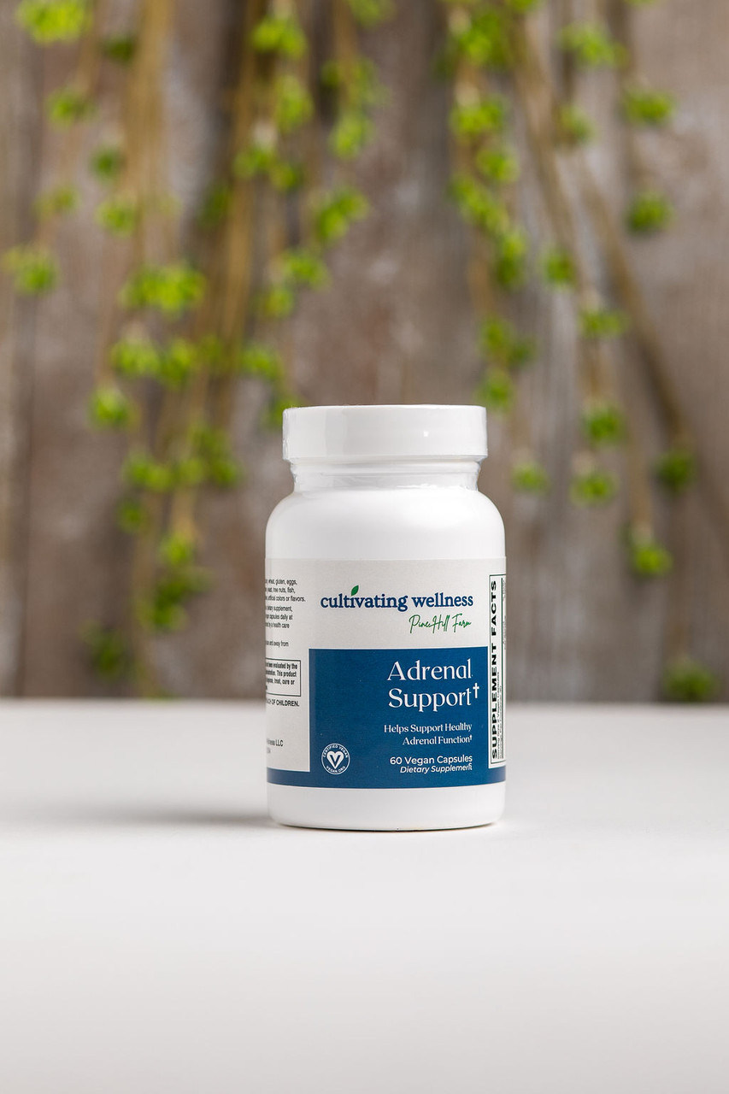

Formulated to support healthy adrenal function, stress response, energy, and immunity.

**Overview**  
 Chronic stress and overstimulation—such as from anxiety, caffeine, or sugar—can overwork the adrenal glands, leading to fatigue, hormonal imbalance, and weakened immunity. This formula delivers targeted nutrients and adaptogens to help restore balance and resilience.

**Features**

* Ashwagandha (1.5% withanolides – Sabinsa®)
* Rhodiola rosea (3% rosavins, 1.5% salidrosides – Russian source)
* Eleuthero, Licorice, Astragalus, Ginger, Gotu Kola, Schizandra
* Vitamin C, Vitamin B6, Pantothenic Acid

**Benefits**

* Supports healthy adrenal hormone production
* Promotes energy, stress resilience, and immune defense
* Helps regulate cortisol and maintain focus during stress
* Adaptogens enhance the body’s ability to cope with physical and mental challenges
* Essential vitamins support adrenal recovery and hormone balance

**Advanced Beauty Care (60’s & 120’s)**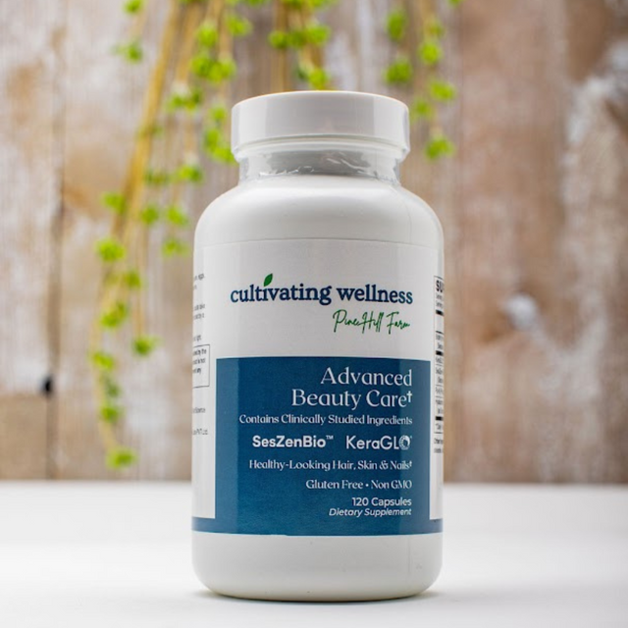

**Dose:** 2 capsules daily

Science-backed ingredients to support vibrant hair, radiant skin, and strong nails.

**Features**

* 500 mg **SesZen-Bio®** (2,500 mcg natural, bioavailable biotin)
* 500 mg **KeraGLO®** Hydrolyzed Keratin
* 100 mg **Fo-Ti Extract** (12:1)
* 100 mg **Hyaluronic Acid** (plant-based)
* Gluten-free, vegan, non-GMO, allergen-free

**Benefits**

* Promotes hair strength, density & thickness
* Supports skin hydration and nail health
* SesZen-Bio® shown to outperform synthetic biotin in clinical studies
* KeraGLO® delivers key amino acids for keratin production
* Fo-Ti and hyaluronic acid support anti-aging and overall beauty

**Advanced Blood Sugar Support**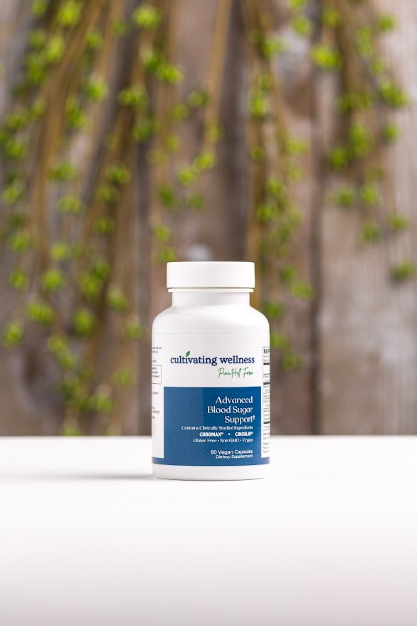

Advanced Blood Sugar Support

**Dose:** 2 capsules daily

Clinically studied ingredients to support healthy blood sugar balance, insulin function, and antioxidant protection.

**Features**

* 500 mg Chromax® Chromium Picolinate
* 500 mg Berberine HCl
* 300 mg Alpha Lipoic Acid
* 250 mg CinSulin® Cinnamon Extract
* 5 mg BioPerine® Black Pepper Extract
* Gluten-free, vegan, non-GMO, allergen-free

**Benefits**

* Supports glucose metabolism, insulin sensitivity & energy
* Berberine activates AMPK, aiding glucose control & cardiovascular health
* Alpha Lipoic Acid supports nerve health & insulin function
* CinSulin® clinically shown to help manage blood sugar levels
* BioPerine® enhances nutrient absorption

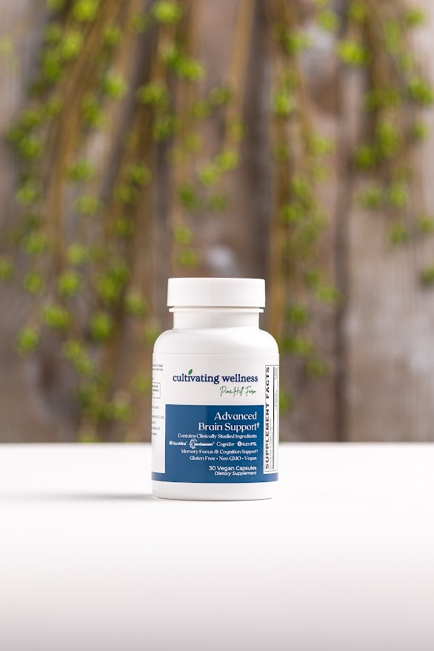

**Advanced Brain Support Vcaps 30's**

**Dose:** 2 capsules daily

A potent blend of clinically studied ingredients designed to boost memory, focus, and cognition for optimal mental performance.

**Features**

* 300 mg BacoMind® Bacopa (cognitive support)
* 250 mg Cognizin® Citicoline (brain energy & focus)
* 125 mg Velvet Bean (50 mg L-DOPA; mood & alertness)
* 100 mg NutriPS™ Phosphatidyl Serine (cognition & stress relief)
* 65 mg Brainberry® Aronia Berry (enhances concentration)
* 5 mg BioPerine® Black Pepper Extract (improves absorption)
* Gluten-free, vegan, non-GMO, allergen-free

**Benefits**

* Clinically shown to improve memory, focus, mental speed, and mood.
* Supports brain energy, cognitive performance, and well-being.
* Brainberry® increased concentration by 43% in a 12-week trial.
* BioPerine® enhances ingredient absorption for maximum effect.

**Advanced Eye Care Caps 30's**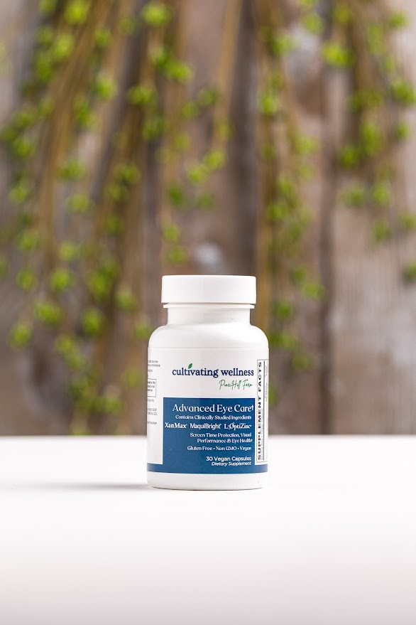

**Dose:** 1 capsule daily

A comprehensive formula with clinically studied ingredients to protect eye health, support vision, and combat blue light damage from screens.

**Features**

* 5000 mcg Vitamin A (beta-carotene)
* 200 mg XanMax® Marigold extract (20% lutein, 1% zeaxanthin)
* 90 mg Vitamin C
* 60 mg MaquiBright® Maqui berry extract (35% anthocyanins)
* 15 mg Zinc (L-OptiZinc®)
* 15 mg Vitamin E, 1 mg Copper
* Gluten-free, vegan, non-GMO, allergen-free

**Benefits**

* Protects eyes from free radicals and supports healthy eye circulation.
* MaquiBright® boosts tear production and ocular hydration.
* XanMax® enhances night vision, contrast sensitivity, focus, and reduces screen fatigue.
* Vitamins E, C, beta-carotene, zinc, lutein, and zeaxanthin may slow progression of age-related eye issues.

**Advanced FEM Support Caps 60's**

**Dose:** 2 capsules daily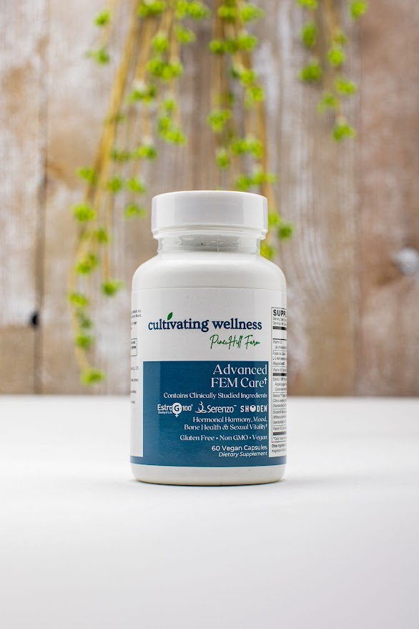

Clinically formulated to support hormonal balance, mood, bone health, and sexual vitality for women at all life stages.

**Features**

* 515 mg EstroG-100® (Cynanchum Wilfordii, Phlomis umbrosa, Angelica gigas)
* 500 mg Serenzo™ (Citrus sinensis essential oil)
* 120 mg Shoden® Ashwagandha (35% withanolides)
* Folate (670 mg Magnafolate® C 5-MTHF), 500 mcg B12 (methylcobalamin)
* 100 mcg Vitamin K2 (menaquinone-7)
* 50 mcg (2000 IU) VegD3® (organic, vegan)
* Gluten-free, vegan, non-GMO, allergen-free

**Benefits**

* EstroG-100® eases menopausal symptoms and boosts libido (53% reported increased sex interest).
* Serenzo™ reduces stress and improves emotional well-being significantly within 6 weeks.
* Vitamins D3 and K2 support bone health, cardiovascular health, and blood sugar balance.
* Shoden® Ashwagandha helps manage stress, sleep, hormonal fluctuations, and menstrual/menopausal symptoms

**Advanced Gut Care Powder 109.5g**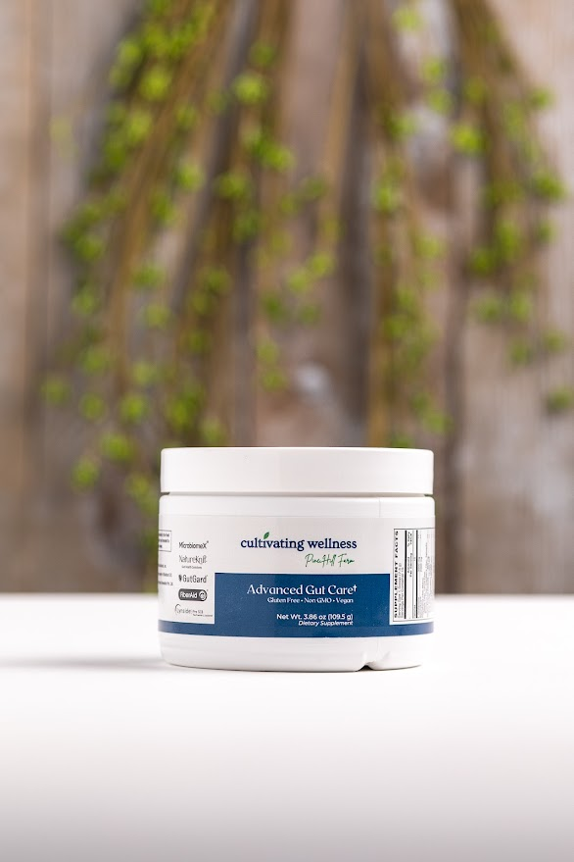

**Dose:** 1 scoop daily in water, juice, or smoothie

Clinically studied ingredients that balance the gut microbiome, soothe the intestines, and support gut lining integrity.

**Features**

* 3000 mg L-Glutamine
* 2000 mg NatureKnit™ fiber-bound polyphenols
* 850 mg Gluten Enzyme Formula
* 250 mg MicrobiomeX® (grapefruit & orange extract)
* 250 mg Lynside® PRO SCB Saccharomyces boulardii
* 150 mg GutGard® licorice root extract
* 100 mg FiberAid® (prebiotic)
* 100 mg Organic Acacia Gum
* 100 mg Ginger root extract
* 100 mg Marshmallow root
* 100 mg Slippery Elm bark
* Vegan, gluten-free, non-GMO, allergen-free

**Benefits**

* L-Glutamine supports gut lining integrity, microbiome balance, and reduces inflammation.
* NatureKnit™ delivers fiber-bound polyphenols with antioxidant benefits for gut health.
* MicrobiomeX® enhances gut microbiome and immune function through beneficial SCFAs.
* GutGard® reduces digestive discomfort and helps relieve H. pylori symptoms.
* Additional enzymes, probiotics, prebiotics, and soothing botanicals support overall digestive health

**Advanced Stress Support Vcaps 60's**

**Dose:** 2 capsules daily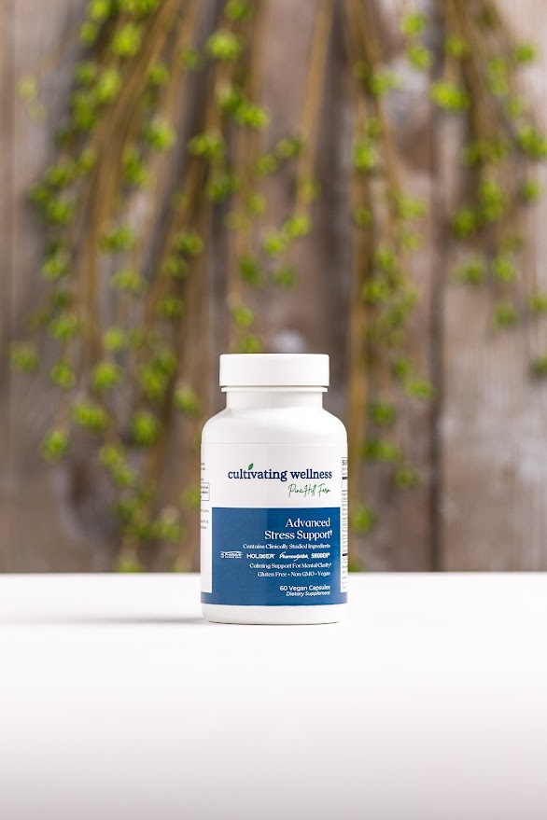

Clinically proven natural ingredients that promote calm, mental clarity, and healthy stress response.

**Features**

* 250 mg Holixer™ Holy Basil (Tulsi)
* 120 mg Shoden® Ashwagandha (35% withanolides)
* 100 mg AlphaWave® L-Theanine
* 100 mg PharmaGABA®
* 100 mg Cacao Seed Extract (10% Theobromine)
* Vegan, gluten-free, non-GMO, allergen-free

**Benefits**

* Holy Basil supports cortisol balance, reduces irritability, and promotes calm without drowsiness.
* Shoden® Ashwagandha boosts stress resilience, energy, sleep, and focus with high bioavailability.
* AlphaWave® aids relaxation, reduces nervous tension, and limits caffeine’s stimulatory effects.
* PharmaGABA® cuts perceived stress by over 50% in clinical studies.
* Theobromine from cacao may enhance mood and blood flow.

**AdvancedTestosterone Support Caps 30's** 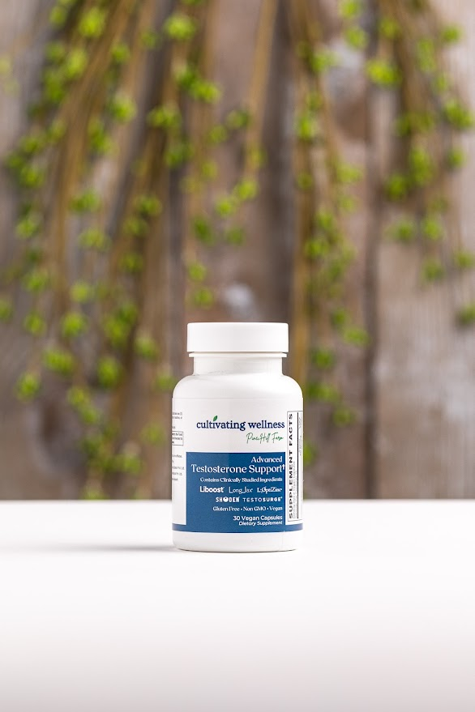

**Dose:** 2 capsules daily, ideally 1 hour before physical activity or bedtime. Supports free and total testosterone with clinically studied ingredients to help counter age-related declines and improve sexual health, energy, and muscle strength.

**Features**

* 500 mg Testosurge® Fenugreek extract (80% glycosides)
* 200 mg LongJax® Longjack (Tongkat Ali) root extract
* 120 mg Shoden® Ashwagandha extract (35% withanolides)
* 100 mg Liboost® Damiana leaf extract (1.5% flavonoids)
* 15 mg L-OptiZinc® (zinc monomethionine)
* 3 mg Boron Chelate
* Vegan, gluten-free, non-GMO, allergen-free

**Benefits**

* Testosurge® reduces body fat and boosts total and bioavailable testosterone without side effects.
* LongJax® enhances libido, sexual function, free testosterone, and lowers cortisol.
* Shoden® improves testosterone and reduces cortisol significantly.
* Liboost® increases erectile function by 40%, boosting nitric oxide and inhibiting testosterone breakdown.
* Zinc supports testosterone levels, reduces inflammation, and promotes erectile health.
* Boron converts total testosterone to free testosterone for better hormonal function.

**Advanced Urinary Care Caps 60's**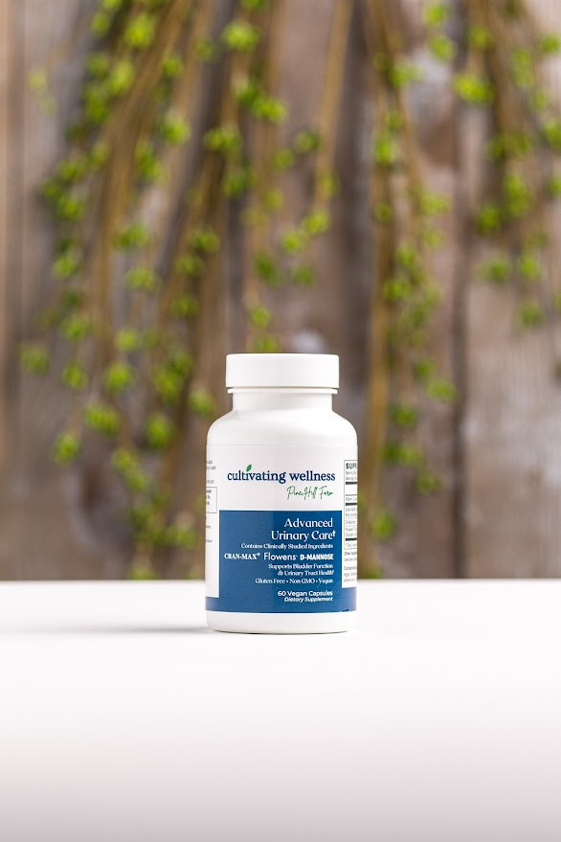

**Dose:** 2 capsules daily

Clinically studied ingredients support urinary and bladder health, reducing frequent urges that disrupt daily life—especially common in women.

**Features**

* 500 mg D-Mannose
* 500 mg Cran-Max® cranberry concentrate
* 250 mg Flowens™ full-spectrum cranberry powder
* 90 mg Vitamin C
* Vegan, gluten-free, non-GMO, allergen-free

**Benefits**

* D-Mannose helps prevent bacteria from sticking to urinary tract walls, aiding their removal and reducing infection risk.
* Cran-Max® provides PACs and anthocyanins to support urinary health and antioxidant protection.
* Flowens™ reduces lower urinary tract symptoms (LUTS) like frequent urges and discomfort, especially in adults over 40.
* Vitamin C may help lower urinary tract infection frequency.

**Algae-Based Calcium SLIM Tabs 90’s & 180's**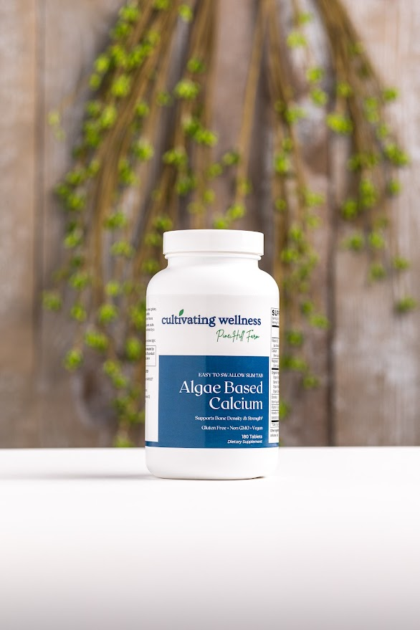

**Dose:** 3 tablets daily

A plant-based calcium supplement featuring Aquamin®—a mineral-rich red algae from Iceland—providing calcium, magnesium, 72 trace minerals, plus Vitamin D3 and K2 to support bone strength, density, and healthy calcium metabolism.

**Features**

* 930 mg Aquamin® Calcium & 68 mg Magnesium
* 80 mcg Vitamin K2 (MK-7) from natto
* 25 mcg VegD3® Organic Vitamin D3 (algae-based)
* 25 mg Organic Veggie & Fruit Blend
* Contains 72 trace minerals including strontium, boron, vanadium
* Vegan, gluten-free, non-GMO, allergen-free, easy-to-swallow slim tablets

**Benefits**

* Clinically shown to improve bone density, strength, and reduce calcium serum levels
* Supports osteoarthritis relief and may reduce NSAID use
* Vitamin D3 boosts calcium absorption and retention
* Vitamin K2 promotes calcium binding to bone and supports arterial health
* Addresses widespread Vitamin K2 deficiency
* Meets FDA calcium recommendations for bone health

**All Season Support Tabs 90's**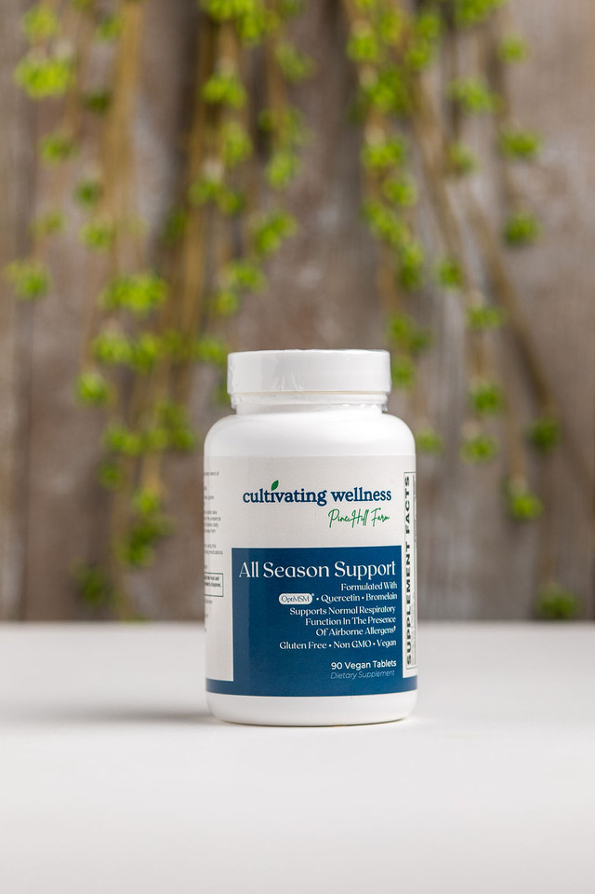

**Dose:** 3 tablets, up to twice daily during allergy season or 3 daily year-round

A proven formula with 10+ years of results featuring a proprietary Seasonal Seven Comfort Blend, VitaBerry® Organic Fruit Blend, OptiMSM®, and key botanicals to support healthy respiratory and immune function during seasonal allergies.

**Features**

* Seasonal Seven Comfort Blend (660 mg): Amla, Chebulic & Beleric Myrobalan, Astragalus, Ginger, Reishi, Black Pepper
* 1500 mg OptiMSM™ (pure MSM) daily
* Stinging Nettle (200 mg), Quercetin (300 mg), Bromelain (25 mg)
* Vitamin C, Turmeric, Ginger, Feverfew
* VitaBerry® Organic Fruit Blend (6 organic berries)

**Benefits**

* Supports normal respiratory function and clear airways
* Helps maintain a balanced immune response to allergens
* Quercetin and stinging nettle stabilize histamine release
* Bromelain promotes healthy inflammation response
* VitaBerry® provides potent antioxidant phytonutrients

**Ashwagandha Extract 500mg Caps 60's**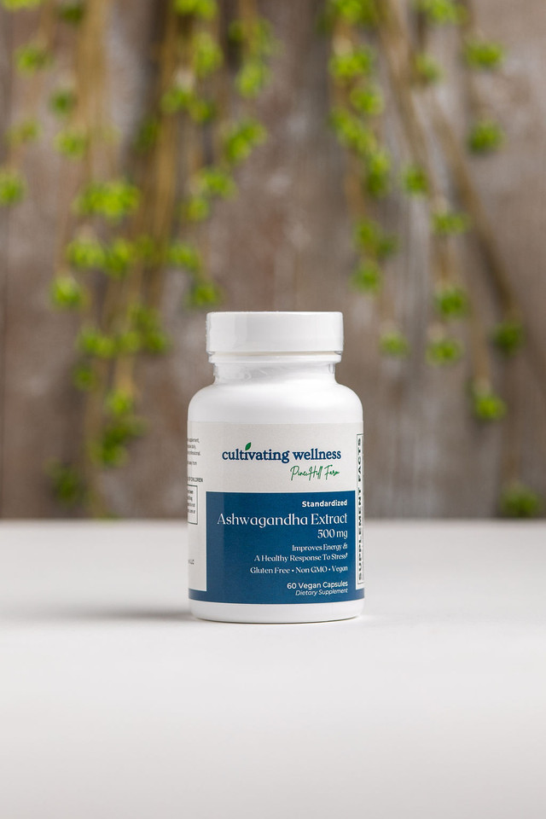

**Dose:** 1 vegetarian, vegan-friendly capsule daily

Standardized to 7% withanolides, from Sabinsa, a leader in Ayurvedic extracts.

**Features**

* 500 mg standardized Ashwagandha extract per capsule
* Clinically studied for over 40 years
* Gluten-free, Non-GMO, vegan, and allergen-free

**Benefits**

* Supports energy, reduces fatigue, and promotes restful sleep
* Helps maintain healthy cortisol and blood sugar levels
* Acts as an adaptogen to manage stress and improve mental focus
* Enhances physical performance and supports a positive mood
* Protects against oxidative stress from nervous tension

**Black Cohosh Caps 120's**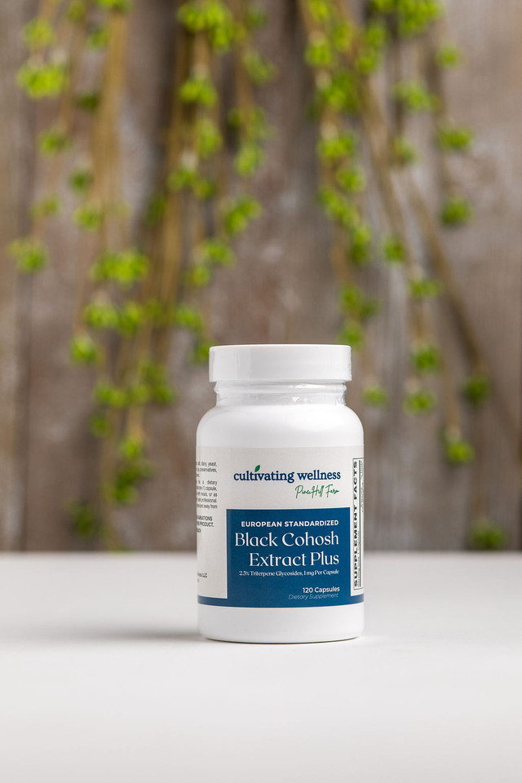

Hormone Balance Formula

**Dose:** 1 capsule, 4 times daily

Contains European standardized Black Cohosh (Euromed) rich in triterpene glycosides, with dong quai and chasteberry for synergistic support.

**Features**

* Standardized Black Cohosh from Euromed, matching clinical study standards
* Clinically effective doses of dong quai and chasteberry

**Benefits**

* Black Cohosh helps normalize hormonal changes and supports healthy luteinizing hormone (LH) levels during menopause
* Dong quai supports a healthy response to female hormone imbalance
* Chasteberry aids in regulating LH and prolactin, easing menopausal symptoms

**Blood Pressure Support Tabs 90's**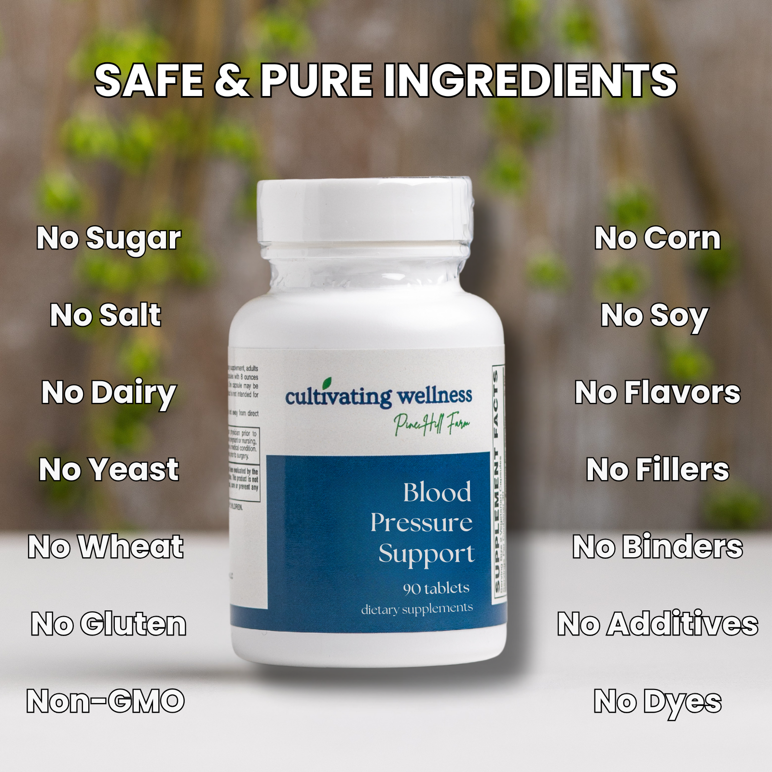

**Dose:** 3 tablets daily

A potent blend featuring 600 mg European Hawthorn berry extract, 600 mg magnesium, 300 mg taurine, and Forslean® coleus forskohlii extract to help maintain normal, healthy blood pressure.

**Features**

* Clinically tested high-potency European Hawthorn (600 mg)
* Magnesium (600 mg) for vascular relaxation and electrolyte balance
* Taurine (300 mg) to support heart muscle and blood pressure
* Forslean® coleus forskohlii, a patented extract supporting heart function
* Includes calming hops extract for stress-related blood pressure support

**Benefits**

* Supports healthy blood vessel relaxation and electrolyte balance
* Helps maintain normal blood pressure and heart function
* Forskolin boosts heart efficiency via cAMP
* Taurine supports heart muscle contraction and overall cardiovascular health
* Hops promote calm to aid blood pressure regulation under stress

**Blood Support plus Superfoods**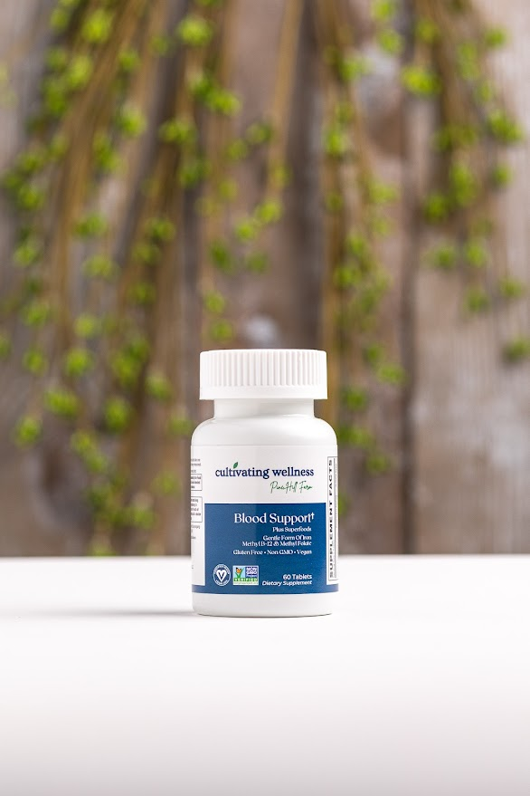

**Dose:** 1 capsule daily

A vegan-certified formula providing 26 mg of Ferrochel® (gentle, non-constipating iron) plus coenzymated B-12 and methylfolate for optimal blood and energy support. Includes organic beet root and a superfood blend to enhance absorption and overall wellness.

**Features**

* 26 mg Ferrochel® (ferrous bisglycinate) for superior absorption
* Coenzymated Methyl B-12 & MagnafolateC® for red blood cell health
* Organic Beet Root (200 mg) and Fruit & Veggie Blend (50 mg)
* Vegan Certified, Non-GMO, Gluten-Free
* Free from common allergens and artificial additives

**Benefits**

* Supports healthy iron levels and combats fatigue without constipation
* Enhances oxygen transport and energy production
* Iron aids neurotransmitter, collagen, antioxidant, and nitric oxide synthesis
* Organic beet root supports blood flow and provides natural vitamins
* Includes vitamin C to boost iron absorption

**C-1000 With Rose Hips S/R Tabs 100's**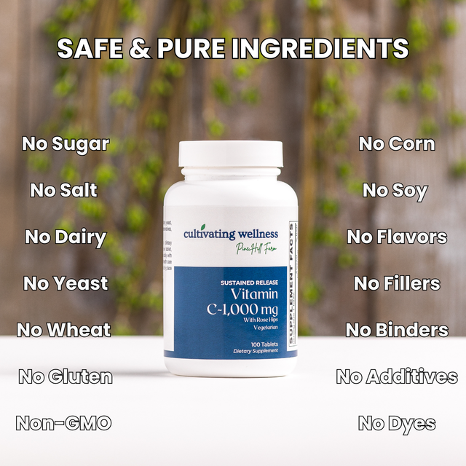

**Dose:** 1 tablet up to 3x daily or to bowel tolerance

A high-potency vitamin C supplement with added rosehips for enhanced antioxidant and immune support. Vitamin C is vital for collagen synthesis, neurotransmitter production, fat metabolism, and immune health. Rosehips provide natural polyphenols and carotenoids that support cardiovascular, immune, and neurological function.

**Features**

* 1000mg vitamin C (also available in 500mg)
* With rosehips for added antioxidant synergy
* Regular or sustained release options
* Gluten-free

**Benefits**

* Supports collagen for skin, joints, and blood vessels
* Aids neurotransmitter and energy production
* Potent antioxidant that regenerates vitamins E and glutathione
* Helps regulate histamine and supports white blood cell function
* May reduce harmful nitrosamine formation from processed foods

**Children's Chewable Grape Multivitamin Tabs 120's**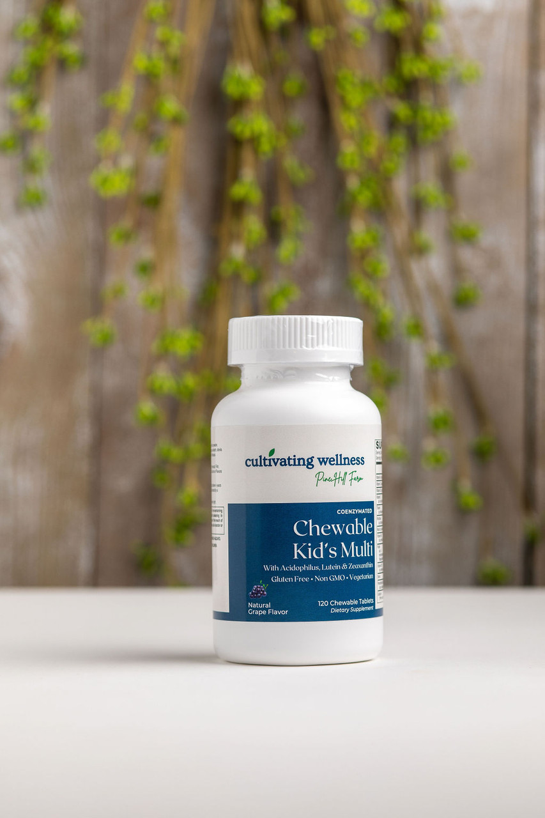

**Dose**: 2 chewable tablets daily

A tasty grape-flavored multivitamin providing essential nutrients for kids’ immune, bone, brain, and digestive health. Includes vitamin C, D3, zinc, B12, folate, and Lactobacillus acidophilus for gut and immune support.

**Features**

* Grape flavor for better compliance
* Chelated minerals for better absorption
* Lactobacillus acidophilus probiotic
* Higher C & Zinc than leading brands
* Xylitol for oral health
* Gluten-free, Non-GMO, Vegetarian
* Free of dairy, wheat, eggs, peanuts, soy, tree nuts, fish, shellfish, sesame, preservatives, and artificial additives

**Benefits**

* Supports immunity, growth, bone and brain development
* Probiotic promotes digestive and immune balance
* Xylitol may support ear and dental health
* Ideal for vegetarian diets, which can lack key nutrients like D, iron, and zinc

**Cod Liver Oil Softgels 100's**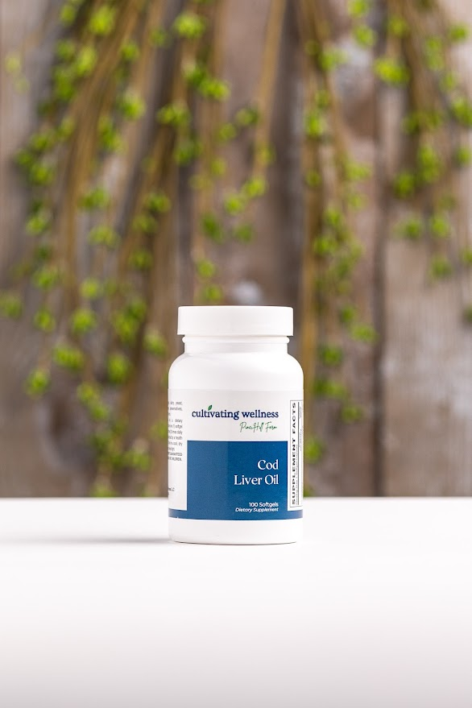

**Dose:** 1 softgel, 1–3 times daily

Provides 90 mg of omega-3s (EPA & DHA) from Icelandic cod liver oil, plus natural vitamins A & D to support heart, brain, vision, bone, and immune health.

**Features**

* 90 mg Omega-3s (EPA & DHA)
* Sourced from Iceland
* Contains natural vitamins A & D
* Easy-to-swallow softgel
* No artificial colors or flavors

**Benefits**

* Supports cardiovascular, brain, and eye health
* Promotes healthy inflammation and cholesterol balance
* Contributes to immune and bone function

**Coenzymated B-Complex Veggie Caps 30's**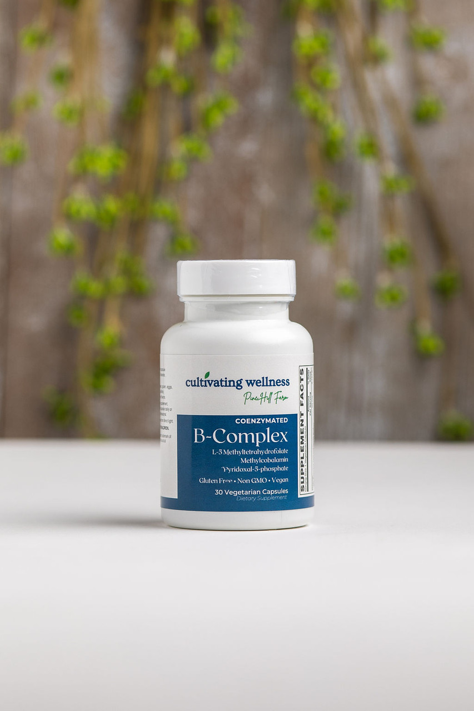

**Dose:** 1 capsule daily

High-potency, once-daily formula delivering fully methylated B-12, folate, and B-6 for superior bioavailability. Supports energy, detox, mood, and metabolism—especially critical for those with MTHFR gene variants.

**Features**

* 500 mcg B-12 (Methylcobalamin)
* 668 mcg DFE Folate (Magnafolate®C 5-MTHF)
* 50 mg B-6 (Pyridoxal-5-Phosphate)
* Includes flush-free Niacin, Biotin, Pantothenic Acid, Choline, Inositol, PABA, and Alpha Lipoic Acid
* Vegan, Non-GMO, Gluten-Free

**Benefits**

* Supports methylation, energy production & nervous system health
* Essential for individuals with MTHFR mutation
* Aids detoxification and red blood cell formation
* Helps manage stress and inflammation response
* Ideal for vegetarians/vegans at risk of B-vitamin deficiencies

**Collagen Peptides Creamer Pwd 240g**

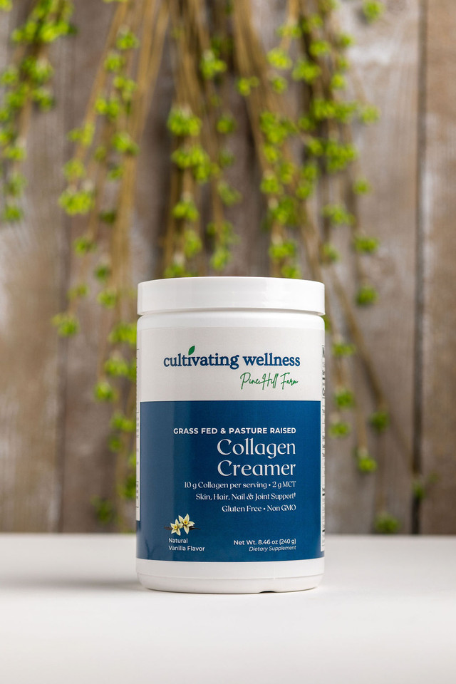

Collagen + MCT Creamer

**Dose:** Mix 2 scoops daily with 8–10 oz of your favorite beverage

A delicious, dairy-free creamer with 10g of hydrolyzed Type I & III collagen peptides and 2g of organic MCTs per serving. Sourced from grass-fed, Non-GMO bovine and designed to support healthy skin, joints, and energy—without gluten, soy, or artificial ingredients.

**Features**

* 10g collagen peptides + 2g organic MCTs
* Hydrolyzed for better absorption
* Grass-fed, pasture-raised, Non-GMO
* Mixes instantly into coffee or hot drinks
* No gluten, dairy, soy, or artificial additives

**Benefits**

* Supports skin, joint, and gut health
* Promotes collagen production and tissue repair
* MCTs provide quick, clean energy without sugar spikes
* Aids in healthy inflammation response and recovery

**Collagen Peptides Unflavored/Chocolate/ Vanilla Pwd** 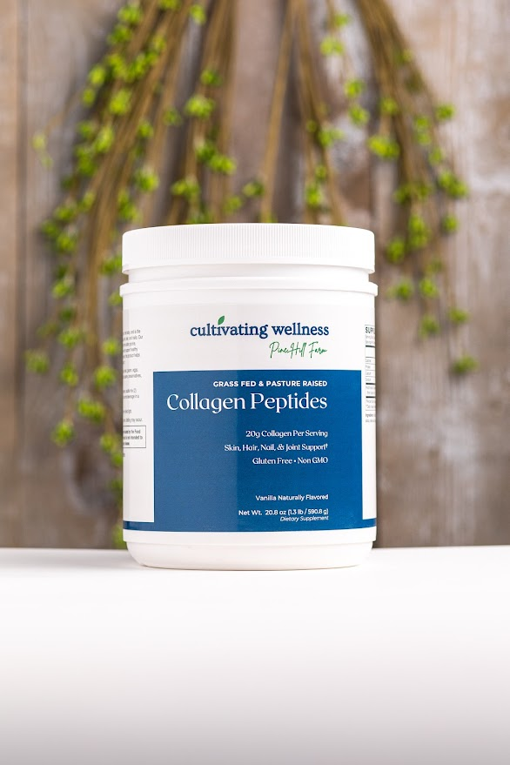

**Dose:** Mix 2 scoops daily with 8–10 oz of your favorite beverage

Delivers 20g of hydrolyzed Type I & III collagen peptides from grass-fed, pasture-raised bovine. Easily absorbed and rich in key amino acids to support skin, joints, bones, and gut health. Naturally flavored and free from gluten, dairy, soy, and GMOs.

**Features**

* 20g collagen per serving
* Hydrolyzed for optimal absorption
* Grass-fed, pasture-raised, Non-GMO
* Delicious vanilla flavor (also in chocolate & unflavored)
* No fillers, artificial ingredients, or common allergens
* Mixes instantly

**Benefits**

* Supports skin elasticity and reduces visible aging
* Promotes joint comfort and mobility
* Aids in gut lining and connective tissue repair
* Helps recovery from physical stress or injury

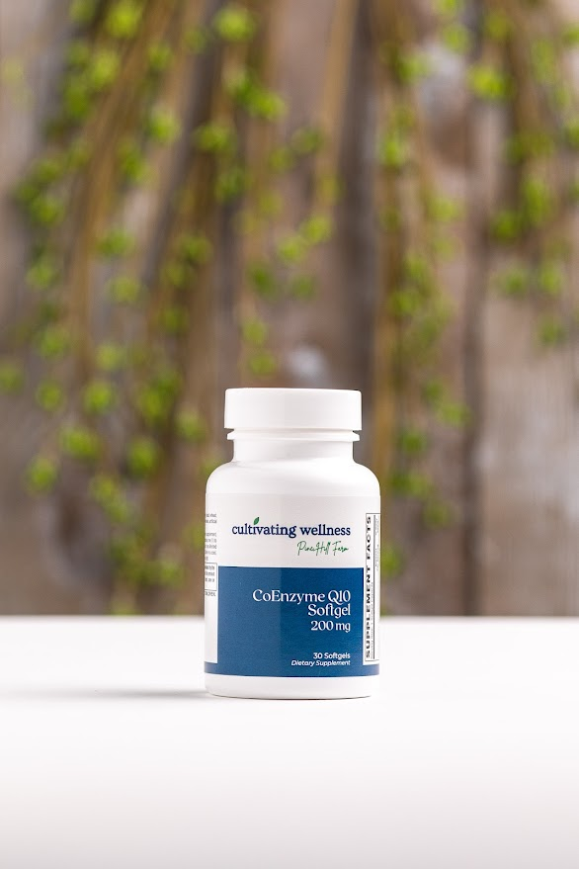

**Coq10 200Mg Softgels 30's**

**Dose:** 1 softgel, 1–2 times daily with meals

A highly bioavailable, naturally fermented form of CoQ10, identical to the body’s own. This all-trans form (free of less-active cis isomers) supports energy production at the cellular level and offers antioxidant protection.

**Features**

* All-trans CoQ10 (most active form)
* Naturally fermented, not synthetic
* Supports mitochondrial energy production (ATP)
* Gluten-free; easy-to-swallow softgel
* Available in multiple strengths

**Benefits**

* Essential for energy in heart, liver, and muscle cells
* Supports cardiovascular health and normal blood pressure
* Helps counteract CoQ10 depletion from statin use
* Protects cells, mitochondria, and LDL cholesterol from oxidative stress
* Promotes neurological and cellular health through improved energy and antioxidant defense

**Creatine Monohydrate Powder 500g**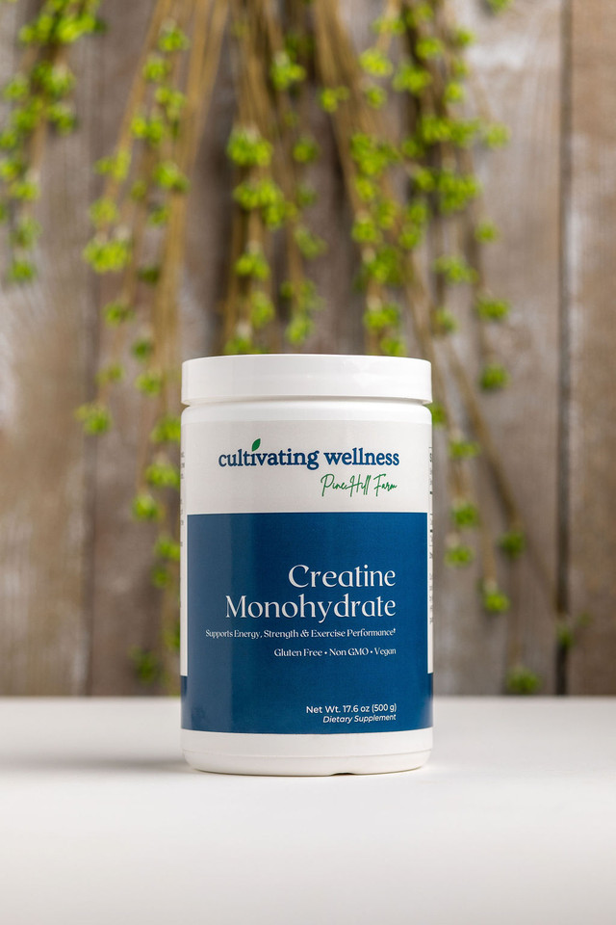

**Dose:** Mix 1 scoop in 8 oz water or juice.  
 *Loading phase:* 4x/day for 5 days  
 *Maintenance:* 1–2x/day. Loading phase optional.

*\*May skip loading dose if desired*

High-purity creatine monohydrate manufactured via a patented process and used in the majority of clinical studies on performance enhancement.

**Features:**

* 5g pure creatine monohydrate per serving
* Pharmaceutical grade; rigorously tested for impurities
* Produced by a global leader in creatine research
* Free from creatinine, dicyandiamide, and other contaminants

**Benefits:**

* Boosts muscle strength, power, and endurance
* Enhances ATP regeneration for improved performance
* Supports lean muscle growth and recovery
* Improves cognitive function
* Potential neuroprotective benefits in conditions like Parkinson’s, ALS, and Traumatic Brain Injuries
* May help with blood sugar by improving glucose tolerance

**D-Mannose 1,000 mg Caps 120's & 60’s**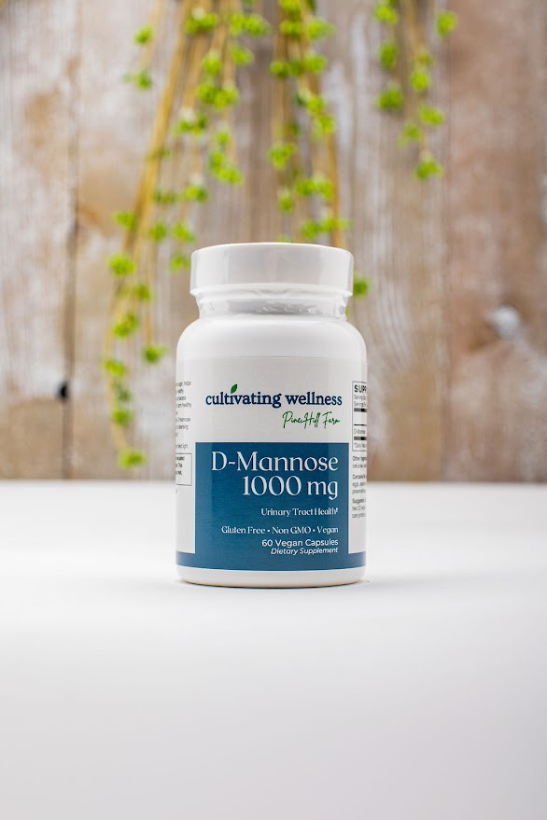

**Dose:** 2 capsules daily

A vegan, gluten-free formula designed to support urinary tract health, especially in those prone to recurrent UTIs.

**Features:**

* 1000 mg of D-Mannose per serving
* Free from common allergens and artificial additives
* Vegan, Non-GMO, Gluten-Free

**Benefits:**

* Helps flush bacteria from the urinary tract and maintain a healthy bladder lining
* Shown in clinical studies to support normal urinary function and reduce UTI frequency
* Naturally occurring sugar that’s safe for blood sugar control and has anti-inflammatory properties

**Glucosamine, Chondroitin & Msm Tabs 90's**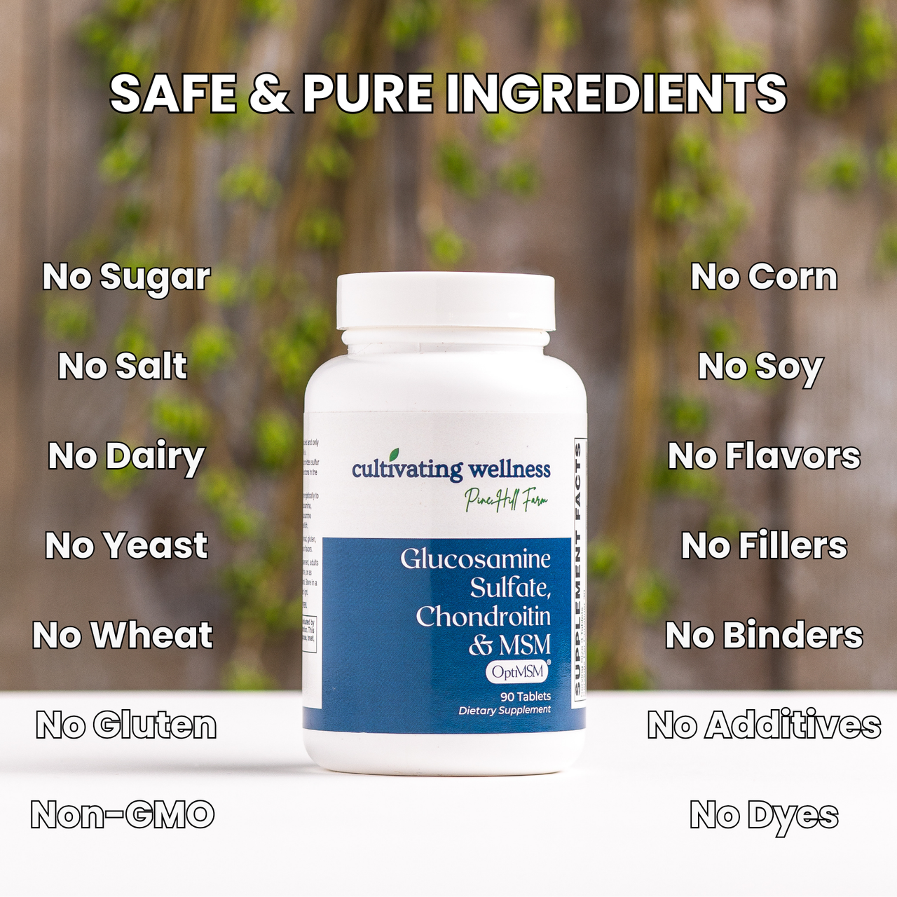

**Dose:** 3 tablets daily with a meal

Provides clinically effective doses of glucosamine sulfate, chondroitin sulfate, and triple-distilled OptiMSM® for joint health.

**Features:**

* High-quality glucosamine sulfate (potassium chloride form) and chondroitin sulfate from top manufacturers
* OptiMSM® (USA-made, triple-distilled MSM) backed by clinical studies
* Added manganese and vitamin C for collagen and cartilage support

**Benefits:**

* Supports cartilage production and limits breakdown, especially in knee joints
* Enhances joint lubrication via hyaluronic acid
* Sulfur in MSM promotes healthy joint tissue and a balanced inflammatory response
* Manganese and vitamin C aid collagen formation to strengthen cartilage

**Glucose Support Caps 60's**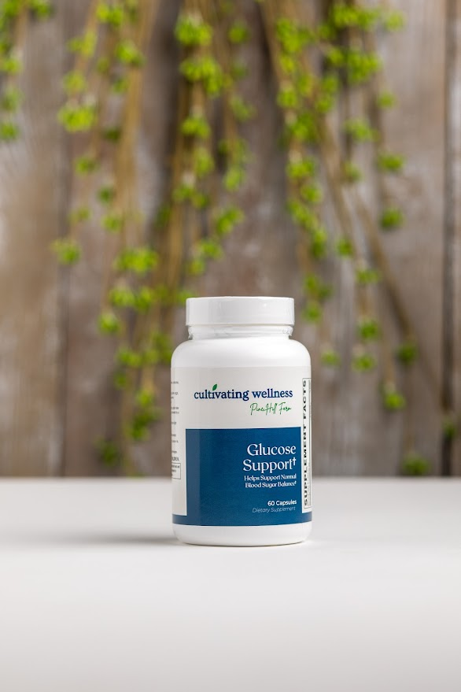

**Dose:** 3 capsules daily with meals

A synergistic blend of minerals, herbs, and patented ingredients like GlucoHelp® and L-OptiZinc®, designed to support healthy blood glucose metabolism.

**Features:**

* Includes clinically backed GlucoHelp® (1% corosolic acid) and L-OptiZinc®
* Contains alpha-lipoic acid, gymnema sylvestre, ginkgo biloba, milk thistle, and more for comprehensive glucose support

**Benefits:**

* Supports healthy blood sugar levels and insulin function
* Slows glucose absorption via Jerusalem artichoke and fenugreek
* Protects neurological, vascular, and liver health affected by glucose metabolism
* Backed by scientific studies demonstrating safety and efficacy

**Glutathione Support Vcaps 60's**

**Dose:** 1 capsule, 1-2 times daily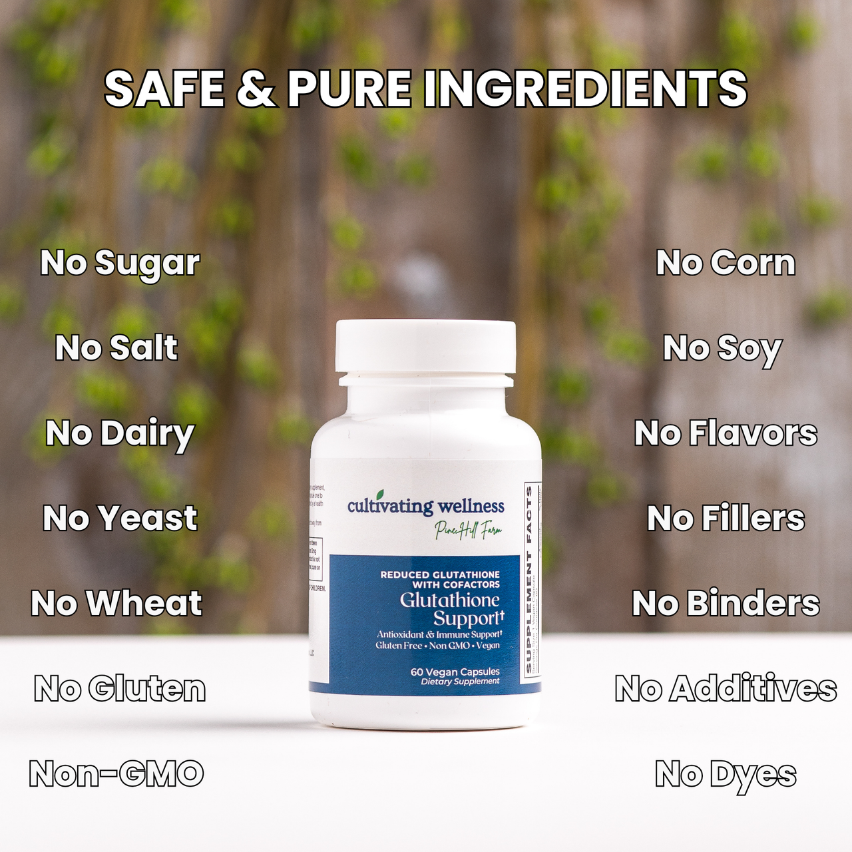

**Overview:** Provides 250 mg vegan reduced L-Glutathione with cofactors (ALA, L-Cysteine, selenium, molybdenum, riboflavin) to boost antioxidant defense, liver health, and detoxification.

**Features:**

* 250 mg stable, reduced L-Glutathione
* Cofactors: 50 mg Alpha Lipoic Acid, 50 mg L-Cysteine, 1.3 mg Riboflavin-5-Phosphate, 55 mcg L-Selenomethionine, 45 mcg Chelated Molybdenum
* Vegan, Non-GMO, free from common allergens and artificial additives

**Benefits:**

* Supports liver function and natural glutathione replenishment
* Enhances immune defense and protection against oxidative stress
* Promotes healthy skin by protecting against toxins and UV damage
* Supports brain health by reducing oxidative damage linked to cognitive decline
* Cofactors enhance glutathione activity and detoxification enzymes
* Helps maintain normal cell growth and repair

**Hair, Skin And Nails Tabs 90's**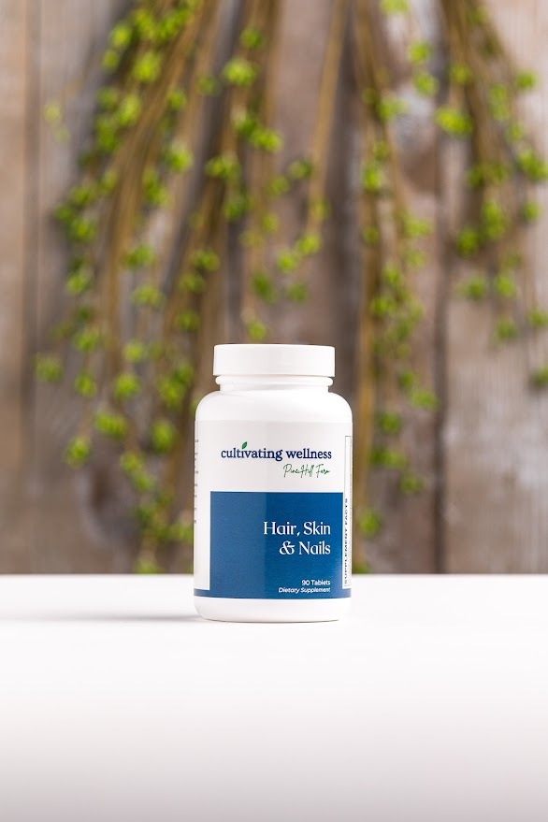

**Dose:** 3 tablets daily

**Overview:** Supports healthy hair, skin, and nails with essential vitamins, minerals, amino acids, and patented ingredients L-OptiZinc® and OptiMSM®, both backed by clinical studies.

**Features:**

* Patented L-OptiZinc®, the most researched zinc form
* OptiMSM®, high-quality US-made MSM with clinical support
* Vitamins C, E, biotin, copper, selenium, and horsetail extract for antioxidant protection and structural support

**Benefits:**

* Promotes production of collagen, elastin, and keratin for strong hair, skin, and nails
* Supports cell growth, repair, and collagen synthesis
* Rich in sulfur compounds (MSM, L-cysteine, methionine) for tissue strength
* Biotin aids fatty acid metabolism for healthy skin and hair
* Antioxidants protect against UV and free radical damage
* Silicon from horsetail strengthens structural integrity

**Immune Support Caps 60's**

**Dose:** 2 capsules, three times daily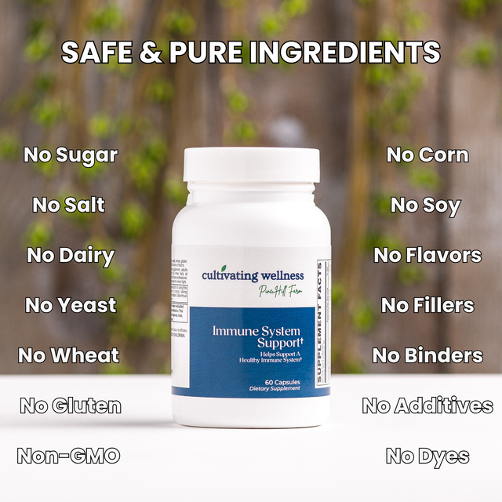

**Overview:** A comprehensive immune formula featuring European standardized echinacea and astragalus, L-OptiZinc®, maitake, shiitake, and reishi mushrooms, quercetin, goldenseal, and ligustrum to promote optimal immune function.

**Features:**

* Clinically studied European standardized echinacea and astragalus extracts
* Premium mushroom extracts (Maitake, Shiitake, Reishi) with immune-stimulating polysaccharides
* L-OptiZinc® — the most researched zinc form for immune cell health
* Vitamins A, C, B6, B12, folic acid, and pantothenic acid
* Quercetin for antioxidant and histamine support
* Goldenseal (berberine) and ligustrum for added immune benefits

**Benefits:**

* Activates and supports key immune cells
* Supports respiratory health, especially in winter
* Enhances thymus and T-cell function
* Provides antioxidant and allergy support
* Combines traditional and modern immune botanical

**ImmunoLyte Fizz Berry Powder & Orange Powder**

**Dose:** 1 scoop in 4–6 oz water, stir and drink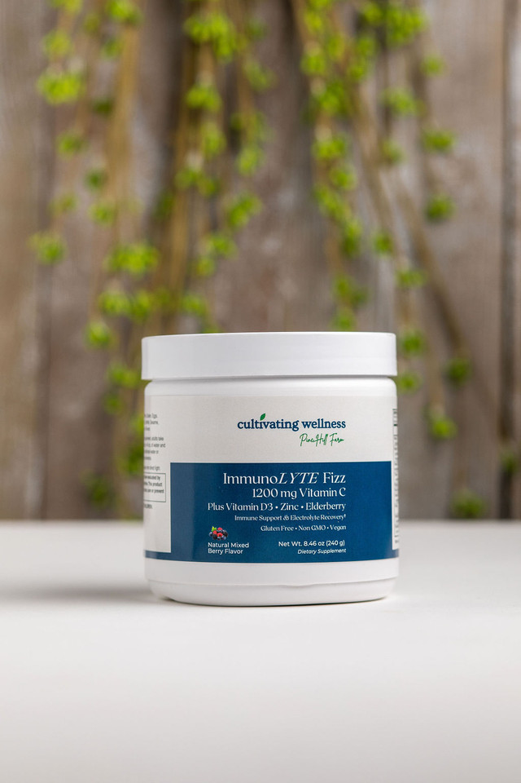

**Overview:** Combines effective doses of vitamins, minerals, and herbs to support immune health, hydration, energy, and endurance—perfect for workouts, heat, or travel.

**Features:**

* 1200 mg Vitamin C, 25 mcg (1000 IU) Vitamin D3, 11 mg Zinc
* 500 mg proprietary immune complex: Arabinogalactan & Beta-Glucan
* 75 mg herbal blend: Elderberry, Ginger, Echinacea
* 6 electrolytes: Calcium, Magnesium, Sodium, Potassium, Phosphorus, Manganese
* B-Complex & Chromium for energy
* Available in berry flavor
* Free from major allergens, sugar, preservatives, gluten-free, Non-GMO, vegan

**Benefits:**

* Supports immune function with proven vitamins and minerals
* Boosts hydration for sustained energy and recovery
* Convenient, tasty supplement for daily use or travel

**Kid's Calm Chewable Tabs 30's**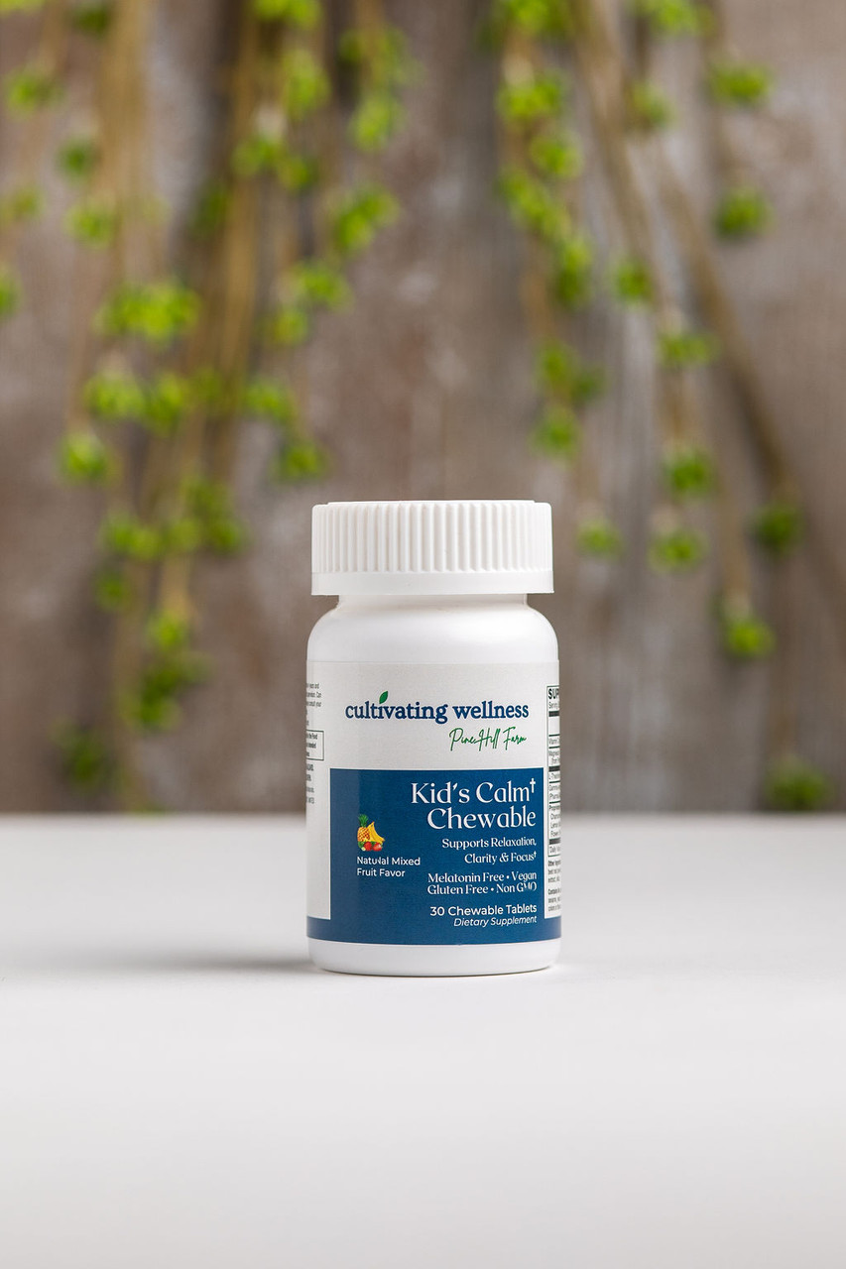

**Dose:** Chew 1 tablet daily, with or without food

**Overview:** Designed to support relaxation, focus, and clarity in kids, addressing common stress and sleep challenges that affect health and school performance.

**Features:**

* 40 mg AlphaWave® L-Theanine
* 10 mg PharmaGABA®
* 30 mg Aquamin® Magnesium (from Irish seawater)
* 25 mg proprietary botanical blend (Chamomile, Lemon Balm, Passion Flower)
* Melatonin-free, grape-flavored
* Free from sugar, dairy, gluten, nuts, soy, preservatives, artificial colors/flavors
* Gluten-Free, Non-GMO, Vegan

**Benefits:**

* Promotes calm, alert mental state without drowsiness
* PharmaGABA® reduces stress and boosts calm focus
* Magnesium supports relaxation, sleep, and stress regulation
* Botanical blend offers natural calming effects

**L-Theanine 100Mg Vcaps 60's**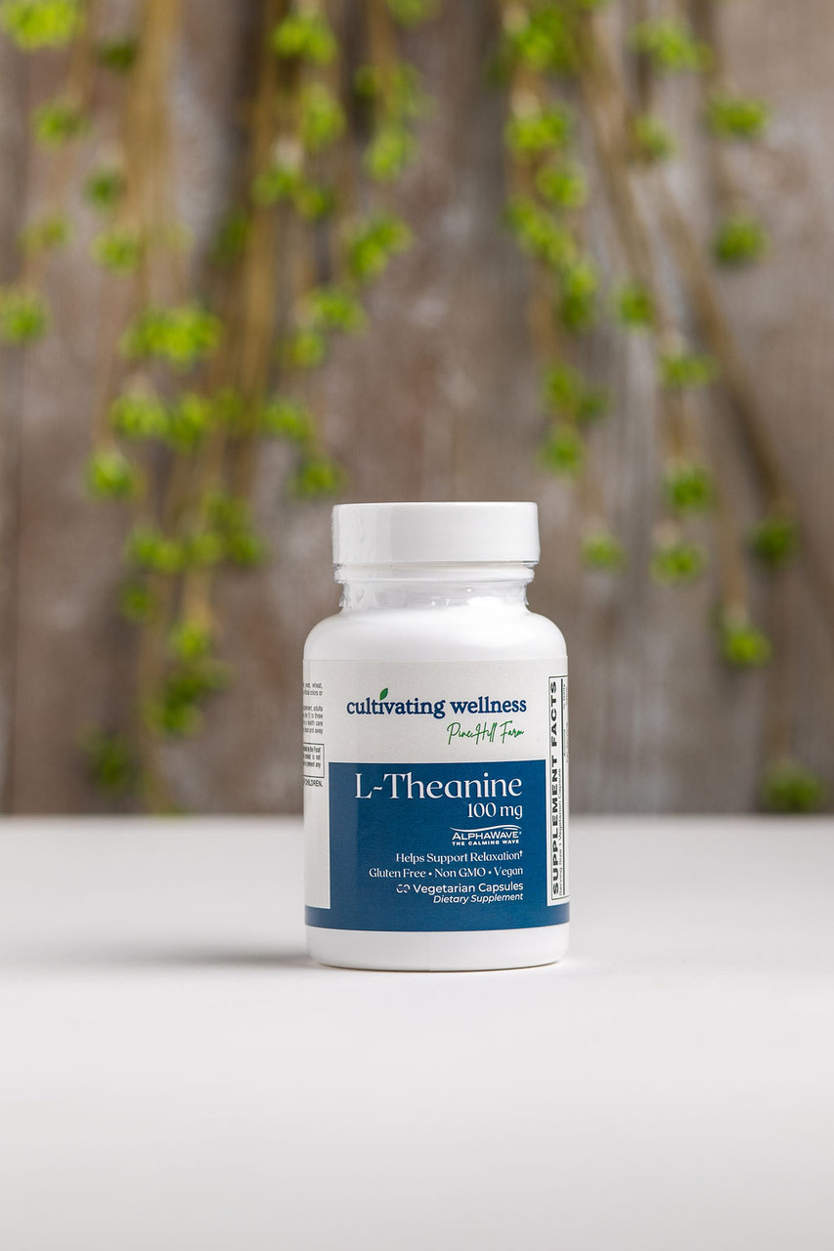

**Dose:** 1 capsule, 1-3 times daily

**Overview:**  
 AlphaWave® L-Theanine is a purified form of L-Theanine, an amino acid from green tea known for promoting relaxation by boosting alpha brain wave activity and increasing dopamine and serotonin. It induces calm focus without drowsiness.

**Features:**

* 100 mg per vegetarian capsule
* Clinically studied, manufactured by Ethical Naturals
* Proven in randomized, placebo-controlled trials

**Benefits:**

* Supports relaxation, mental clarity, focus, and memory
* Reduces nervous tension and stress responses
* Balances effects of caffeine and adrenaline
* May support PMS symptom relief

**L-Theanine Chewable 200 mg 30's**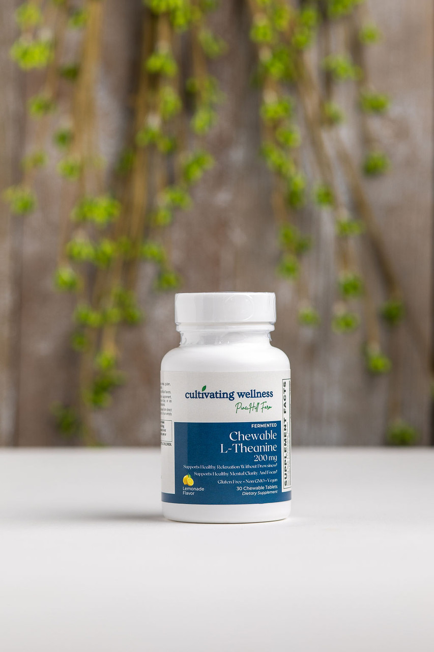

**Dose:** 1 daily or as needed

**Features:**

* Clinically proven, purified AlphaWave® L-Theanine from a proprietary fermentation process
* Natural lemonade flavor, sugar-free, gluten-free, vegan, non-GMO
* Free from common allergens and artificial additives

**Benefits:**

* Promotes relaxation without drowsiness by enhancing alpha brain wave activity
* Supports mental clarity, focus, learning, and memory
* Reduces nervous tension and stress responses
* Balances effects of caffeine and adrenaline
* May support PMS symptom relief

**Magnesium Glycinate 400Mg Veggie Capsules 180's & 90’s**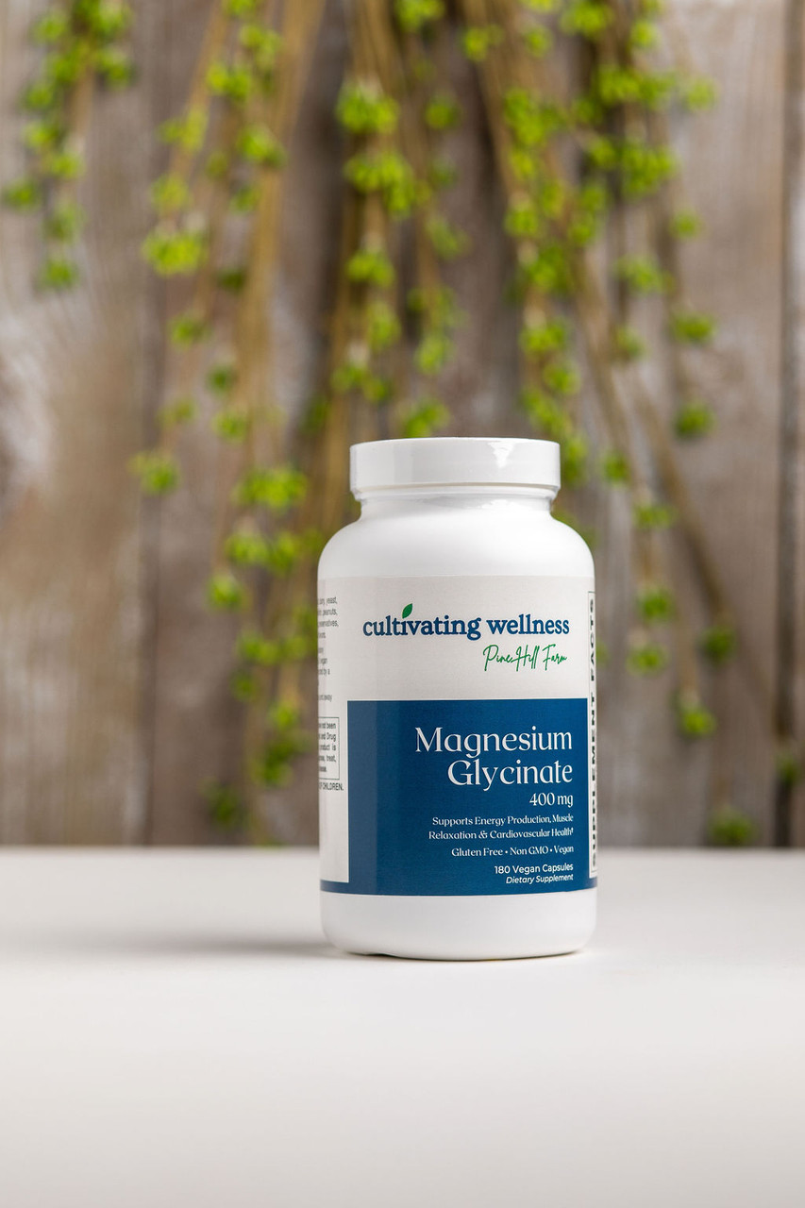

**Dose:** 3 capsules daily

**Features:**

* Highly absorbable, bioavailable magnesium glycinate (chelated with glycine)
* Not dependent on gastric acid for absorption
* Soy, dairy, gluten-free, non-GMO, vegan

**Benefits:**

* Supports 300+ vital biological processes, including energy production, muscle & nerve function, and DNA synthesis
* Promotes healthy heart rhythm, blood pressure, and artery health
* Helps reduce anxiety and supports stress response and relaxation
* Associated with lower risk of cardiovascular disease and arrhythmias

**Melatonin 5Mg Tabs 60's**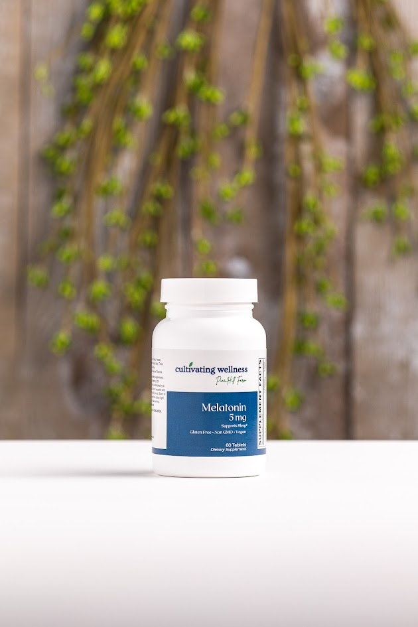

Pharmaceutical-Grade Non-Animal Melatonin with B6

**Dose:** 1 capsule, 20 minutes before bedtime

**Features:**

* Non-animal source, safer than bovine-derived melatonin
* Pharmaceutical-grade melatonin
* Includes 10 mg Vitamin B6 to aid melatonin utilization

**Benefits:**

* Supports healthy sleep cycles and helps with jet lag
* Powerful antioxidant protecting against free radicals
* Supports neurological, cardiovascular, and immune health
* B6 enhances the body’s natural melatonin production

**Methylfolate 800 Mcg Lozenges 60's**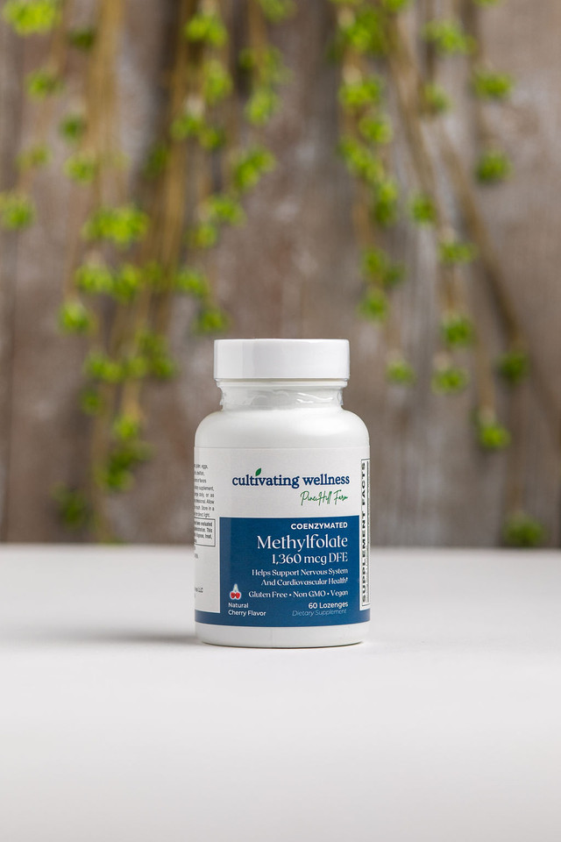

**High-Potency Methylfolate Lozenge**Patented Magnafolate® methyl folate in a tasty cherry-flavored lozenge.

**Dose:** 1 lozenge daily

**Features:**

* Uses Magnafolate® (5-MTHF), more stable and bioavailable than competitors
* Fast-absorbing sublingual lozenge
* Gluten-free, Non-GMO, vegan
* Great cherry flavor

**Benefits:**

* Supports fetal neural development and cardiovascular health by regulating homocysteine
* Enhances brain function, mental focus, and mood
* Aids neurotransmitter synthesis (dopamine, serotonin, acetylcholine)
* Helps address folate deficiency (affects ~70% of people)
* Supports red blood cell formation and liver detoxification

**Multi Source Collagen Peptides 454.5g & 246g**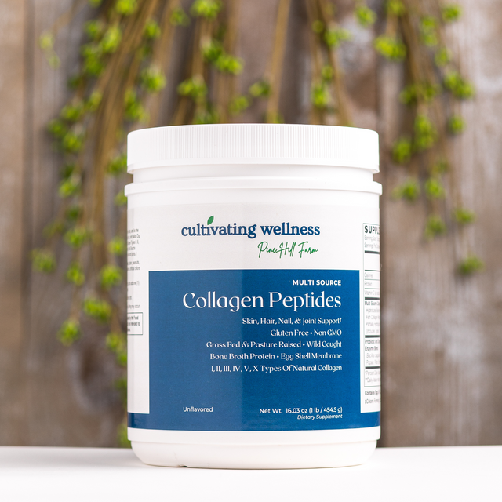

A 10g collagen formula from bovine, fish, chicken bone broth, and U.S.-sourced eggshell membrane, delivering broad-spectrum support for skin, joints, gut, and more.

**Dose:** 1 scoop in 8–10 oz of your favorite beverage

**Features:**

* 10g collagen from 4 sources (Types I, II, III, IV, V, X)
* With 2 Billion CFU Bacillus coagulans (SBO probiotic)
* Includes prebiotics & enzymes (e.g., bromelain, papain)
* Gluten-free, Non-GMO, no dairy, soy, or artificial additives

**Benefits:**

* Supports healthy hair, skin, joints, and digestion
* Diverse collagen types optimize absorption and benefits
* SBO probiotics aid gut health and regularity

**Oregano Oil Veggie Vcaps 60's**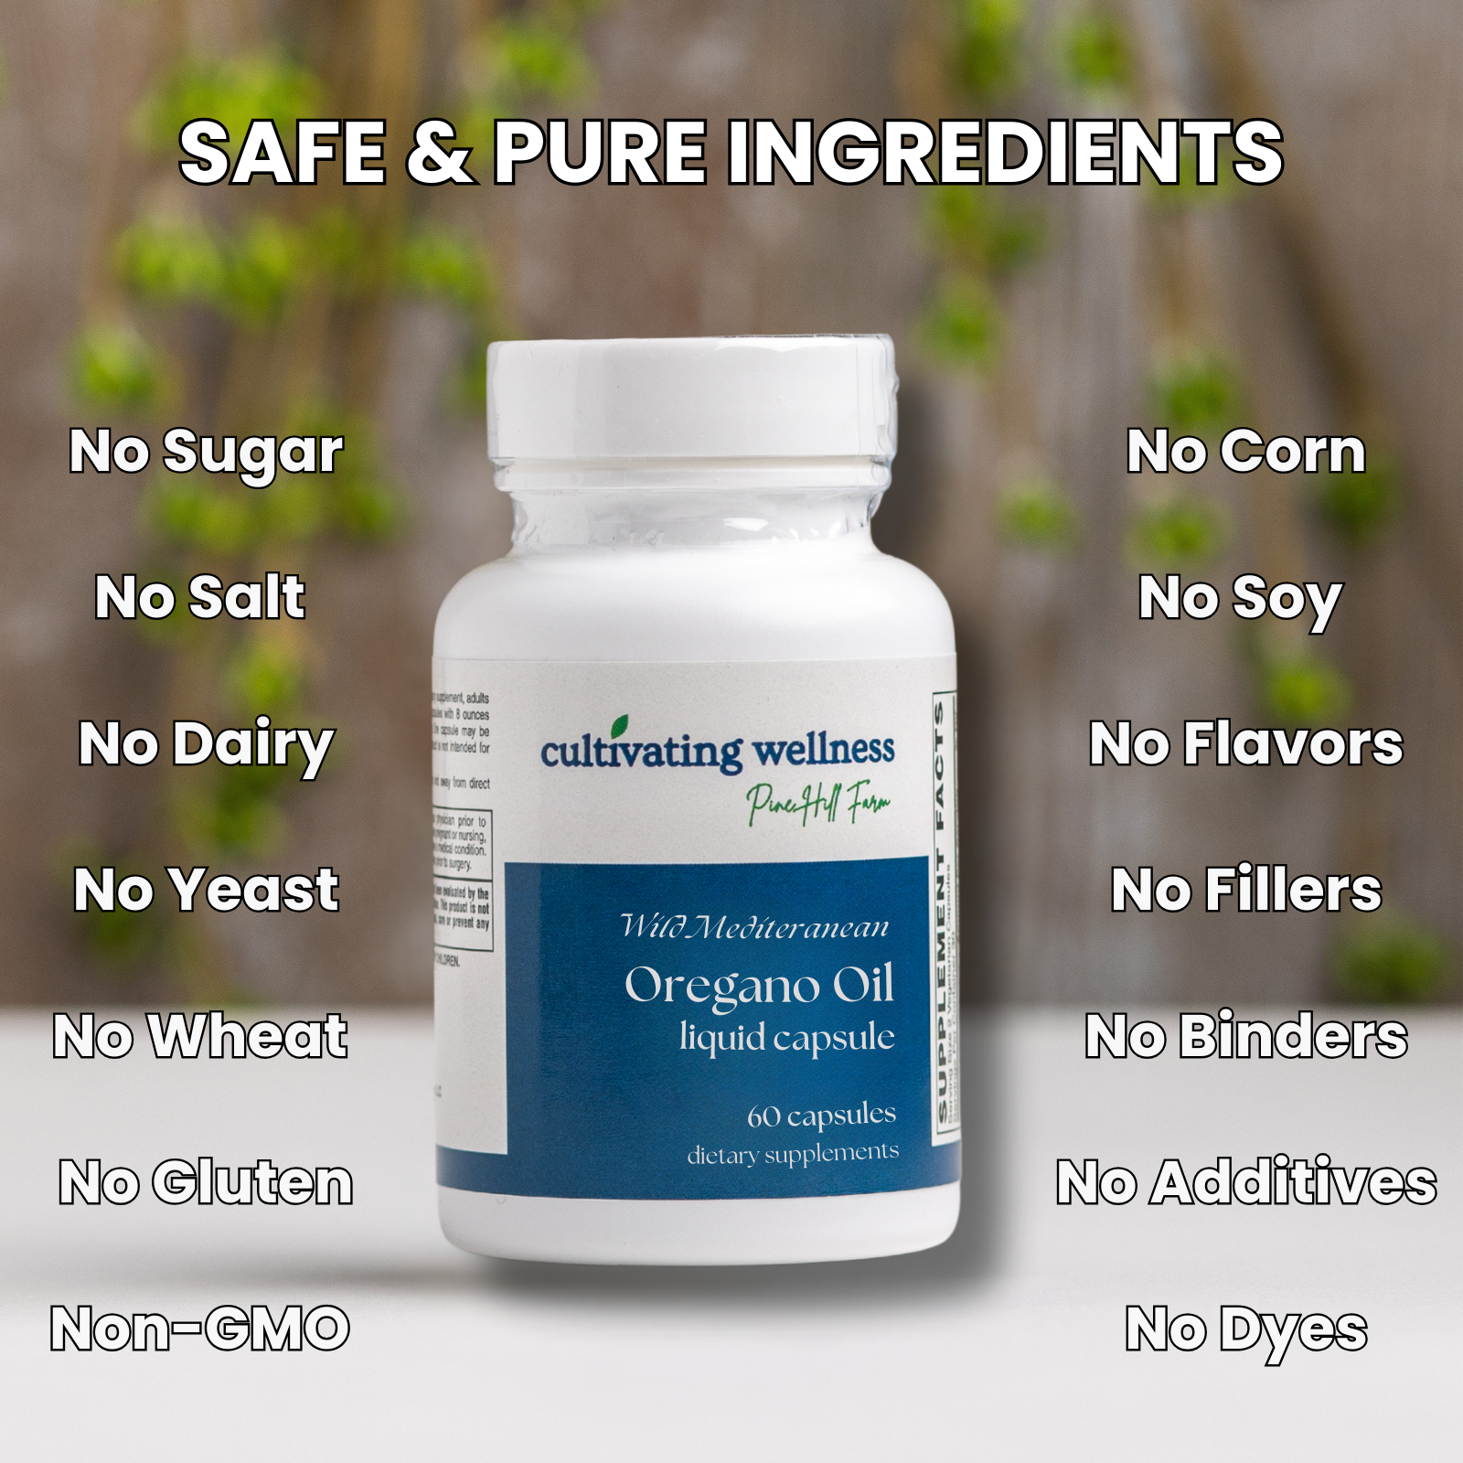

Organic Mediterranean oregano oil, standardized to 70% carvacrol—the key active compound—for immune and antioxidant support.

**Dose:** 1 softgel, 1–3 times daily with meals

**Features:**

* Wildcrafted, organic oregano from native Mediterranean plants
* Gently steam-distilled (no harsh chemicals)
* Standardized to 70% carvacrol
* Delivered in a vegetarian softgel with non-GMO soy lecithin & olive oil

**Benefits:**

* Supports immune function and healthy inflammation response
* Provides natural antioxidant protection
* Aids in seasonal and environmental immune challenges

**Organic Kid's Comfort 5 Billion Probiotic Berry Tabs 30's**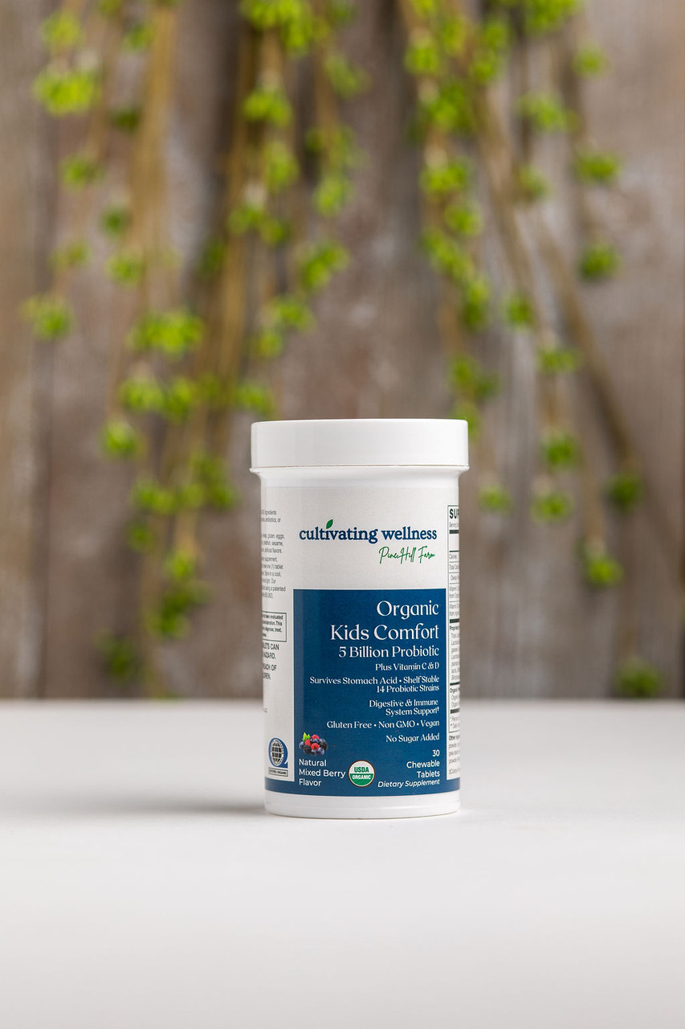

A sugar-free, chewable probiotic with 5 billion CFUs and 14 strains to support kids’ digestive and immune health.

**Dose:** Chew 1 tablet daily

**Features:**

* USDA Organic, Non-GMO, Vegan
* 5 Billion CFUs from 14 probiotic strains
* 310 mg Prebiotic Fiber Blend (Acacia, Cranberry, Amla)
* 30 mg Vitamin C (from Amla)
* 10 mcg (400 IU) Vitamin D3 (from algae)
* No added sugar, gluten, dairy, or allergens
* Shelf-stable, acid & bile resistant
* Available in Strawberry-Banana flavor

**Benefits:**

* Supports gut health and immune function
* Helps restore healthy bacteria after antibiotics
* May ease colic, diarrhea, and promote skin health (eczema)
* Builds a balanced microbiome for overall wellness

**Organic Kids Immune & Seasonal Support Tabs 60's**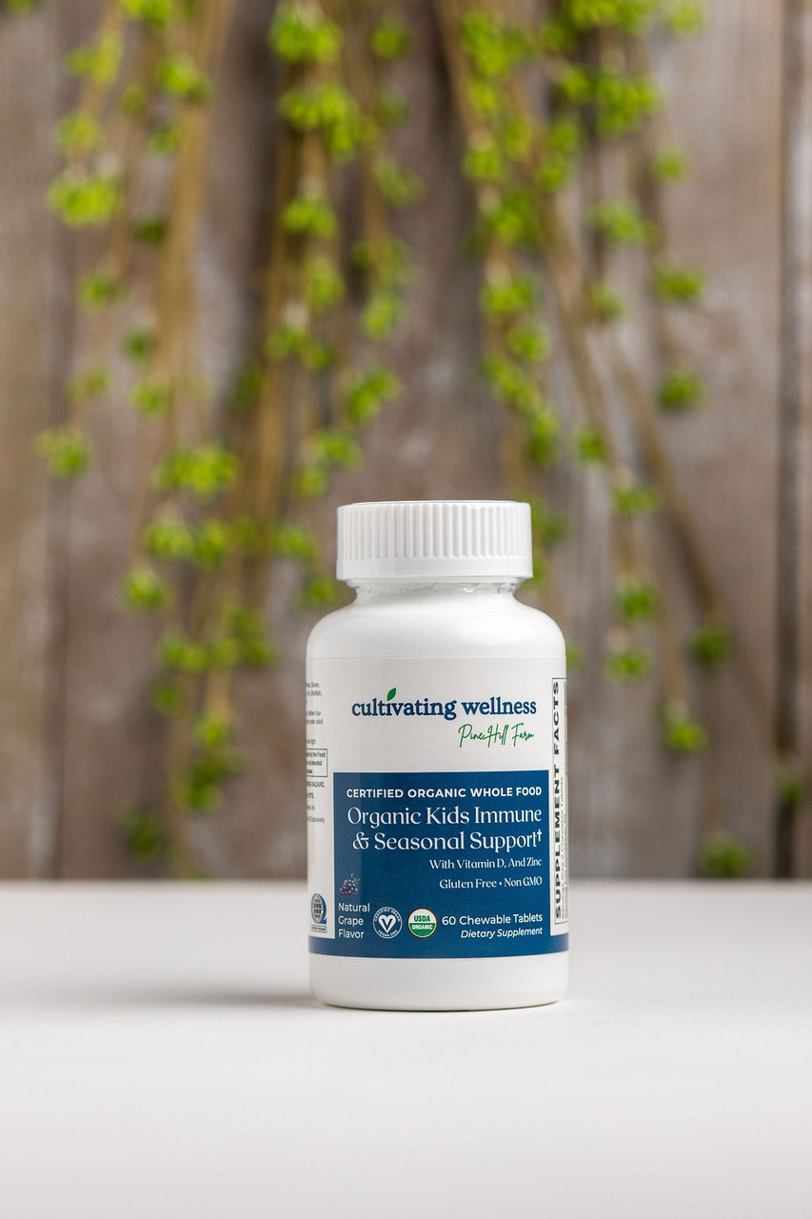

A sugar-free, grape-flavored chewable with Vitamin C, D3, Zinc, and an organic Immune Blend—safe and effective for kids 4+.

**Dose:** Chew 2 tablets daily

**Features:**

* USDA Organic, Vegan, Non-GMO
* 22.5 mg Vitamin C (from Acerola Cherry)
* 5 mcg Vitamin D3 (VegD3® from algae)
* 2.75 mg Zinc (from Guava Leaf)
* 50 mg Immune Blend: Elderberry, Quercetin, Guava Leaf & Citrus Bioflavonoids
* Free from sugar, gluten, dairy, soy, allergens, and artificial additives

**Benefits:**

* Supports immune health and seasonal defense
* Promotes respiratory and sinus wellness
* Kid-friendly taste and gentle, whole-food nutrients

**Organic Lion's Mane Mushroom 500mg Vcaps 60's**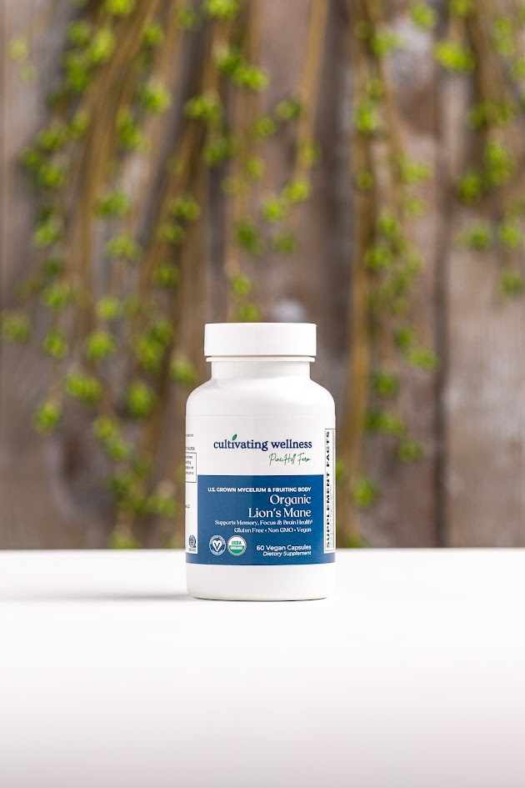

1,000 mg of organic Lion’s Mane (mycelium + fruiting body), standardized to 400 mg polysaccharides, to support brain health and cognition.

**Dose:** 2 vegan capsules daily

**Features:**

* USDA Organic, Vegan, Non-GMO, U.S. Grown
* Standardized to 40% polysaccharides (400 mg)
* Gluten-, dairy-, soy-, and allergen-free

**Benefits:**

* Supports memory, focus, and cognitive function
* Promotes Nerve Growth Factor (NGF) for brain and nerve health
* Enhances mental clarity, mood, and stress resilience
* May support healthy circulation and reduce fatigue

**Organic Men’s Multi Tabs 60's**

**\*Reformulating**

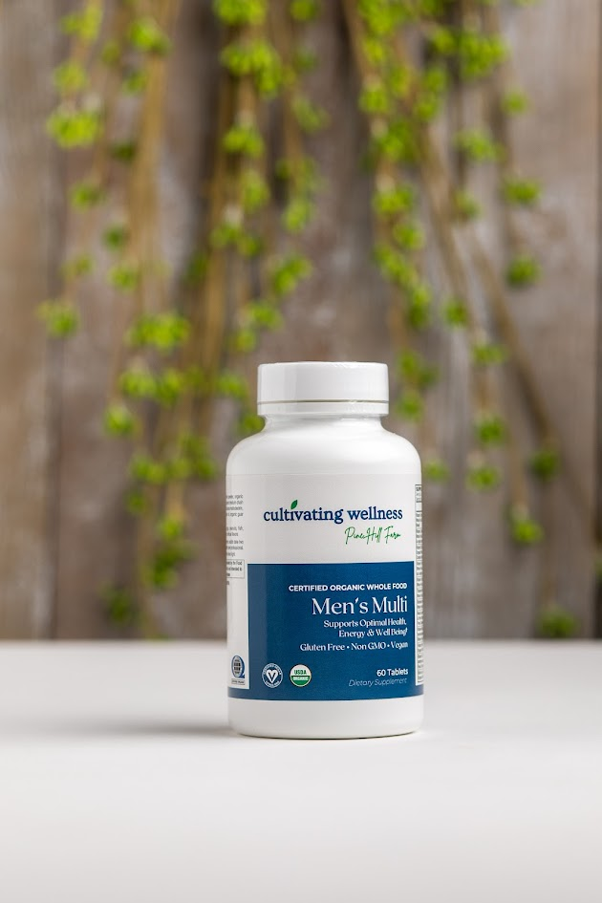

**Organic Mushroom Immune Support Caps 60's**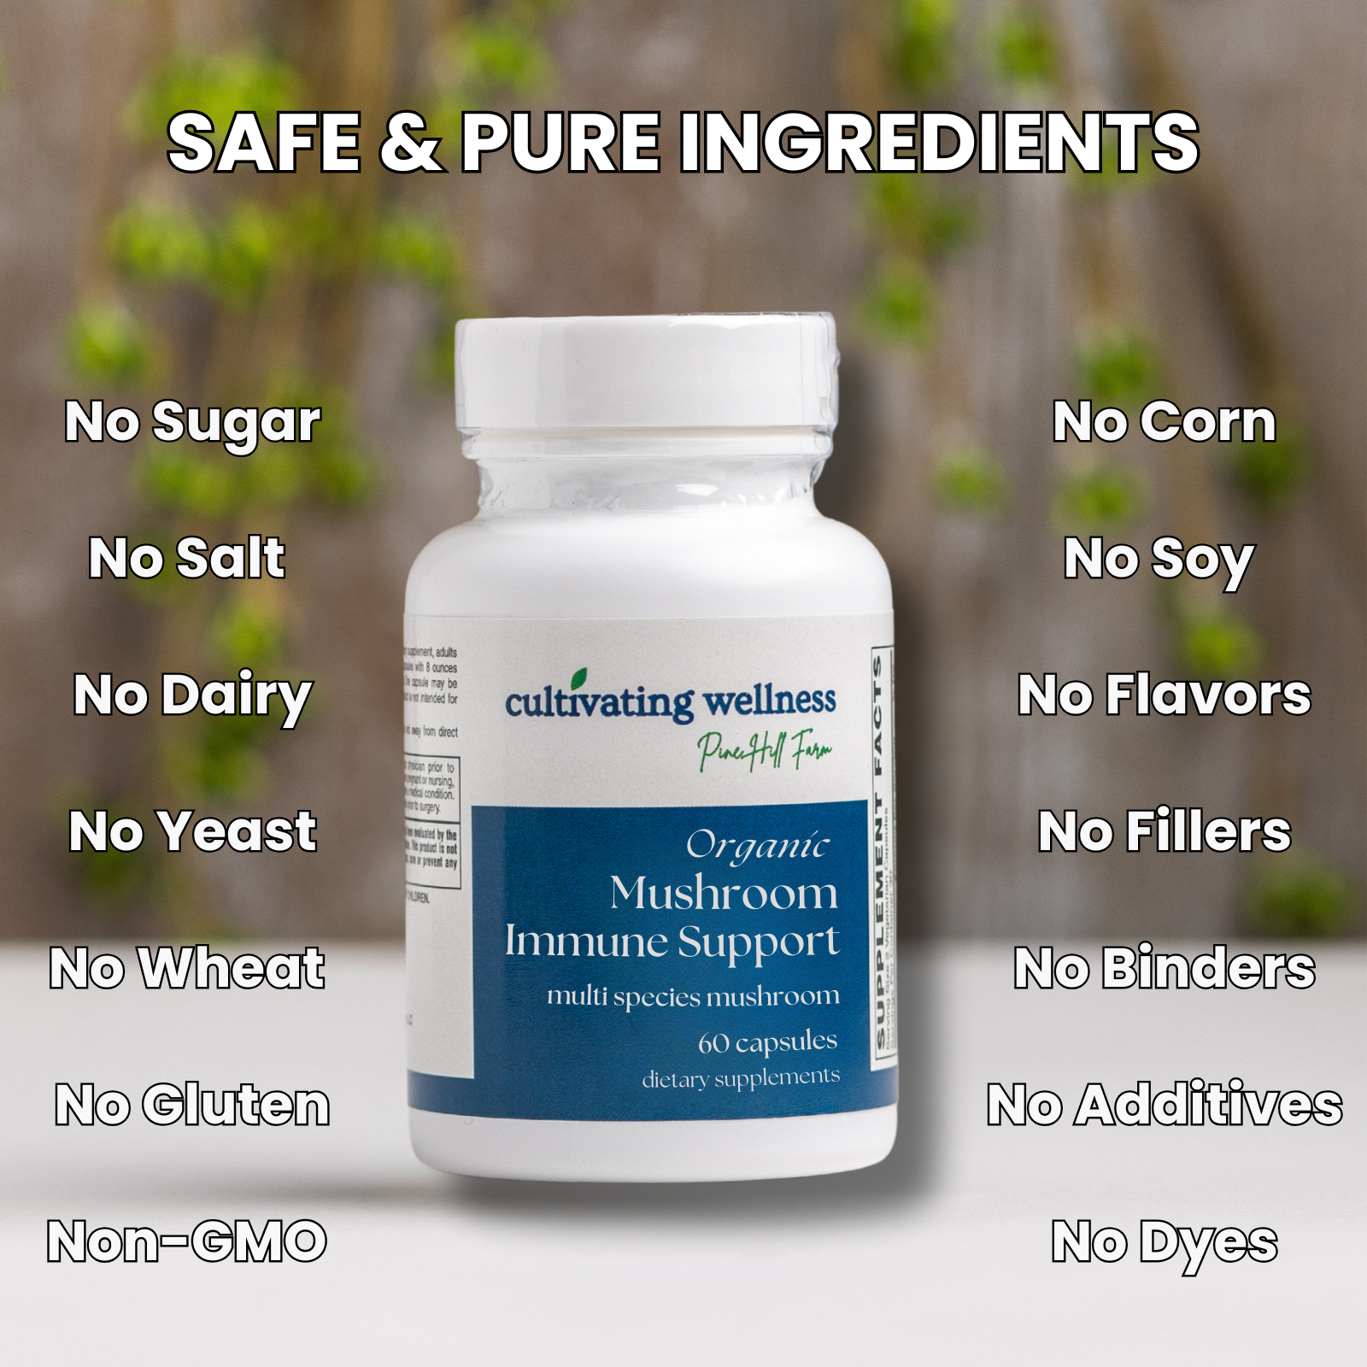

A synergistic blend of 9 organic mushrooms providing 1g of mycelium and fruiting body per serving to support balanced immune function and overall wellness.

**Dose:** 2 vegetarian capsules daily

**Features:**

* 1g Multi-Species Mushroom Blend (mycelium + fruiting body)
* Includes Reishi, Maitake, Chaga, Shiitake, Cordyceps, Lion’s Mane & more
* U.S. grown | Organic | Vegan | Non-GMO | Gluten-free
* No sugar, dairy, wheat, or artificial additives

**Benefits:**

* Promotes immune balance and resilience
* Rich in beta-glucans and other immune-supportive nutrients
* Supports respiratory, digestive, and circulatory health
* Helps the body adapt to stress and immune challenges

**Organic Once Daily Men's Multi Tabs 30's & 60’s** 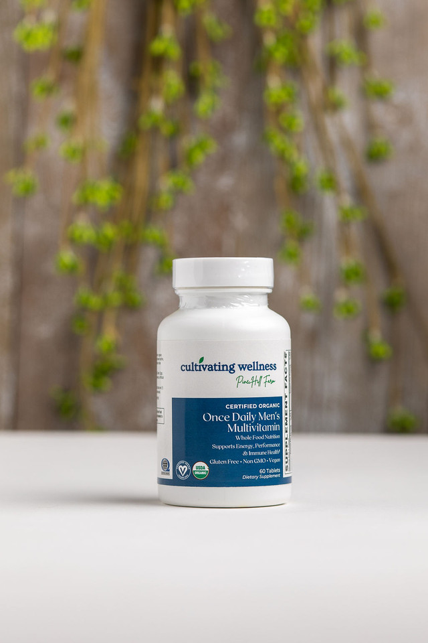

A USDA Organic, Vegan-certified multivitamin tailored to meet men's nutritional needs with essential vitamins, minerals, and high-potency B vitamins for energy, heart, and nerve health. Includes plant-based VegD3® for immune and bone support.

**Dose:** 1 capsule daily

**Features:**

* 500 mg Organic Whole Food Complex (guava, amla, moringa & more)
* High-potency B vitamins | 25 mcg VegD3® (from algae)
* No added iron
* Free from common allergens and artificial additives
* Non-GMO, simple and clean excipients

**Benefits:**

* Supports energy, performance, and immunity
* Aids stress response and well-being
* Ideal for vegans, vegetarians, and those seeking clean, plant-based nutrition

**Organic Once Daily Prenatal Multi Tabs 30's**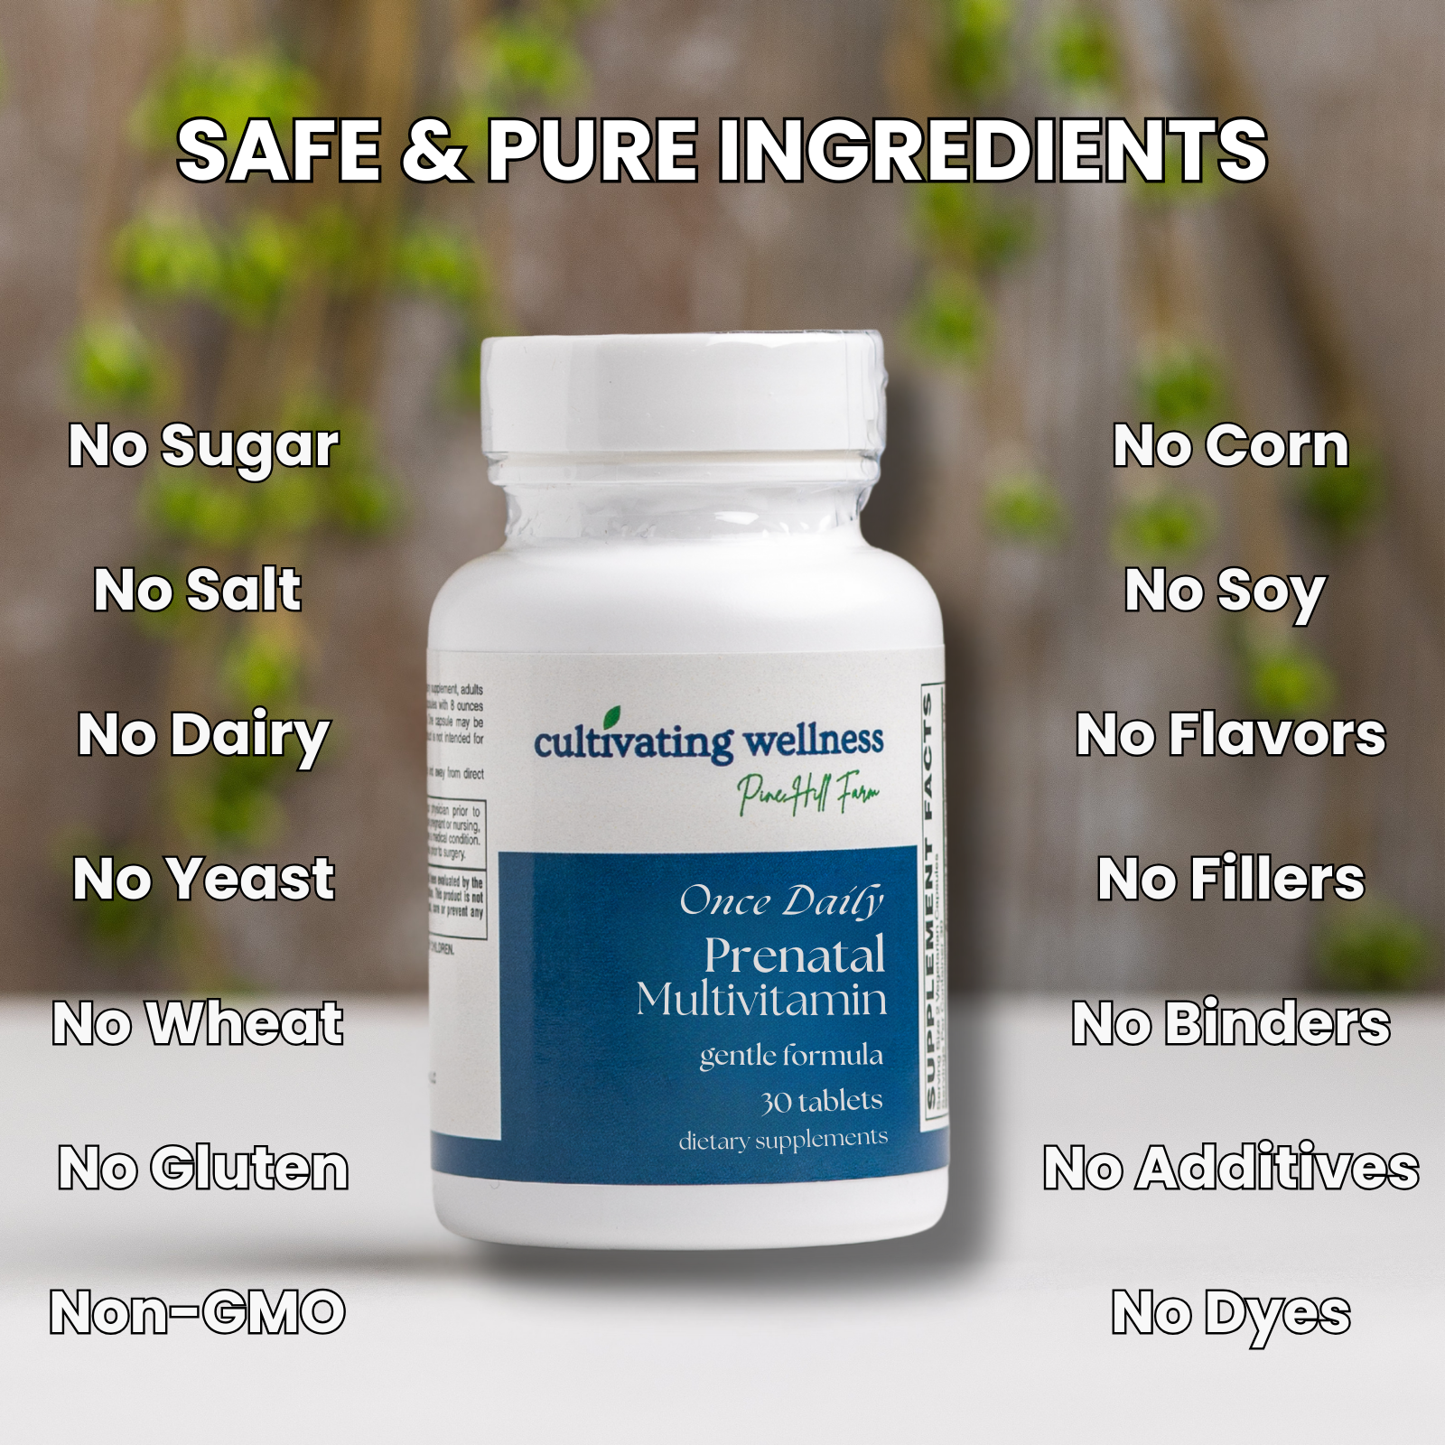

A once-daily, USDA Organic and Vegan formula designed to support mom and baby before and during pregnancy, and while breastfeeding. Includes 600 mcg folate for fetal development and 18 mg plant-based iron to help prevent anemia and support increased blood volume.

**Dose:** 1 tablet daily

**Features:**

* Certified Organic, Vegan, and Non-GMO
* 500 mg Organic Whole Food Complex (guava, amla, moringa & more)
* 600 mcg DFE folate | 18 mg iron | VegD3® | Methylcobalamin B-12
* Free from dairy, gluten, soy, corn, eggs, fish, shellfish, sesame, and artificial additives

**Benefits:**

* Supports fetal brain and neural development
* Helps maintain mom’s energy, blood health, and nutrition
* Ideal for vegans, vegetarians, or anyone seeking a clean, plant-based prenatal

**Organic Once Daily Women's Multi Tabs 30's & 60’s**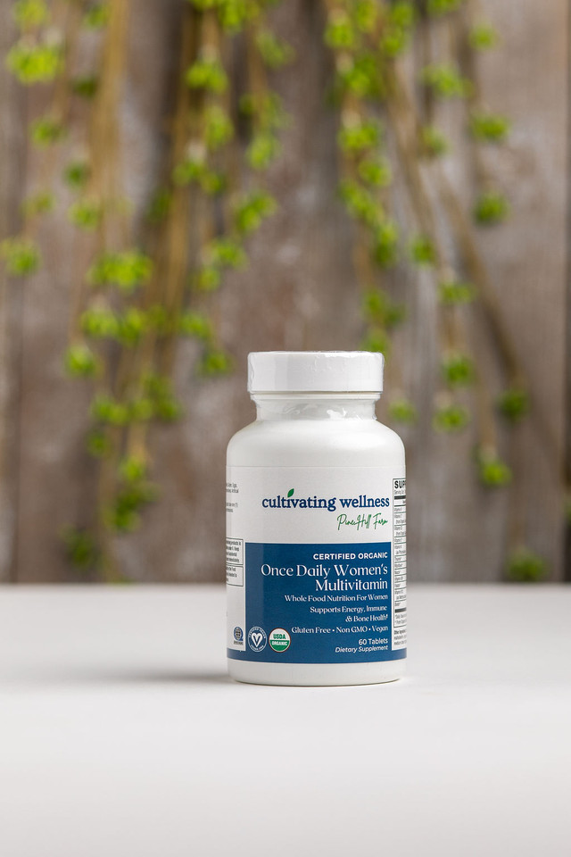

A certified USDA Organic, Non-GMO multivitamin formulated for women’s unique needs, with whole food nutrients and high-potency B vitamins for energy, beauty, immunity, and bone health.

**Dose:** 1 tablet daily

**Features:**

* USDA Organic, Vegan, and Non-GMO
* 500 mg Organic Whole Food Complex (guava, amla, moringa, holy basil & more)
* High-potency B vitamins
* 25 mcg (1,000 IU) VegD3® from organic algae
* Free of dairy, gluten, soy, corn, eggs, fish, shellfish, sesame, and artificial additives

**Benefits:**

* Supports energy, immunity, and bone health
* Promotes healthy skin, hair, and nails
* Provides iron for blood support
* Ideal for vegans, vegetarians, or plant-based lifestyles

**Organic Vitamin B-Complex Tabs 60's**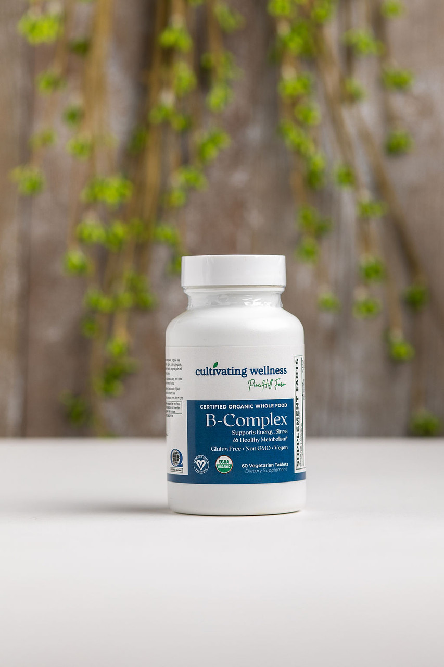

A complete B-vitamin formula with probiotics, enzymes, and organic food blend for energy, cellular, and metabolic support. **Dose:** 2 capsules daily

**Features:**

* USDA Organic, Vegan, Non-GMO
* 850 mg Organic Food Complex with probiotics, enzymes, berries, and sprouts
* Free of major allergens, artificial additives, and preservatives

**Benefits:**

* Supports energy production from carbs, fats, and proteins
* Promotes healthy brain, nerve, heart, and muscle function
* Helps maintain healthy homocysteine and cardiovascular function
* Supports red blood cell formation and neurotransmitter synthesis
* Provides essential daily B-vitamins not stored by the body

**Organic Women’s Multi Tabs 60's**

**\*Reformulating**

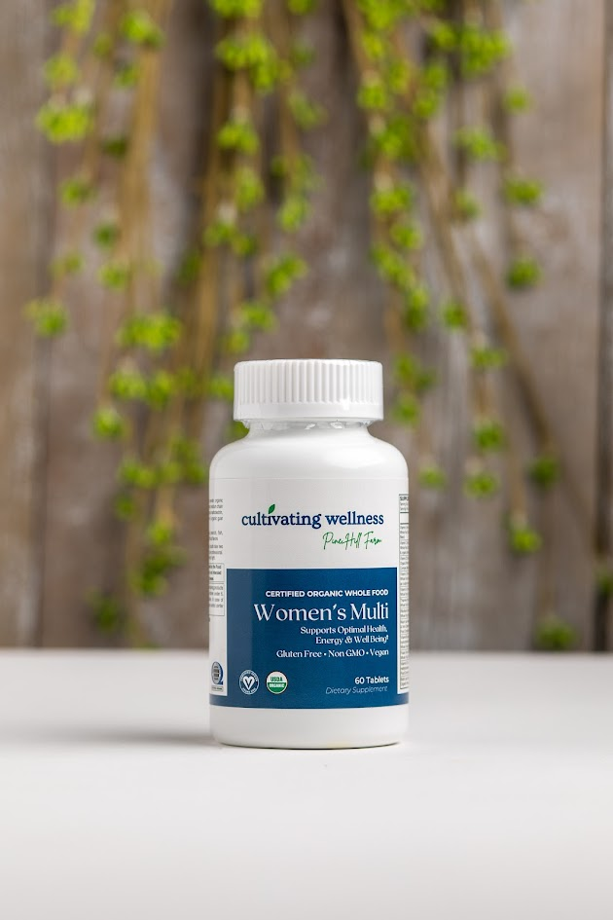

**Plant Protein Chocolate & Vanilla Powder**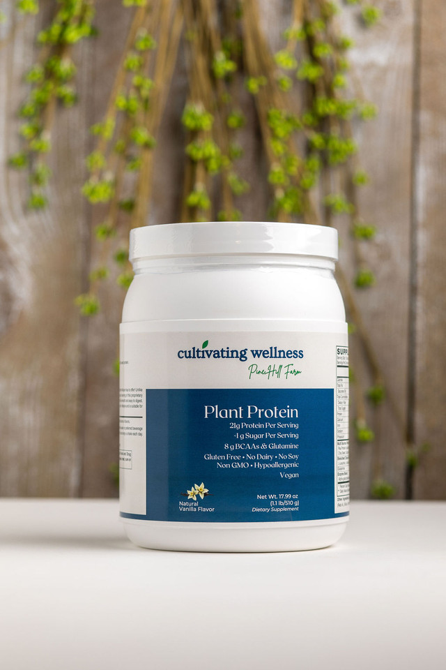

Delicious vegan shake with 21g protein from peas, cranberry, chia, and omega-3 rich sacha inchi.

**Dose:** Mix 1 scoop with 9-12 oz beverage

**Features:**

* 21g complete, hypoallergenic plant protein
* Easy to digest, dairy-, soy-, and gluten-free
* Includes sacha inchi for omega-3 EFAs

**Benefits:**

* Supports muscle growth, strength, and recovery with BCAAs and leucine
* Helps build and maintain lean muscle and healthy tissues
* Aids digestion with enzymes to reduce gas and bloating
* Pea protein supports healthy cholesterol levels
* Omega-3s promote a healthy inflammatory response
* Supports healthy weight management

**Red Yeast Rice 600Mg Vcaps 60's**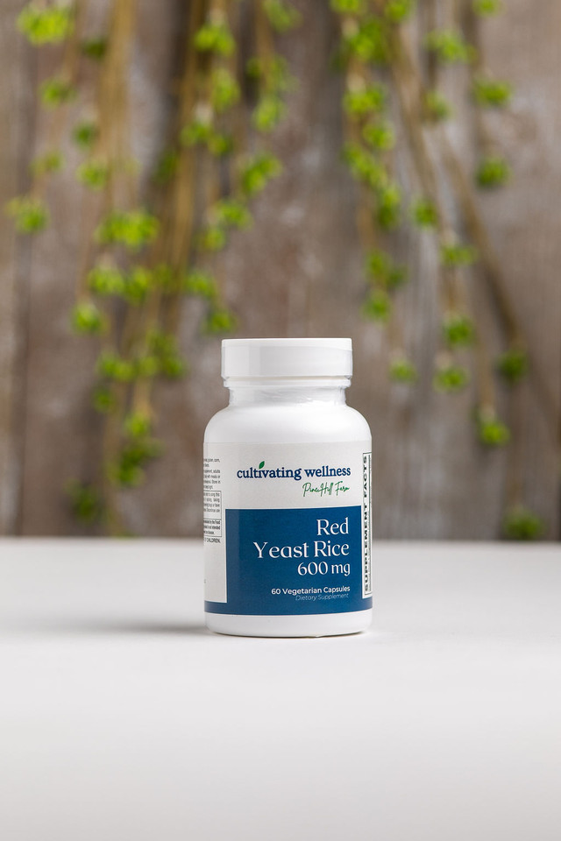

600mg per serving, citrinin-free, in an easy-to-swallow vegetarian, gluten-free capsule.

**Dose**: 1 capsule twice daily with meals

**Summary:**

Supports healthy cholesterol and cardiovascular health as a natural alternative to statins.

**Features:**

* 600mg red yeast rice (monacolins)
* Manufactured to avoid toxic citrinin
* Vegetarian and gluten-free

**Benefits:**

* Helps maintain normal LDL, total cholesterol, and triglyceride levels
* Supports heart health safely
* Best used with CoQ10 for enhanced effects

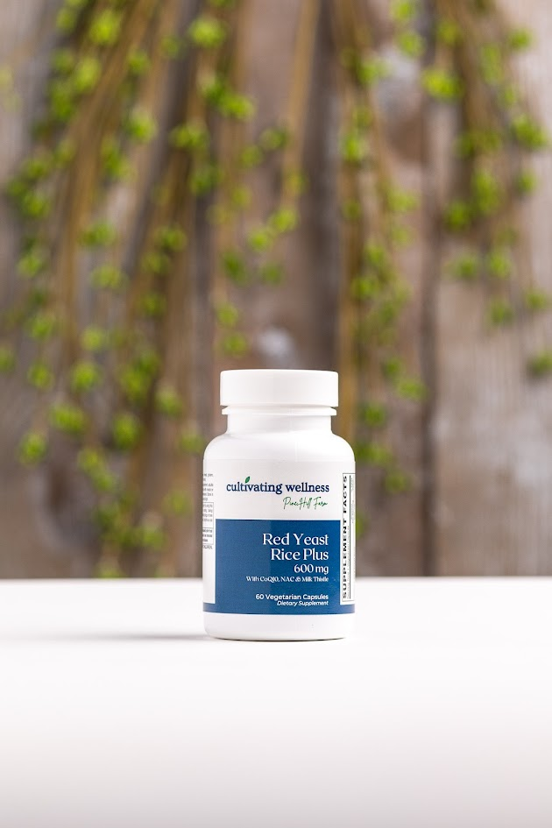

**Red Yeast Rice Complex Vcaps 60's**

600mg red yeast rice (citrinin-free) with 30mg CoQ10, 50mg NAC, and 25mg standardized Milk Thistle in an easy-to-swallow vegetarian capsule.

**Dose: 1** capsule twice daily with meals

**Summary:** Supports healthy cholesterol levels and cardiovascular health while promoting liver protection.

**Features:**

* 600mg red yeast rice (monacolins)
* Citrinin-free fermentation
* Added CoQ10 for heart and muscle energy
* NAC and milk thistle for liver detox and protection
* Gluten-free, vegetarian capsule

**Benefits:**

* Helps lower total and LDL cholesterol
* Supports healthy triglycerides and heart function
* NAC boosts liver antioxidant glutathione
* Milk thistle protects liver cells from toxins

**Saw Palmetto Pygeum Softgels 60's**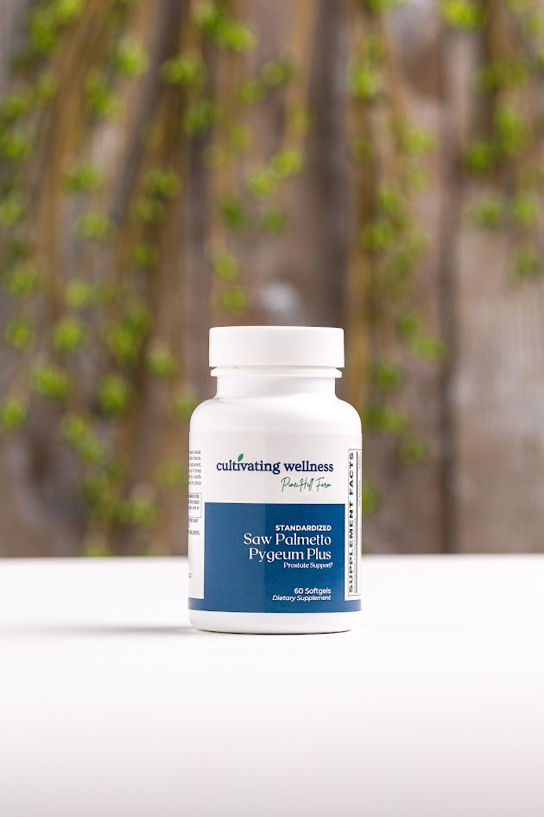

Prostate Support  
 Premium formula with saw palmetto, nettle, pumpkin seed oil, and patented L-OptiZinc® zinc and Lyc-o-mato® lycopene.

**Dose:** 1 softgel, 4 times daily

**Summary:**  
 Designed to support normal prostate structure and function, reduce urinary discomfort, and promote healthy hormone balance.

Features:

* Saw palmetto standardized to 85-95% fatty acids and sterols
* Pygeum, nettle, pumpkin seed oil, zinc, and lycopene for synergistic prostate support
* Patented L-OptiZinc® and Lyc-o-mato® lycopene

**Benefits:**

* Saw palmetto supports healthy DHT levels and prostate cell function
* Pygeum’s beta-sitosterol promotes normal urine flow and prostate health
* Lycopene acts as a powerful antioxidant protecting prostate cells
* Nettle supports healthy inflammatory response
* Zinc supports prostate cell function and declines with age

**Sinus Breakup 1 oz**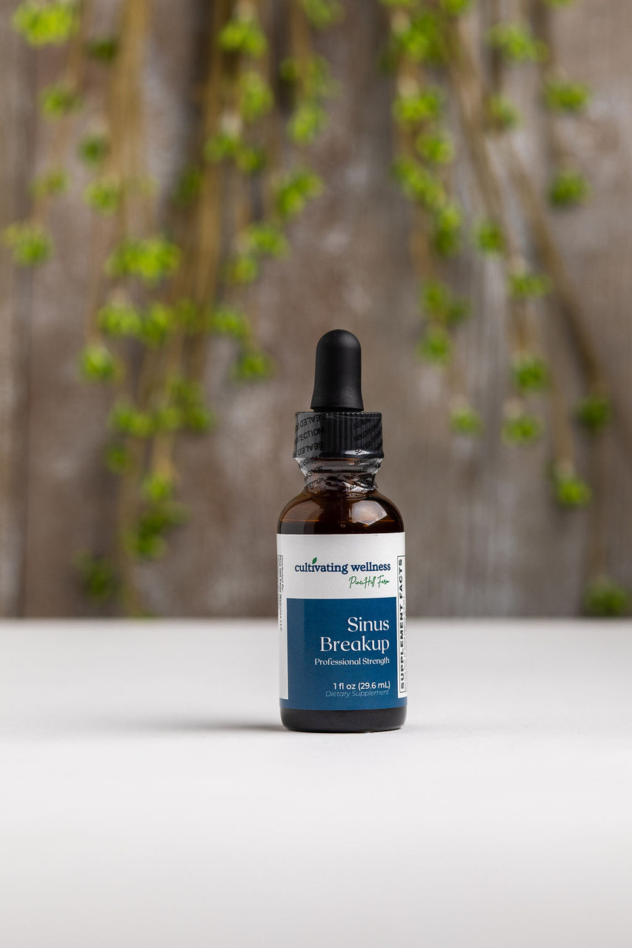

A powerful blend of horseradish, garlic, onion, cayenne, and herbs, naturally sweetened with organic honey, designed to quickly open sinuses, thin mucus, and support respiratory health.

**Dose**: 15-30 drops in mouth or water, up to 3 times daily

**Features:**

* Strong, pungent, aromatic formula
* Natural sweetening with organic honey

**Benefits:**

* Thins thick mucus and promotes drainage
* Increases circulation to relieve congestion
* Supports the body’s defense against microbes with Echinacea, Goldenseal, Elderberry, and more
* Clears lungs with decongestant herbs like Horehound and Licorice
* Helps manage fever and immune response
* May reduce snoring by easing inflammation before sleep

**Sleep Support Caps 60's**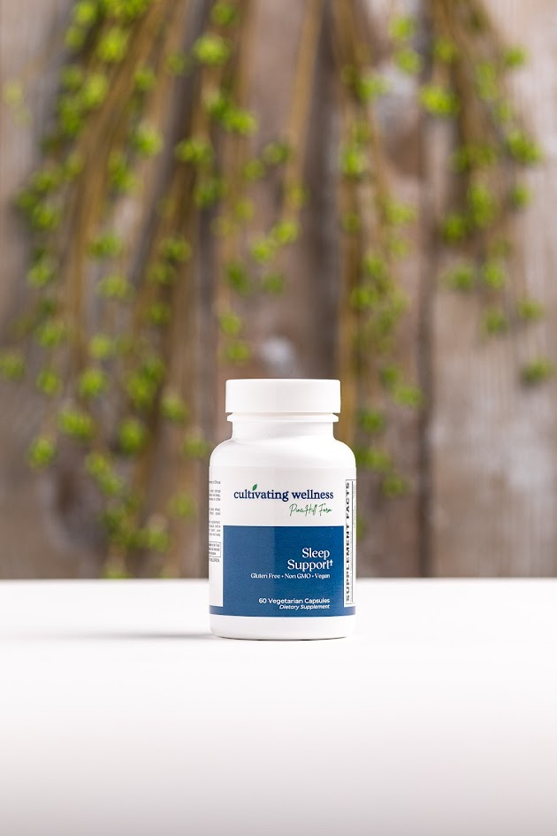

A potent blend of Alphawave® L-theanine, melatonin, passionflower, valerian, vitamin B6, and magnesium to promote relaxation, reduce stress, and support restful sleep. **Dose:** 1 capsule before bedtime

**Key ingredients:**

* Melatonin 1 mg
* L-Theanine (Alphawave®) 100 mg
* Passionflower extract 100 mg (3.5% Vitexin)
* Valerian root extract 50 mg (0.8% Valerenic Acids)
* Vitamin B6 2 mg
* Magnesium 50 mg

**Benefits:**

* Reduces mental and physical stress responses
* Supports relaxed, alert brain activity and healthy blood pressure
* Counters caffeine’s stimulating effects
* May ease PMS symptoms
* Uses high-quality, standardized European herbal extracts

**Superzymes Tabs 180's**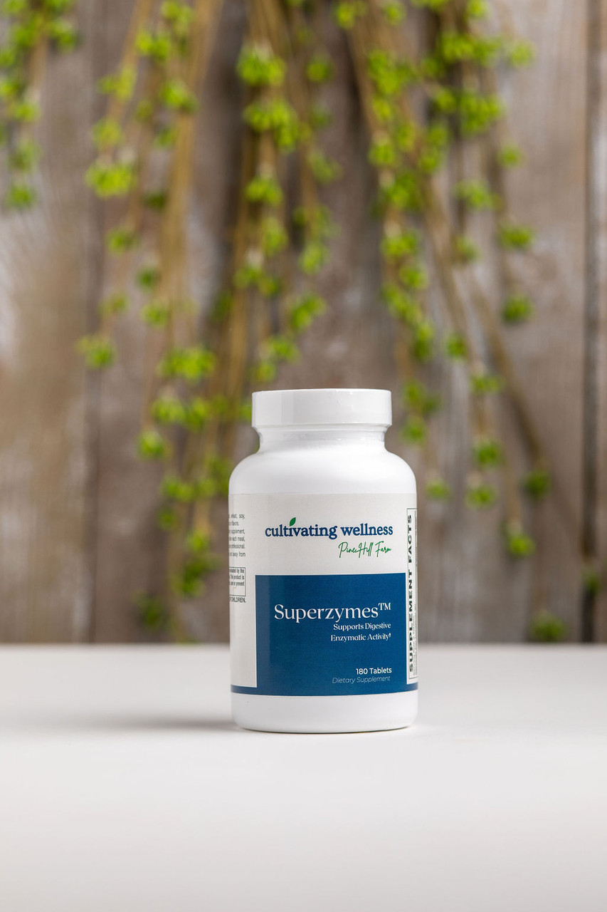

Superzymes: A multi-enzyme formula with animal and plant enzymes—Pepsin, Bromelain, Papain, Ox bile, Pancreatin, and Betaine HCL. **Dose:** 2 tablets after each meal

Supports healthy digestion of proteins, fats, and carbs, reducing symptoms like gas, bloating, and nutrient malabsorption.

**Features:**

* Betaine HCL to aid stomach acid and protein digestion
* Pepsin, Bromelain, Papain for protein breakdown
* Ox bile for fat emulsification
* Pancreatin for digesting proteins, fats, and carbohydrates

**Benefits:**

* Enhances digestion and nutrient absorption
* Supports stomach acid levels, which decline with age or medication use
* Helps eliminate foodborne pathogens
* Reduces digestive discomfort from slow digestion

**Thyroid Support Vcaps 60's**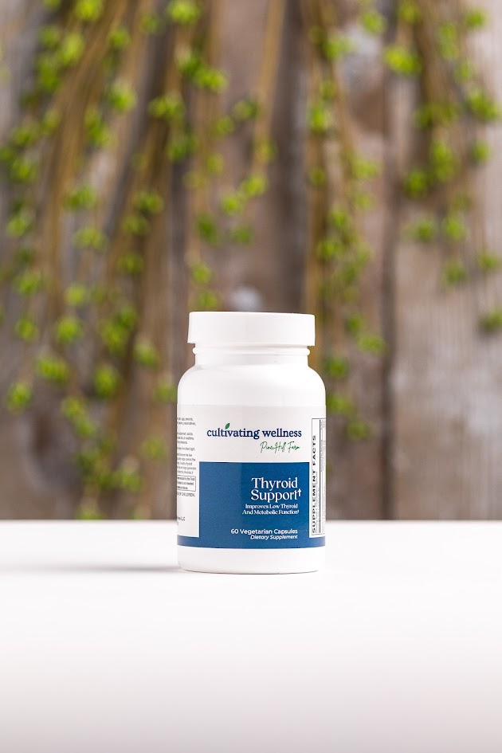

Thyroid Support: A comprehensive blend of essential vitamins, minerals, and standardized botanicals in vegetarian capsules.

**Dose:** 2 capsules daily with a meal

The thyroid regulates metabolism, growth, and energy through hormone production (T4 and active T3). This formula supports thyroid hormone production, activation, receptor function, metabolism, and stress response.

**Features:**

* Essential vitamins and minerals (iodine, selenium, zinc, copper, B6, C, A, D, magnesium, folic acid)
* Standardized botanical extracts (kelp, guggulipid, bacopa, ashwagandha, green tea EGCG)
* Vegetarian, gluten-free

**Benefits:**

* Supports thyroid hormone production and activation
* Enhances thyroid hormone receptor function
* Promotes healthy metabolism and energy
* Helps the body manage stress for optimal thyroid health
* Supports cognitive function and skin heal

**Turmeric Caps 500Mg Caps 60's**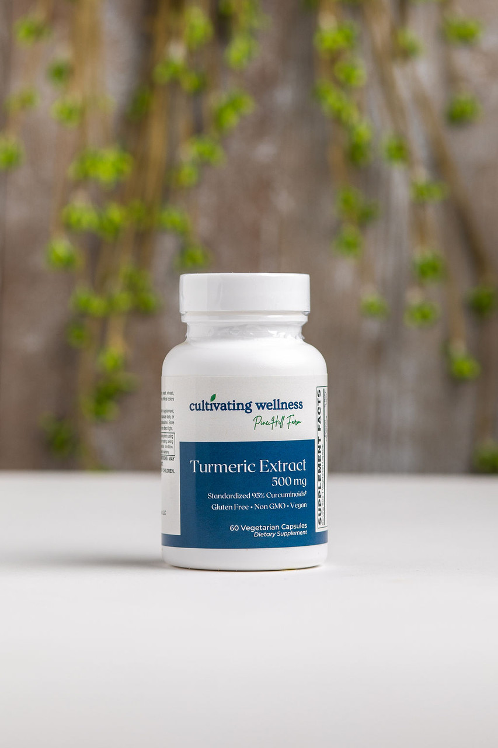

**Dose:** 1 capsule daily

Turmeric’s active compound, curcumin, offers well-researched anti-inflammatory and antioxidant benefits. It supports liver and gastrointestinal health.

**Features:**

* 500 mg turmeric extract (475 mg curcuminoids) per capsule

**Benefits:**

* Supports healthy COX-2 levels linked to inflammation and pain
* Aids recovery from exercise soreness
* Provides antioxidants that neutralize free radicals
* Supports digestive and liver health
* Promotes healthy cell growth and wound healing

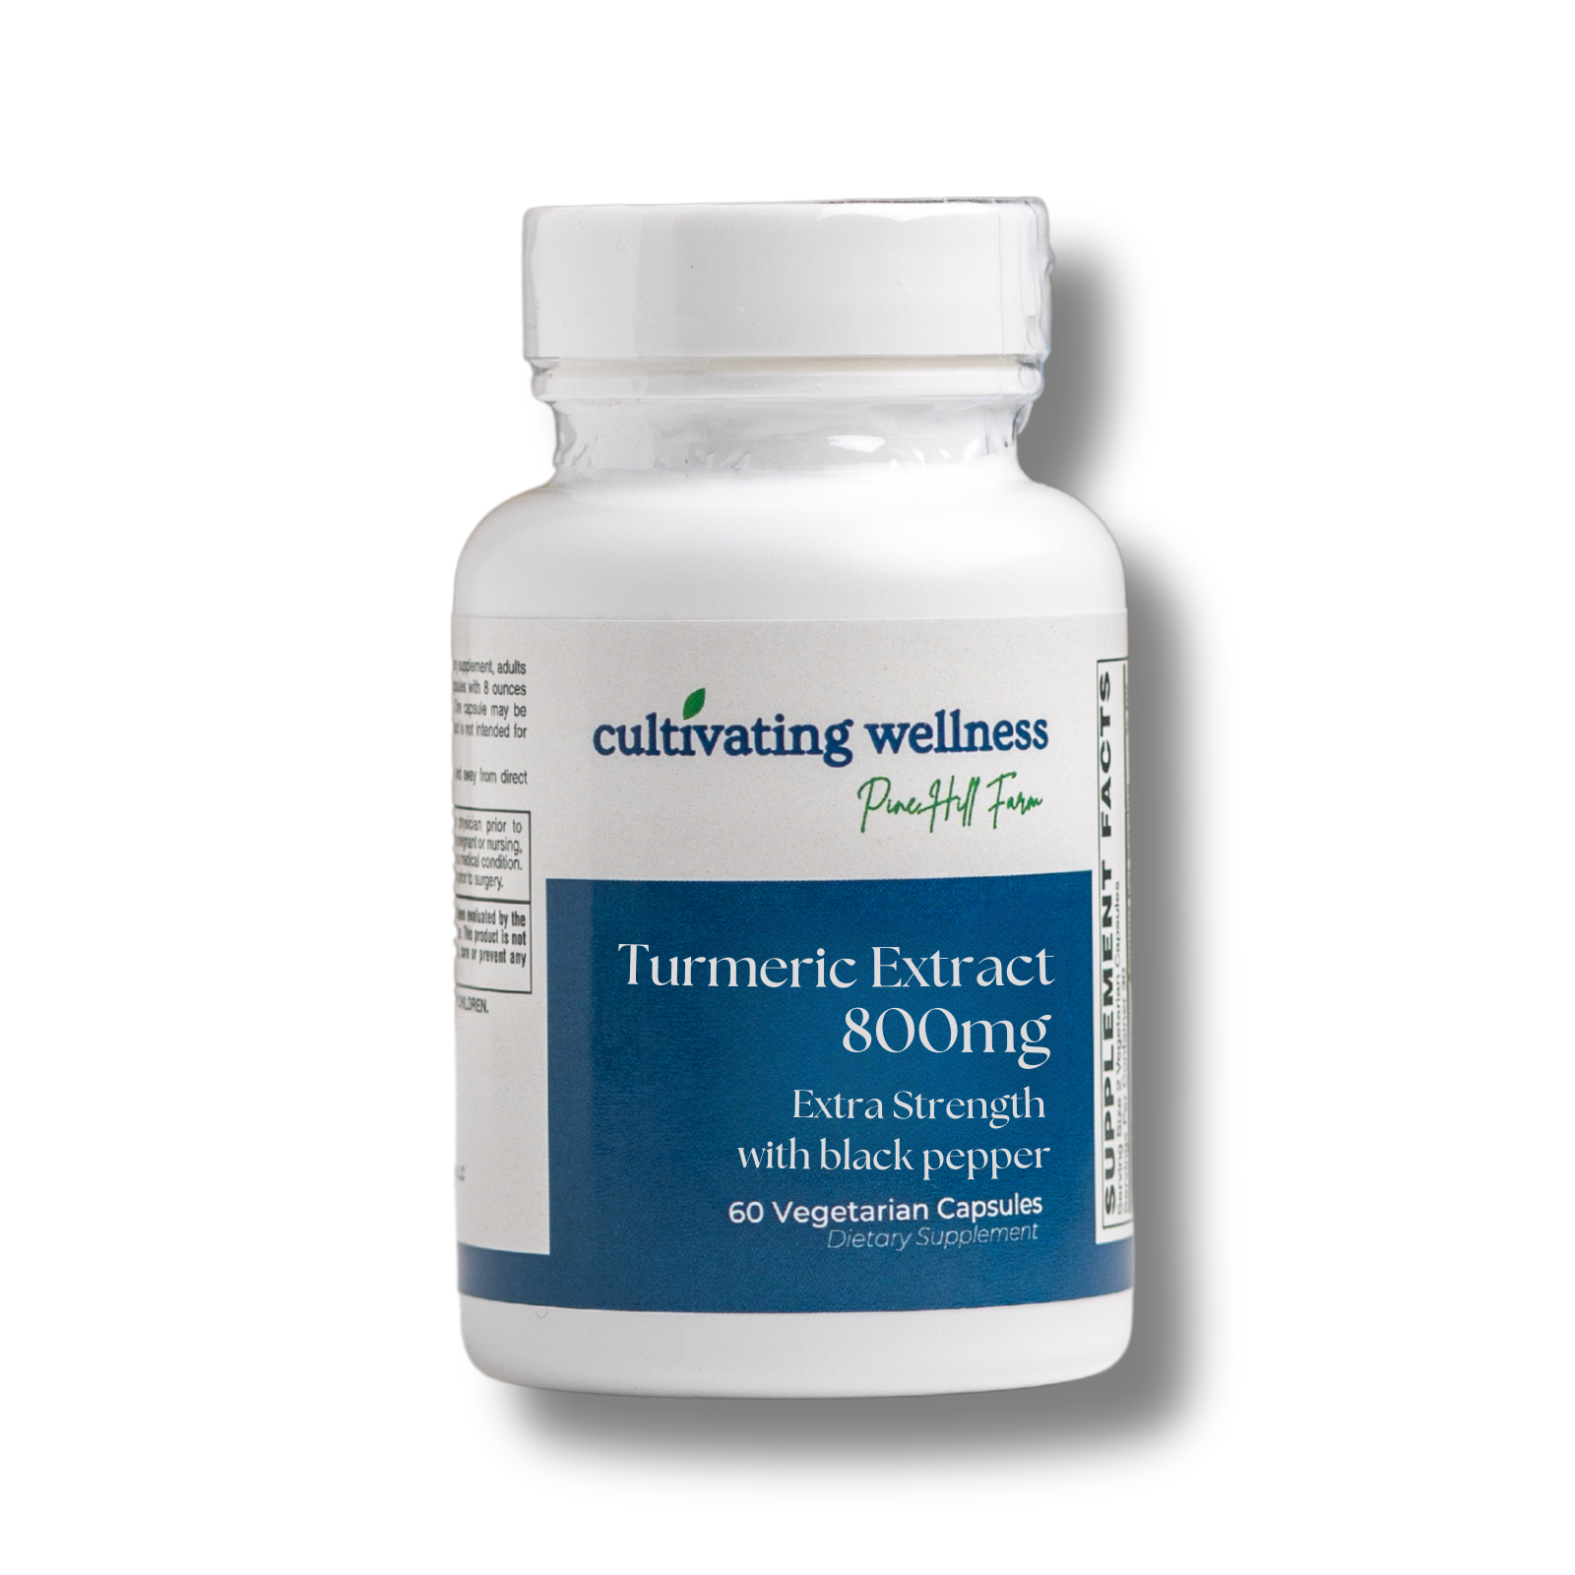

**Extra Strength Turmeric**

**Dose:** 1 capsule daily

Turmeric, a traditional spice and medicinal herb, is rich in curcuminoids known for antioxidant and anti-inflammatory effects. This formula supports healthy inflammation response, cardiovascular health, joint mobility, digestion, and liver detoxification. BioPerine® (black pepper extract) boosts turmeric absorption for maximum benefit.

**Features:**

* 800 mg Turmeric (95% curcuminoids)
* 5 mg BioPerine® (95% piperine)
* Gluten-free, Non-GMO, vegan, no common allergens or additives

**Benefits:**

* Supports healthy inflammation and COX-2 enzyme levels
* Helps ease post-exercise soreness
* Provides antioxidants to neutralize free radicals
* Supports digestive and liver health
* Promotes normal cell growth and maturation

**Ubiquinol CoQH 200Mg Softgels 30's**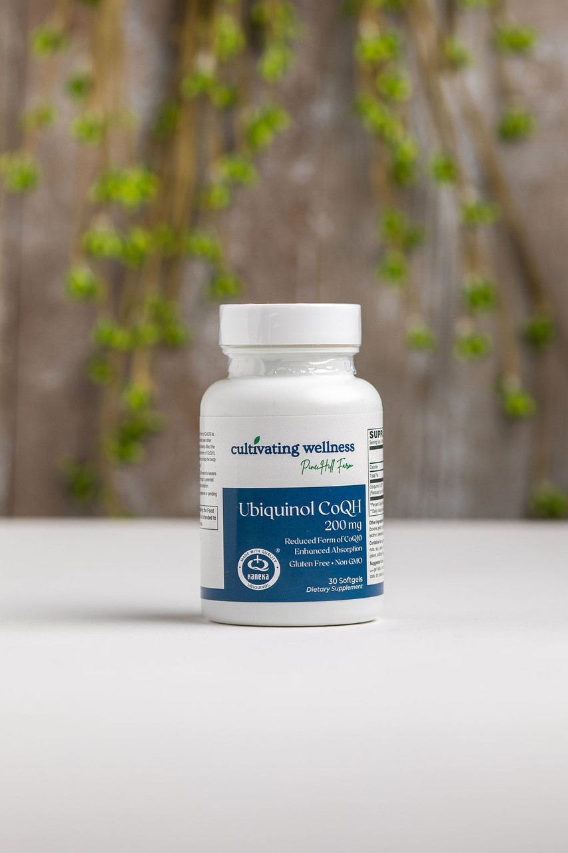

**Dose:** 1 softgel daily

Provides 200 mg of stabilized, reduced ubiquinol—the active, highly bioavailable form of CoQ10—in an easy-to-swallow softgel.

### **Features**

* Kaneka QH™, the world’s leading natural, pharmaceutical-grade ubiquinol
* Patented process ensures stable, all-trans, bioidentical form
* Natural fermentation, non-GMO, allergen-free, no artificial additives

**Benefits**

* Delivers active ubiquinol, bypassing conversion to support energy (ATP) production
* Supports antioxidant defenses and mitochondrial health, especially in aging or those with impaired conversion
* Enhances cellular energy and protects against free radicals
* **Heart health:** Helps improve symptoms and function in heart failure, angina, and high blood pressure. It may also support recovery after heart surgery.
* **Statin side effects:** Helps reduce muscle pain and weakness caused by cholesterol-lowering statin medications.
* **Migraine prevention:** Some studies show CoQ10 can reduce the frequency and severity of migraines.
* **Energy and fatigue:** Supports mitochondrial function, helpful in chronic fatigue, fibromyalgia, and age-related energy decline.
* **Neurodegenerative diseases:** May support brain health in conditions like Parkinson’s and Alzheimer’s (though research is ongoing).
* **Male fertility:** Can improve sperm quality and motility in some cases

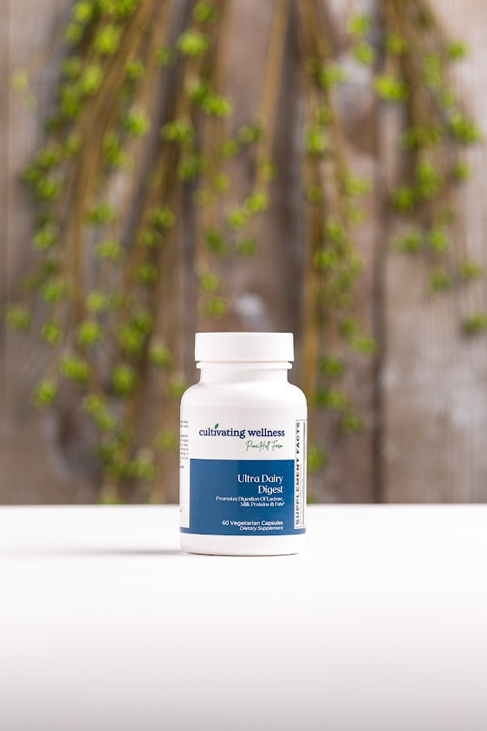

**Ultra Dairy Digest Vcaps 60's**

A gluten-free, vegetarian, comprehensive blend of enzymes designed to aid in the digestion of dairy foods.

**Dose:** 1 capsule immediately for each serving of a dairy-containing food

Ultra Dairy Digest is a comprehensive blend of enzymes designed to aid in the digestion of dairy foods. Intolerance to dairy is often due to the inability to digest the milk sugar lactose. Intolerance to dairy can also be related to the proteins and fats that are found in dairy products. This formula not only contains lactase for lactose digestion but also proteases and lipases that specifically target milk proteins and milk fats for digestion. Our Ultra Dairy Digest formula may help ease the temporary di comfort associated with the incomplete digestion of dairy products. Now you can reap the health benefits of dairy food without the discomforts associated with their digestion.

### **Features**

Multi-enzyme dairy digesting formula

Cost-effective formula

Gluten-Free

Vegetarian

### **Benefits**

30-50 million Americans do not produce adequate lactase enzyme to digest many dairy products; formula helps to compensate for this enzyme deficiency.

The product provides support for the digestion of lactose, proteins, and fats found in dairy products.

Helps alleviate intestinal bloating and discomfort caused by incomplete digestion of dairy products.

Reduces unwanted immune responses to undigested dairy proteins.

**Ultra Diidoylmethane (DIM) Caps 60's**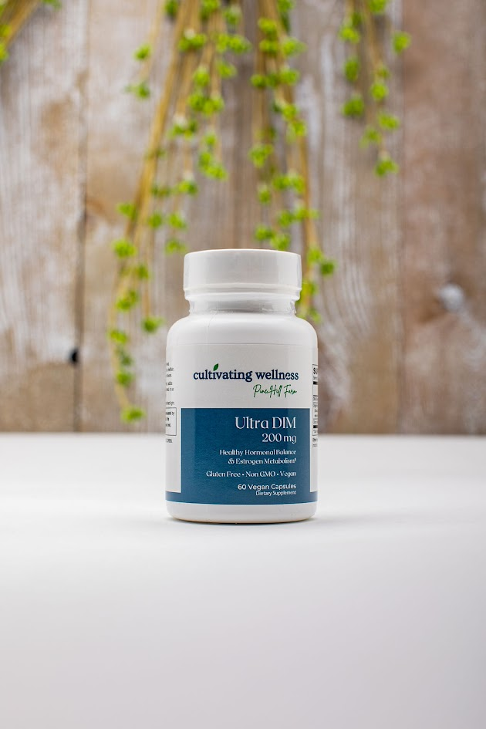

**Dose:** 1 capsule daily

Formulated with 200 mg DIM, organic broccoli powder, and citrus bioflavonoids to support hormonal balance and healthy estrogen metabolism in both women and men.

### **Features**

* Contains 200 mg DIM, 100 mg organic broccoli powder, and citrus bioflavonoid complex (3% hesperidin)
* Gluten-free, non-GMO, vegan, and free from common allergens and artificial additives

### **Benefits**

* Supports healthy estrogen metabolism by promoting a balanced 2:16 hydroxyestrone ratio
* DIM blocks aromatase, reducing excess estrogen and supporting testosterone levels
* Broccoli powder provides vitamins, minerals, and sulforaphane for overall health and healthy aging
* Hesperidin offers antioxidant and heart-supportive benefits

**Ultra GI Cleanse Vcaps 60's**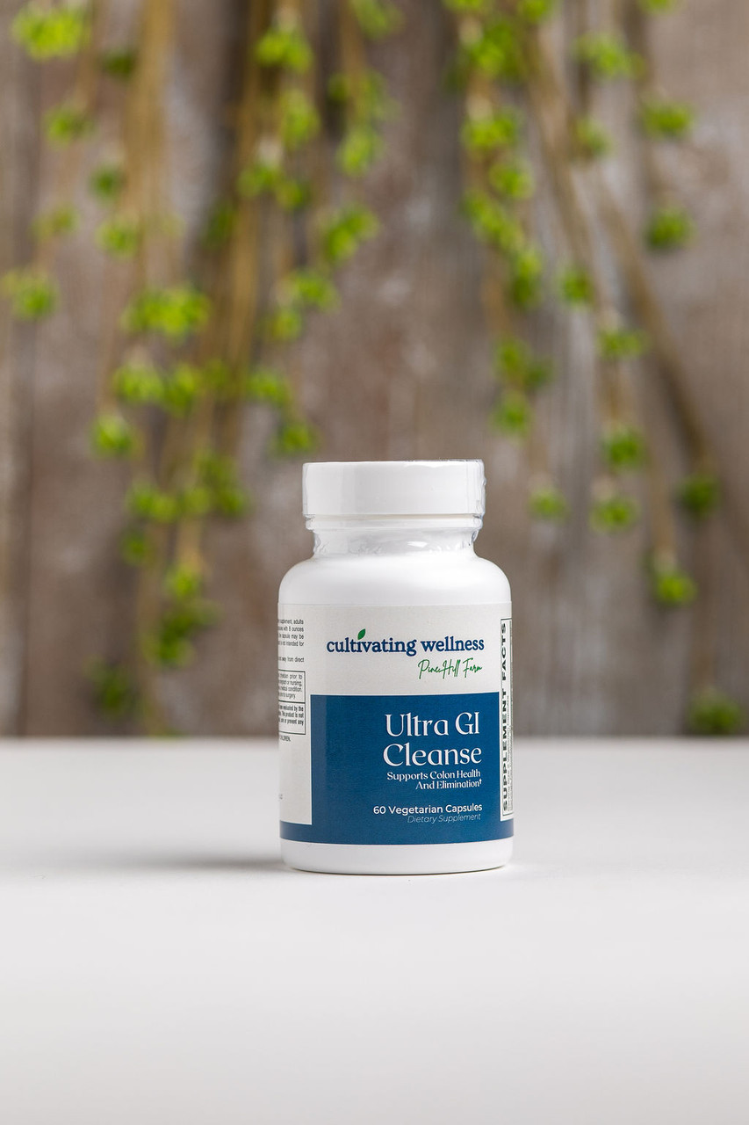

**Dose:** 2 capsules with 8 oz water before bedtime

A gentle, synergistic blend of plant extracts designed to support healthy digestion and promote regular bowel movements without harsh laxatives.

### **Features**

* Supports normal bowel function and regularity
* Contains soothing demulcent and carminative herbs
* Gluten-free, easy-to-swallow vegetarian capsules

### **Benefits**

* Cascara Sagrada & Aloe Vera: promote smooth colon contractions and healthy stool consistency
* Flaxseed: provides fiber, omega-3s, and anti-inflammatory support
* Marshmallow, Slippery Elm, Peppermint: soothe and relax intestinal lining and muscles
* Rhubarb: strengthens intestinal muscles and protects colon lining

**ULTRA GI CLEANSING SYSTEM AM/PM 30 DAY KIT**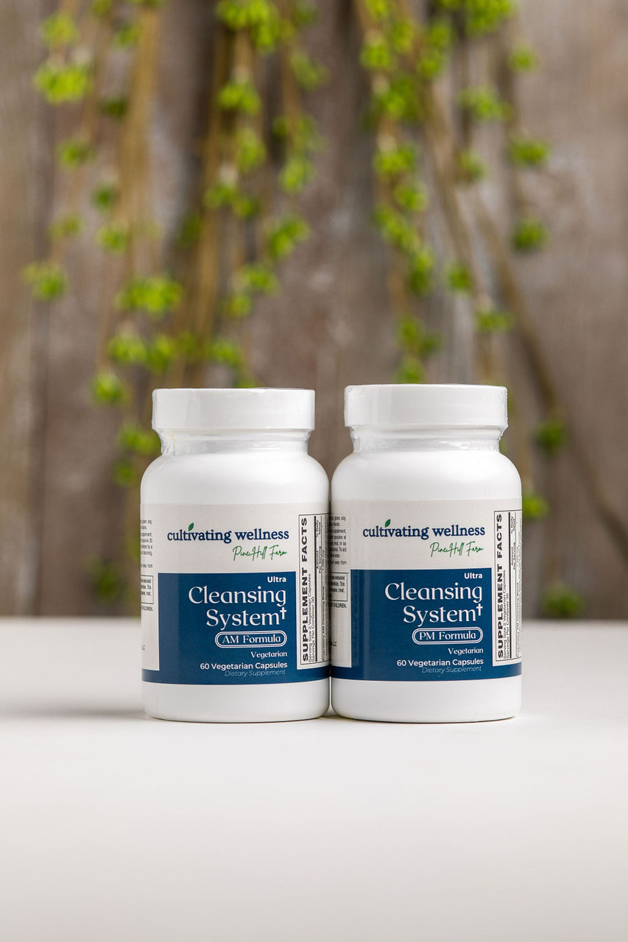

**Dose:** 2 capsules AM, 2 capsules PM

A gentle, laxative-free 30-day detox program with unique AM/PM formulas containing ClearFiber™ and botanicals to support liver, kidneys, colon, lungs, lymphatic system, blood, and skin.

### **Features**

* Promotes natural detoxification and toxin elimination
* Contains patented ClearFiber™ for healthy bowel function
* Easy, safe, and convenient dosing—no harsh laxatives
* Synergistic blend of botanicals targeting multiple detox pathways

### **Benefits**

* Supports liver and multi-system detoxification
* Encourages toxin excretion and bowel regularity
* Enhances overall health and wellness without disrupting daily routine

**Ultra Greens 250Gr Powder**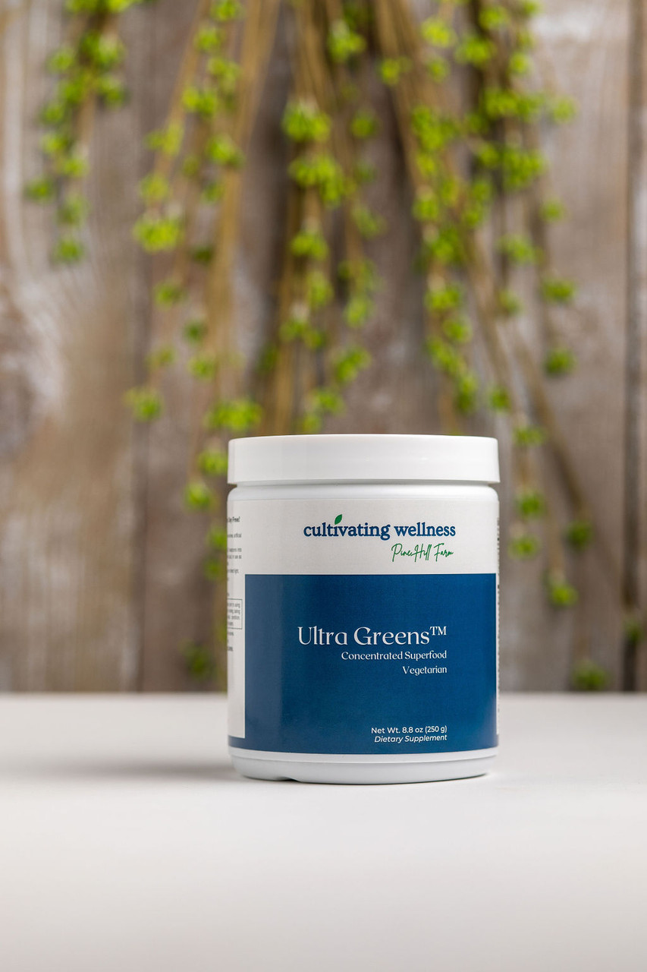

**Dose:** 2 tsp in 8 oz of your favorite liquid

A nutrient-rich blend of organic grasses, algae, herbs, and superfoods, delivering naturally occurring vitamins, minerals, antioxidants, fatty acids, and amino acids for daily whole-food nutrition.

### **Key Benefits**

* Supports energy, immunity, detoxification, and blood sugar balance
* Provides powerful antioxidant protection and adaptogenic support
* Enhances overall vitality with broad-spectrum phytonutrients

### **Features**

* Includes Earthrise® Spirulina and Pines® Cereal Grasses
* Whole-food formula with enzymes, fibers, and plant compounds
* Tastes great in juice or shakes

**Ultra Liver Support and Detox Caps 120's**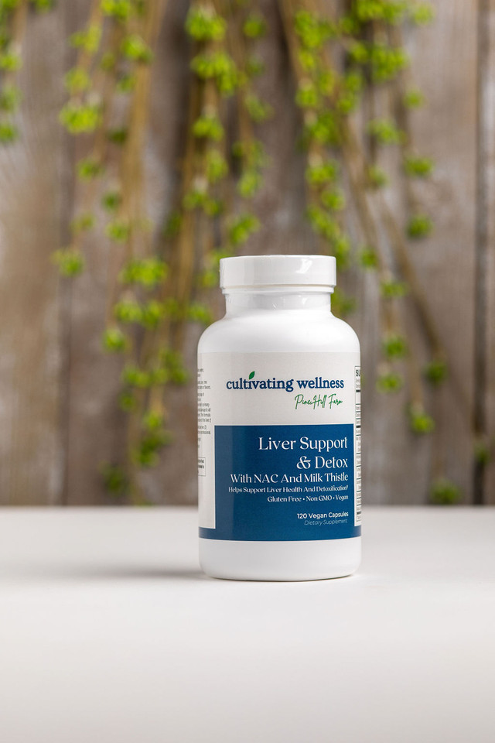

**Dose: 2** capsules daily

A synergistic blend of vitamins, minerals, botanicals, and key nutraceuticals like SelenoExcell® and NAC, designed to support liver detoxification and antioxidant defense.

### **Key Benefits**

* Supports phase I & II liver detox pathways
* Promotes glutathione production (via NAC) and antioxidant defense
* Aids fat metabolism, bile flow, and toxin elimination

### **Key Ingredients**

* Milk thistle, turmeric, artichoke, picrorhiza – standardized extracts for liver protection
* SelenoExcell® – highly researched selenium for glutathione peroxidase activity
* NAC, alpha-lipoic acid, vitamin C – support detox and oxidative stress
* Choline, boldo, dandelion, burdock, yellow dock – promote bile production & elimination

**Ultra Omega-3 Fish Oil Softgels 120's**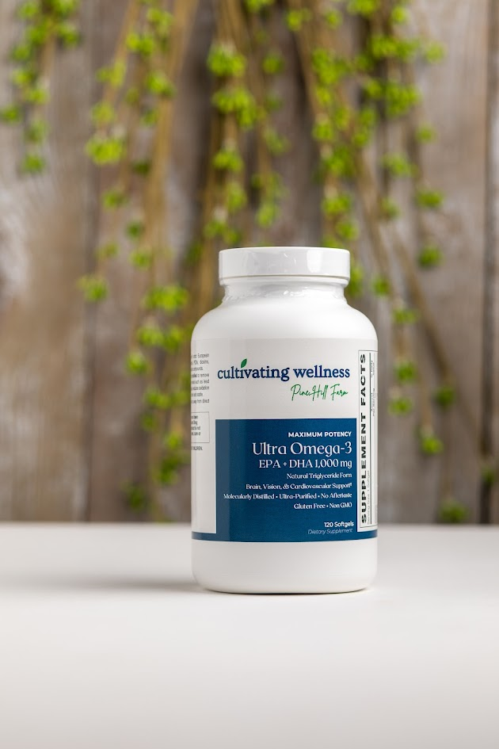

**Dose:** 1 softgel daily

Delivers 687 mg EPA and 313 mg DHA in a single, easy-to-swallow softgel. Made from sustainably sourced cold-water fish and molecularly distilled for purity and no aftertaste.

### **Key Benefits**

* Supports heart, brain, vision, and inflammatory response
* Promotes healthy cholesterol, triglycerides, and circulation
* DHA supports brain development and nerve cell integrity

### **Features**

* 1250 mg purified fish oil in natural triglyceride form
* High potency in one softgel
* Clean, pure, and rigorously tested (meets Prop 65 & EU standards)
* Sourced from wild anchovy, sardine & mackerel

**Ultra Omega-3 Mini Fish Oil Softgels 120's**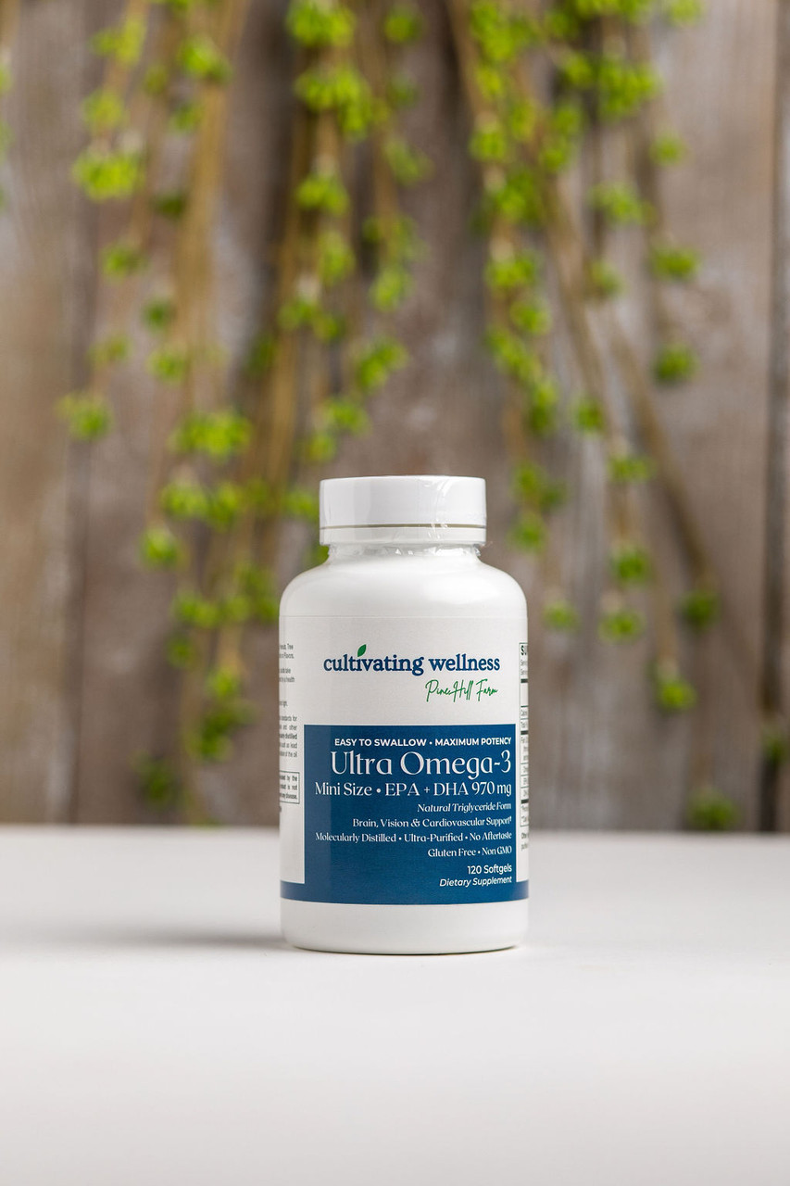

Dose: 2 softgels daily

High-potency Omega-3 softgels delivering 687 mg EPA and 313 mg DHA in a small, easy-to-swallow format. Sourced from sustainably caught cold-water fish and molecularly distilled for purity and no aftertaste.

### **Key Benefits**

* Supports heart, brain, vision, and inflammatory response
* Promotes healthy triglyceride levels, circulation, and cognitive function
* DHA supports brain structure and function; EPA regulates inflammation and cardiovascular health

### **Features**

* 1330 mg natural triglyceride fish oil per serving
* 1020 mg total Omega-3s (EPA + DHA)
* Small, bovine softgels for easy swallowing
* Sustainably sourced; rigorously tested for purity

**Vegetarian Collagen Peptides**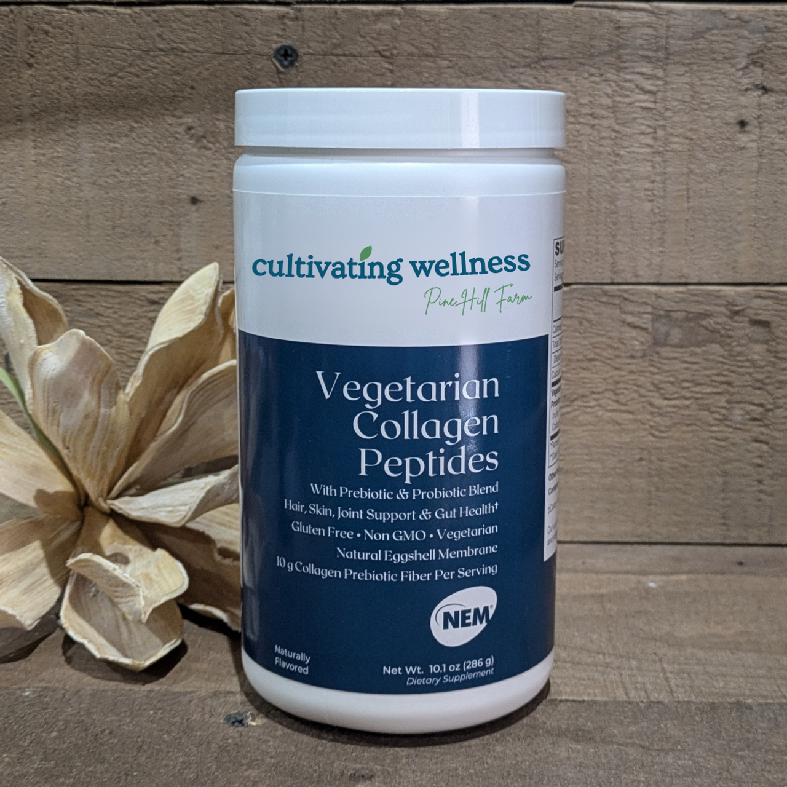

Formulated with clinically studied NEM® eggshell membrane collagen, a sustainable, upcycled source shown to support joint health in as little as 4–11 days.

### **Key Benefits**

* Joint Support: NEM® helps reduce joint pain, stiffness, and cartilage breakdown. Especially beneficial for postmenopausal women starting new exercise routines.
* Gut Health: Includes Bacillus coagulans (a resilient SBO probiotic) and inulin (a gentle prebiotic fiber) to support digestion, gut flora, and bowel regularity.
* Beauty + Wellness: Supports healthy hair, skin, and nails.

### **Why It Stands Out**

* Ethical, sustainably sourced collagen alternative for flexitarians and wellness-focused consumers
* Contains 10g vegetarian collagen peptides, NEM®, prebiotics & probiotics
* Gluten-free, non-GMO, vegetarian
* Free from dairy, soy, nuts, shellfish, artificial additives, and major allergens

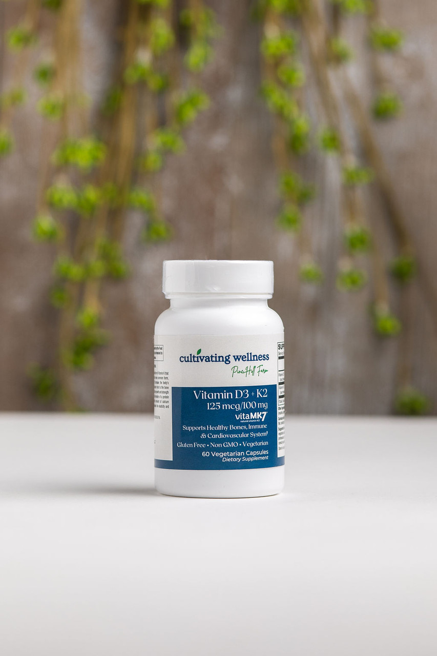

**Vitamin D3 125mcg & K2 100mcg Caps 60's**

**Daily Dose:** 1 capsule

A potent, vegetarian-friendly blend of highly bioavailable Vitamin D3 (from lanolin) and soy-free Vitamin K2 (from chickpeas), formulated to support bone and cardiovascular health.

### **Key Benefits**

* **Bone Health:** Supports calcium absorption (D3) and binding to bones (K2), promoting bone mineralization and reducing fracture risk.
* **Heart Health:** Helps direct calcium away from arteries, supporting vascular elasticity and reducing risk of calcification.
* **Immune & Inflammatory Support:** D3 and K2 promote balanced immune function and inflammatory response.
* **Metabolic Function:** Helps maintain healthy calcium levels, supporting muscle, nerve, and metabolic processes.
* **Superior Forms:** Contains menaquinone-7 (K2), a more bioavailable and long-lasting form of Vitamin K.

### **Features**

* Vegetarian-friendly
* Soy-free, non-GMO
* Free from major allergens: wheat, gluten, dairy, egg, fish, shellfish, tree nuts, peanuts

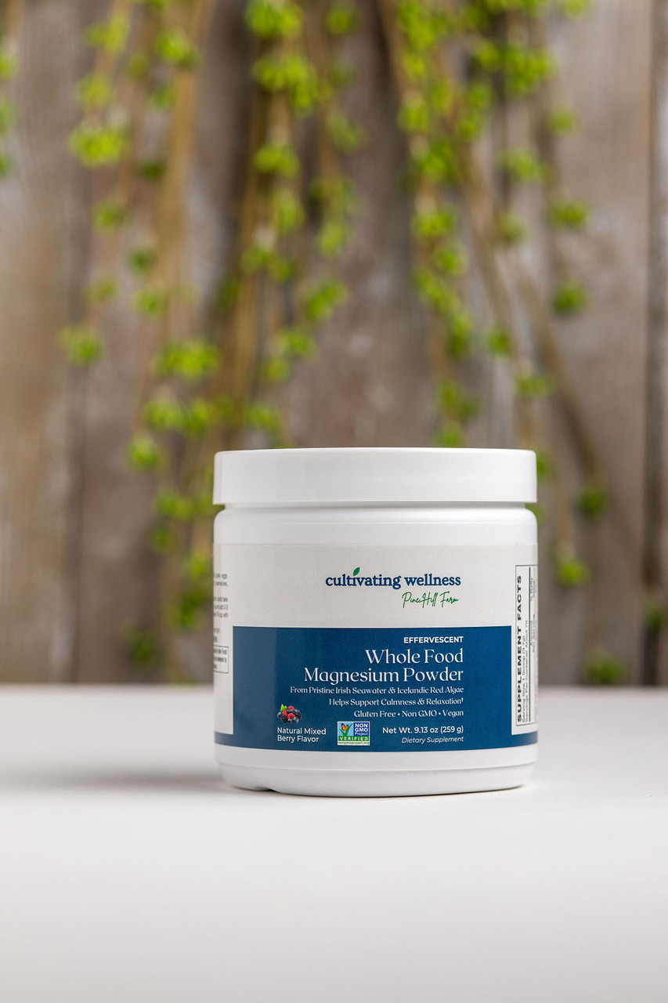

**Whole Food Magnesium Mixed Berry Pwd 259G**

Dose: 1 scoop in 2–3 oz of your favorite liquid

Fast-acting, highly absorbable magnesium from Aquamin®, a patented blend of red marine algae and pristine seawater sourced from the North Atlantic near Ireland. Red algae’s natural honeycomb cell structure enhances bioavailability, making it more effective than many standard magnesium forms.

### Key Benefits

* Supports muscle relaxation, energy production, bone health, and over 300 biological processes
* Aids in healthy blood pressure, DNA/RNA synthesis, hormone activity, and nerve function
* Promotes calm and relaxation

### Features

* 350mg of magnesium per serving
* Effervescent drink mix – dissolves easily in water
* Vegan, non-GMO, allergen-free
* No sugar, artificial additives, or preservatives
* Clean, whole food–based ingredients

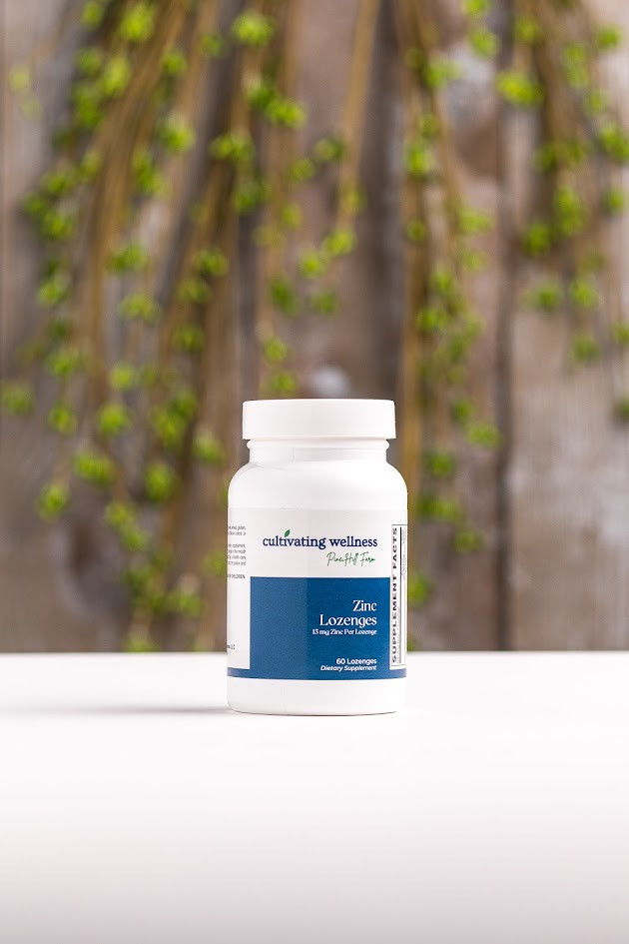

**Zinc Lozenges 60's**

**Dose:** Dissolve 1 lozenge in the mouth as needed

Delivers 15 mg of zinc (citrate & gluconate) in a pleasant-tasting lozenge with slippery elm and propolis to soothe the throat.

### Key Benefits

* Supports healthy immune function and antioxidant defenses
* May reduce cold severity and duration
* Preventive use may lower cold frequency and reduce antibiotic use
* Slippery elm helps soothe throat and mucous membranes

### **Features**

* Zinc citrate & gluconate for immune support
* Natural lemon flavor with sorbitol
* Contains no artificial colors or preservatives

**Wellness Products**

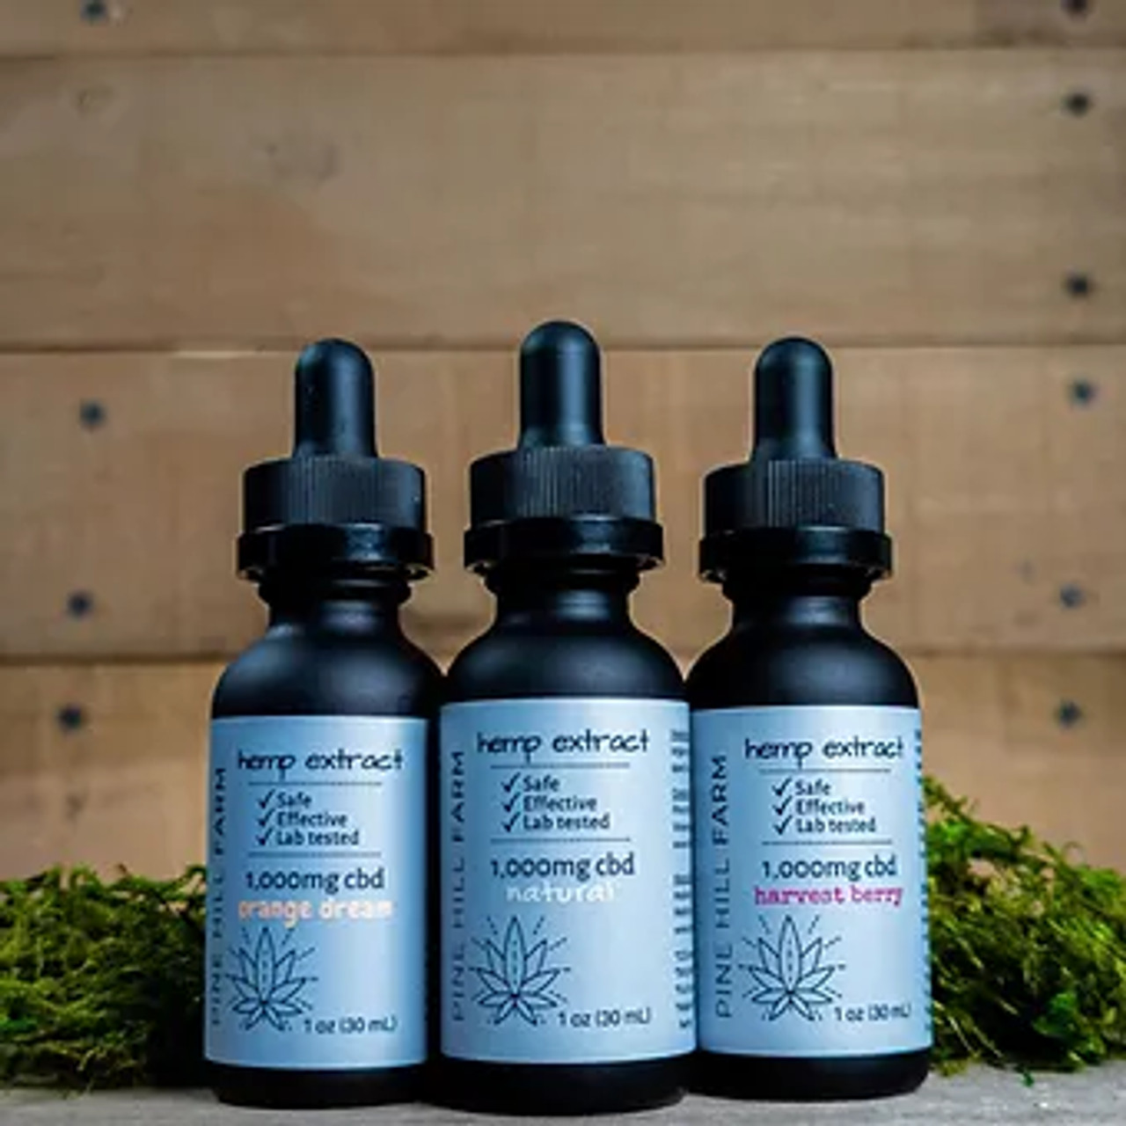

**CBD Oil (Hemp Extract Oil)**

500mg, 1,000mg, & 2,000mg

* CO2 extracted
* 100% USDA certified organic
* Third party lab tested
* <0.3% THC

Ingredients: organic hemp extract & organic MCT coconut oil, flavored or unflavored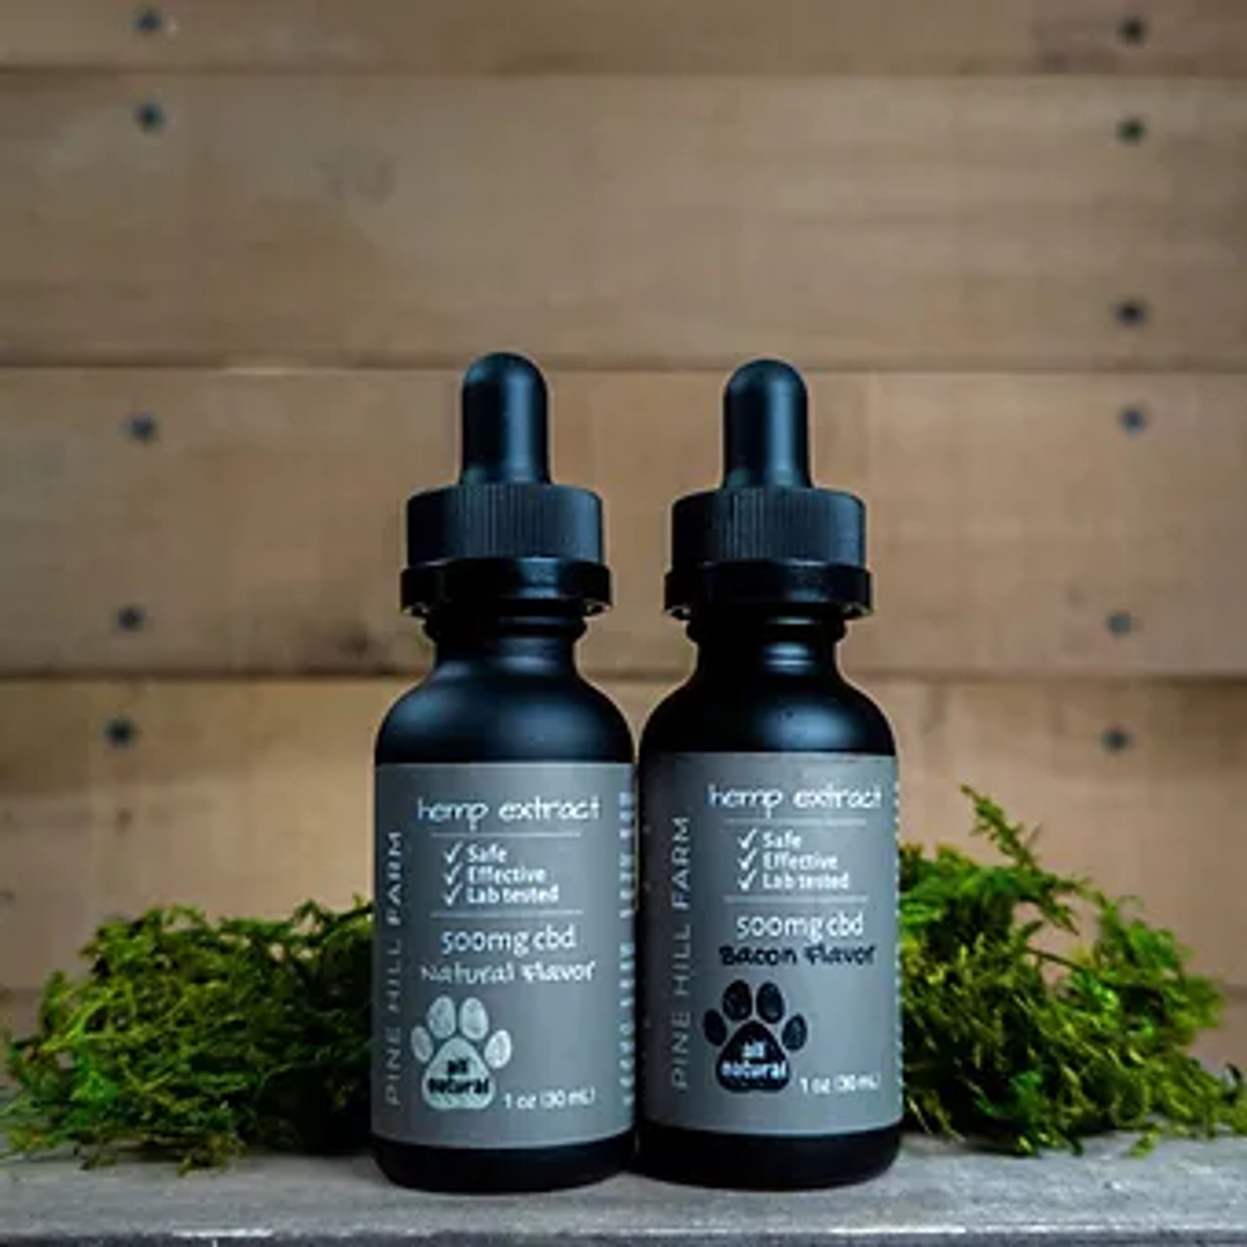

500mg in Bacon flavored only (great for pets)

1,000mg & 2,000mg in Natural, Harvest Berry, and Orange Dream

Uses:

* **Stress & Anxiety Relief**  
   CBD may interact with serotonin receptors in the brain to promote a calming effect, potentially reducing feelings of anxiety and stress.
* **Pain & Inflammation**  
   It's often used for chronic pain, joint discomfort, and inflammatory conditions like arthritis, due to its potential anti-inflammatory properties.  
  **Sleep Support**
* Many use it to help improve sleep quality, especially those dealing with insomnia or disrupted sleep due to stress or pain.
* **Mood Balance**  
   Some people report improved mood or emotional stability, possibly due to CBD's effects on the endocannabinoid system (ECS), which helps regulate mood.
* **Support for Neurological Conditions**  
   Research is ongoing into CBD’s role in managing conditions like epilepsy (e.g., FDA-approved Epidiolex) and neurodegenerative diseases like Parkinson’s or MS.
* **Recovery & Exercise Support**  
   Athletes and active individuals sometimes use CBD for post-workout recovery to ease muscle soreness and inflammation

**Muscle & Joint Infused Salve**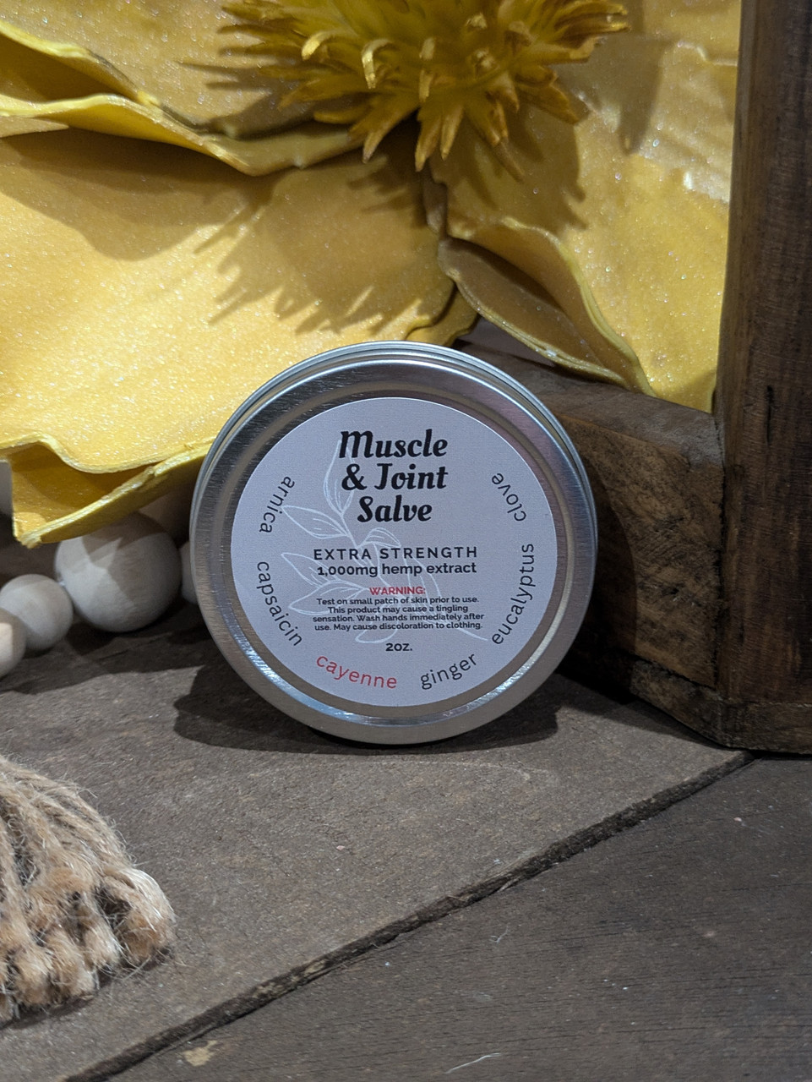

Formulated with a power house of ingredients to combat aches and pains: capsaicin, arnica, and ginger.

* 2oz container
* Made with organic ingredients

WARNING: test on small patch of skin prior to use, may cause a tingling sensation, wash hands after use

Ingredients: organic hemp extract infused MCT/coconut oil, cayenne powder, arnica, ginger, beeswax, shea butter, jojoba oil, organic vitamin E oil, copaiba, eucalyptus, and other blend of essential oils

**Relief Cooling Stick**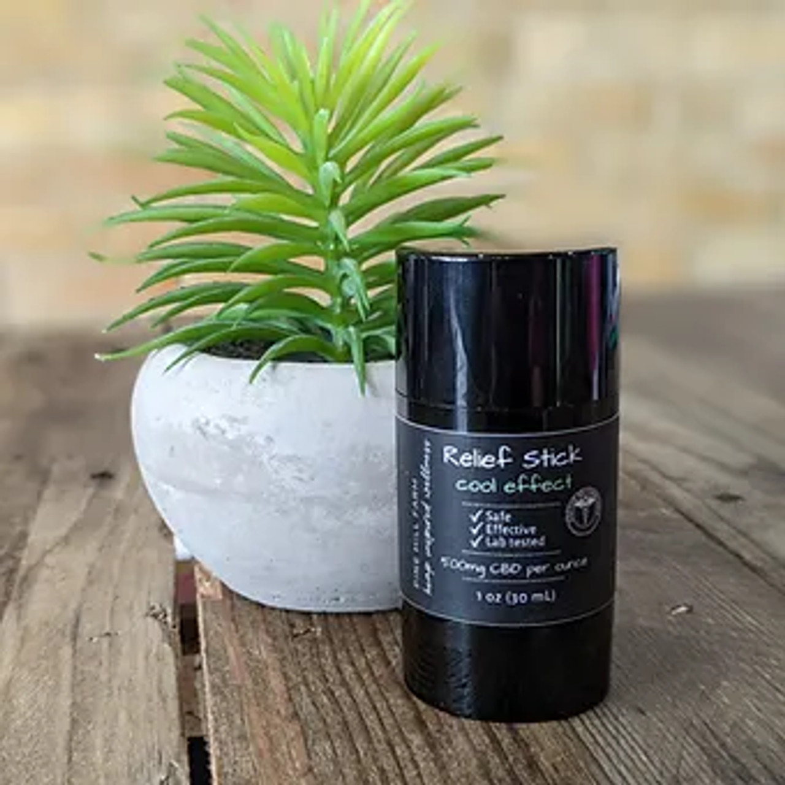

Formulated with an effective combination of concentrated hemp extract and complementary cooling herbs and oils.

USE: Adults only. Use as needed on muscles and areas of pain.

Ingredients: Beeswax, Organic Shea Butter, Organic Jojoba OilOrganic MCT Oil, ArrowRoot, Full Spectrum CBD Oil, Organic Spearmint Essential Oil, Organic Camphor Essential OIl, Organic Eucalyptus Essential Oil, Organic Lavender Essential Oil, Organic Roman Chamomile Essential Oil, Organic Menthol Crystals, Organic Vitamin E.

**Delayed Release Capsules**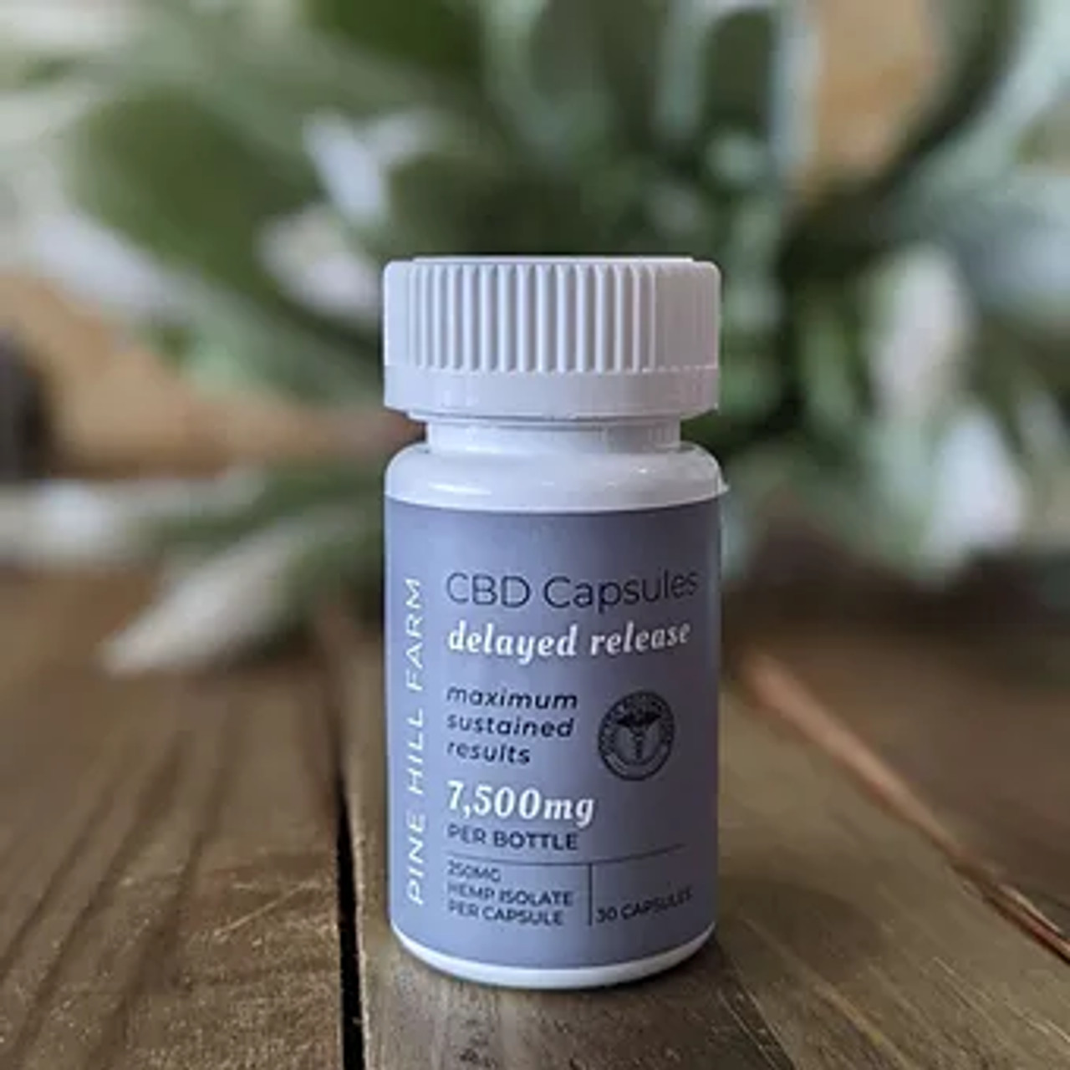

An easy addition to your daily wellness regimen (250mg of hemp isolate in each time release serving, 30 capsules in each bottle). Adults: Take 1-2 capsules as needed daily.

0% THC

*Has protective coating to delay onset so it slowly releases throughout the day. Good for people with symptoms such as chronic pain, autoimmune conditions, anxiety, and those who have a hard time falling asleep.

**Cool Calm Collected (CCC) Gummies**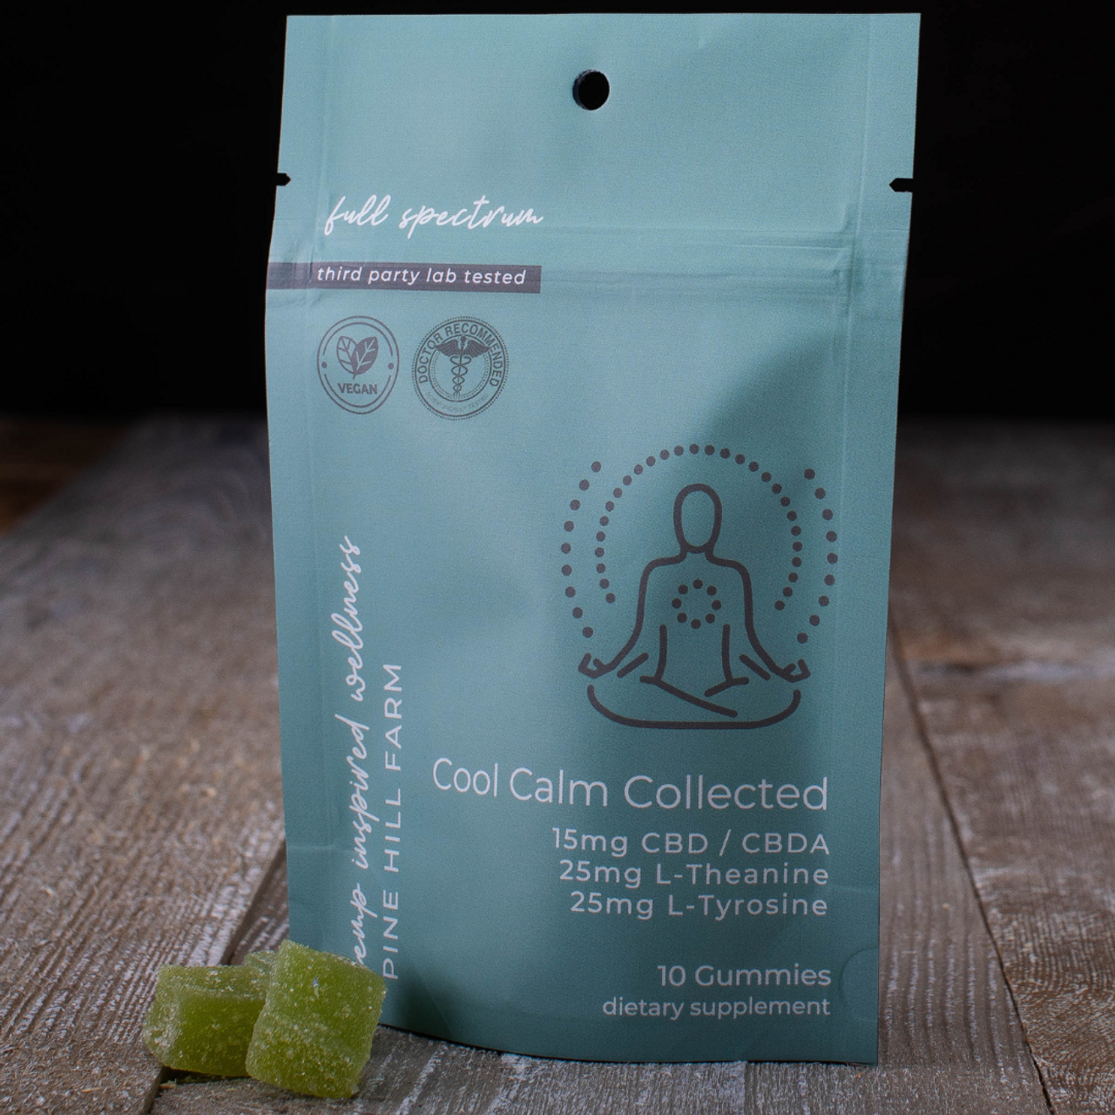

15mg CBD + CBDA, plus 25mg L-Tyrosine & 25mg L-Theanine to keep you cool, calm, and collected!

A great subtle gummy for anxiety or to calm the brain. Can even be used before bed to help with sleeping. 1 gummy works well, but some people might need 2. I have a stash in my purse and car for when I feel anxious. Does not contain THC, so it is not psychoactive. Can be used during the day and shouldn’t cause drowsiness. L Tyrosine and L Theanine are

Ingredients: 15mg CBDA, 25mg L-theanine, 25mg L-tyrosine.

**Deep Sleep Gummies**

...for a truly deep sleep with a refreshing morning! 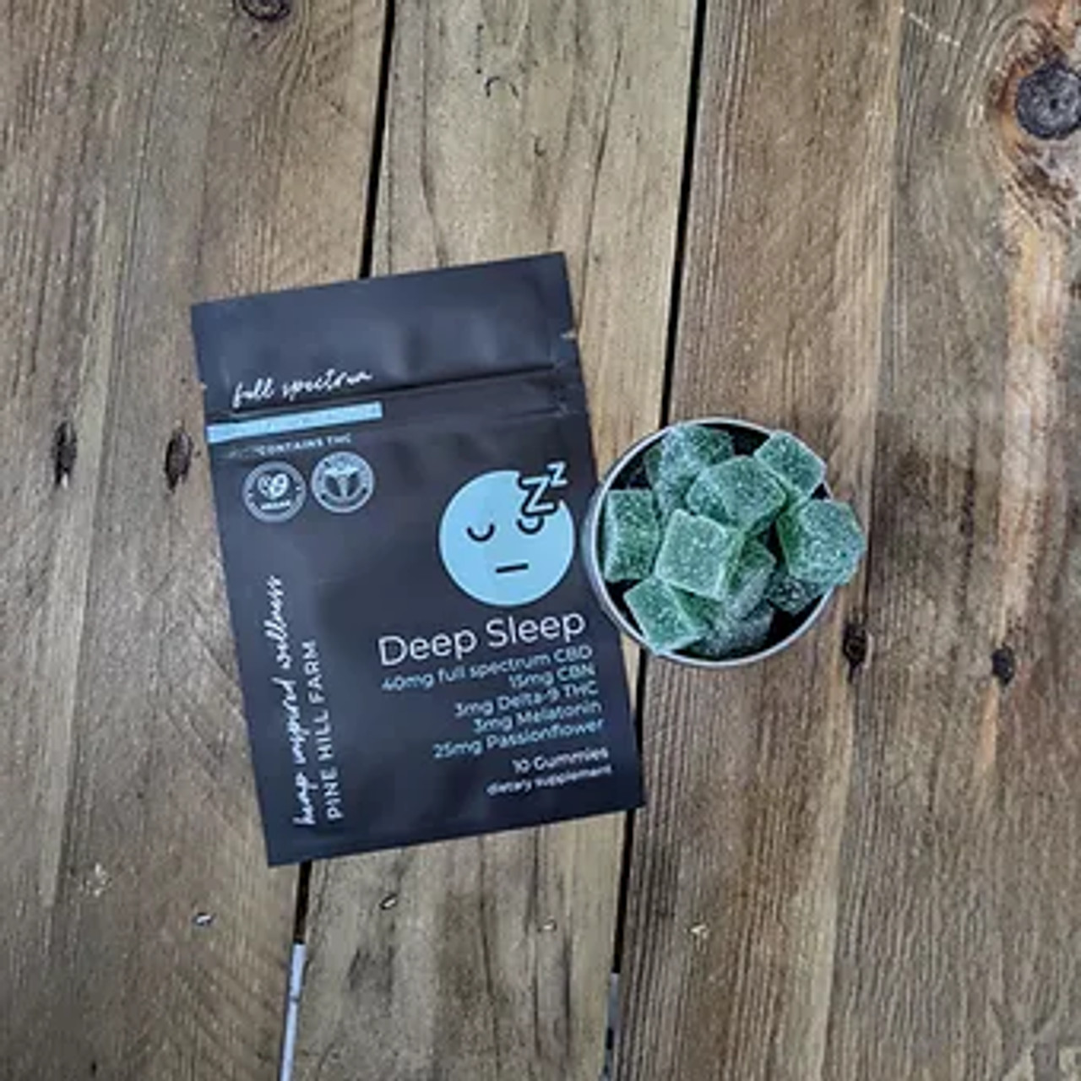

By far our most popular gummy. The complimentary ingredients with the low dose THC is a great combination for a great nights sleep. People can start with ½ gummy 30 min before bedtime if preferred, however, 3mg of THC is low, so most people need a full gummy.

* 1. Ingredients: 40mg CBD, 15mg CBN (a cannabinoid specifically for sleep), 3mg THC, 3mg melatonin, 25mg passionflower.

*This product contains THC.  
Keep out of the reach of children. Do not use if subject to drug testing

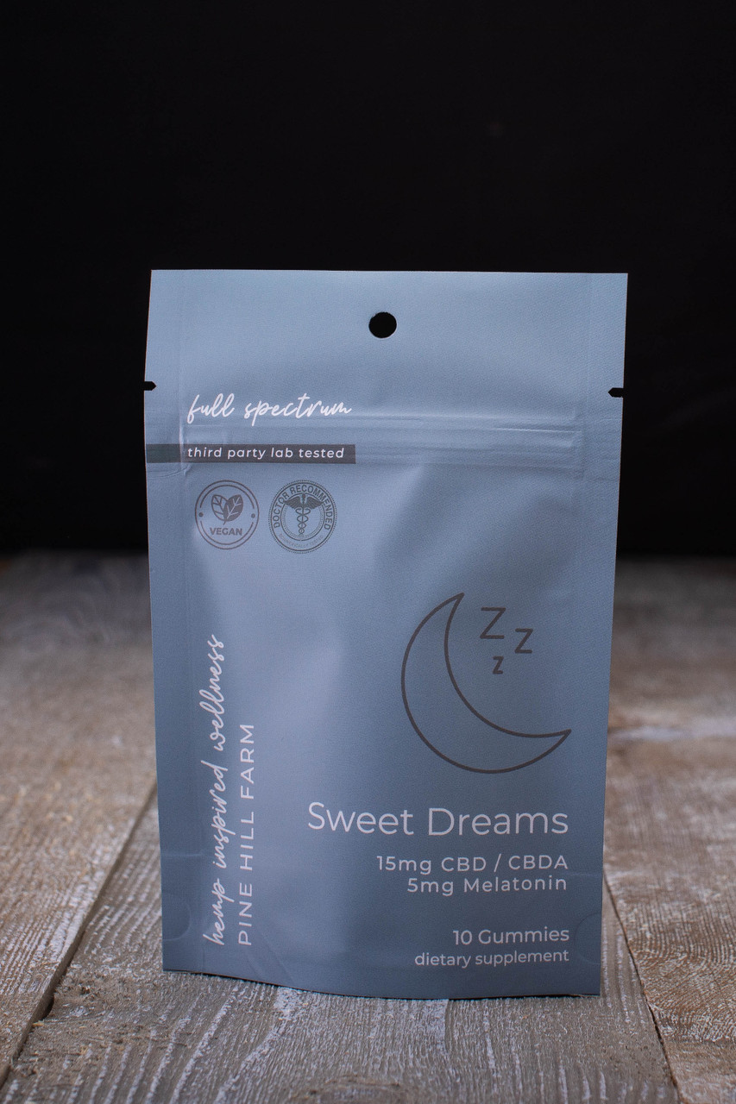

**Sweet Dreams Gummies**

15mg CBD + CBDA, plus 5mg of Melatonin (1 per serving).

Suggested use, adults: take 1-2 gummy supplements 20-30 min prior to bedtime. Store in a cool, dry place away from light.

1. Another great alternative for sleep. I (Leanne) have taken it before bed, and also if I wake up at 1 or 2 and can’t fall back asleep. It’s a great gummy to calm down your brain and get a good nights sleep. My 15 and 17 year olds have also taken it and say it works great.

**Mind Unwind Gummies**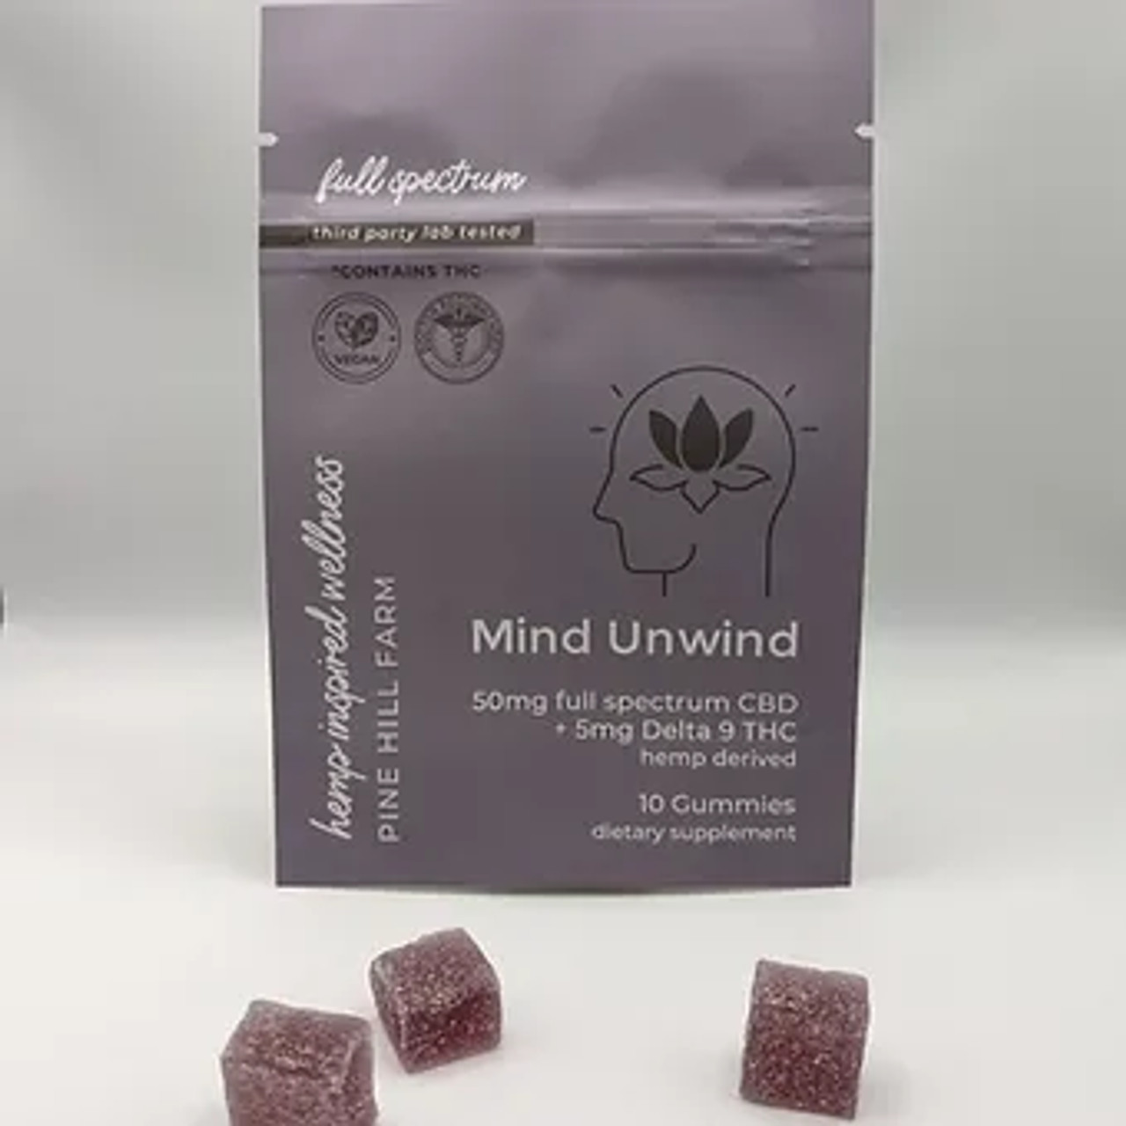

Achieve a higher sense of relief and elevate the mind with a hearty dose of full spectrum hemp extract PLUS hemp derived Delta 9 THC.

-50mg Full Spectrum Hemp Extract

-5mg Delta 9 THC (hemp derived)

The combination of CBD and THC work really well together to balance each other out. Great for people with chronic pain, severe anxiety, or a good option for sleep in people who need a higher dose of THC or if they have adverse effects to melatonin. It’s Important to tell people to start with ½ gummy to see how it works for them, increase as needed.

**Relief Gummies**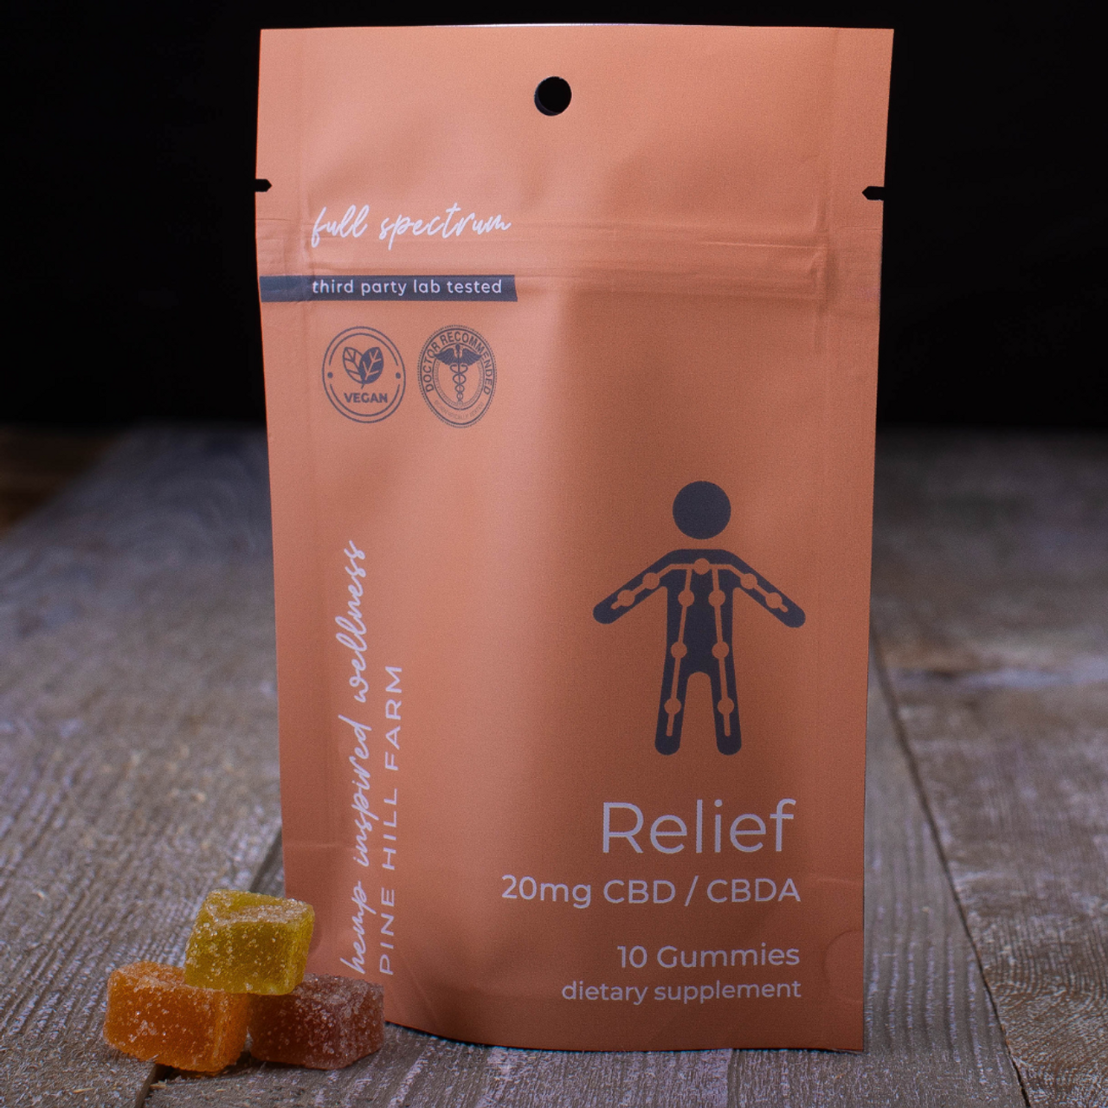

20mg Hemp Extract.

Suggested use, for adults: take 1-2 gummy supplements daily or as recommended by a health provider.Great for overall inflammation, sleep, or anxiety.

Great for inflammation. One of our first gummies that we came out with, it’s versatile and can be used for pain, anxiety, and sleep. It’s best for overall pain and inflammation. .

**Revive Gummies**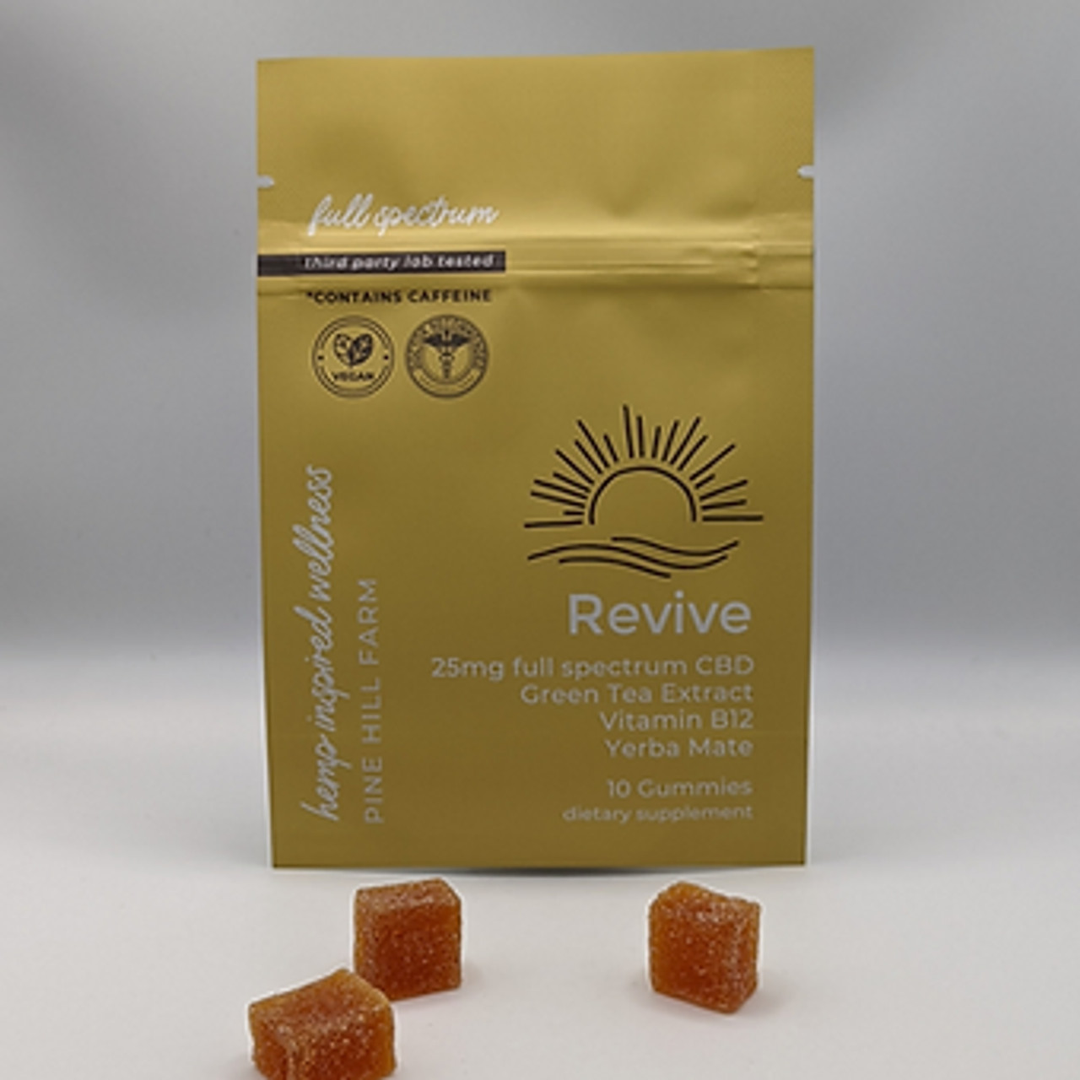

Daytime relief along with supplements and natural sources of caffeine!

25mg Full Spectrum Hemp Extract

Yerba Mate

Green Tea

Vitamin B12

* 1. CBD plus natural caffeine, which is great for a morning coffee replacement, or for an afternoon pick me up. Also an excellent choice for people with ADHD/ADD.

Suggested use, adults: take 1-2 gummies daily or as recommended by a health provider. Store in a cool, dry place away from light.

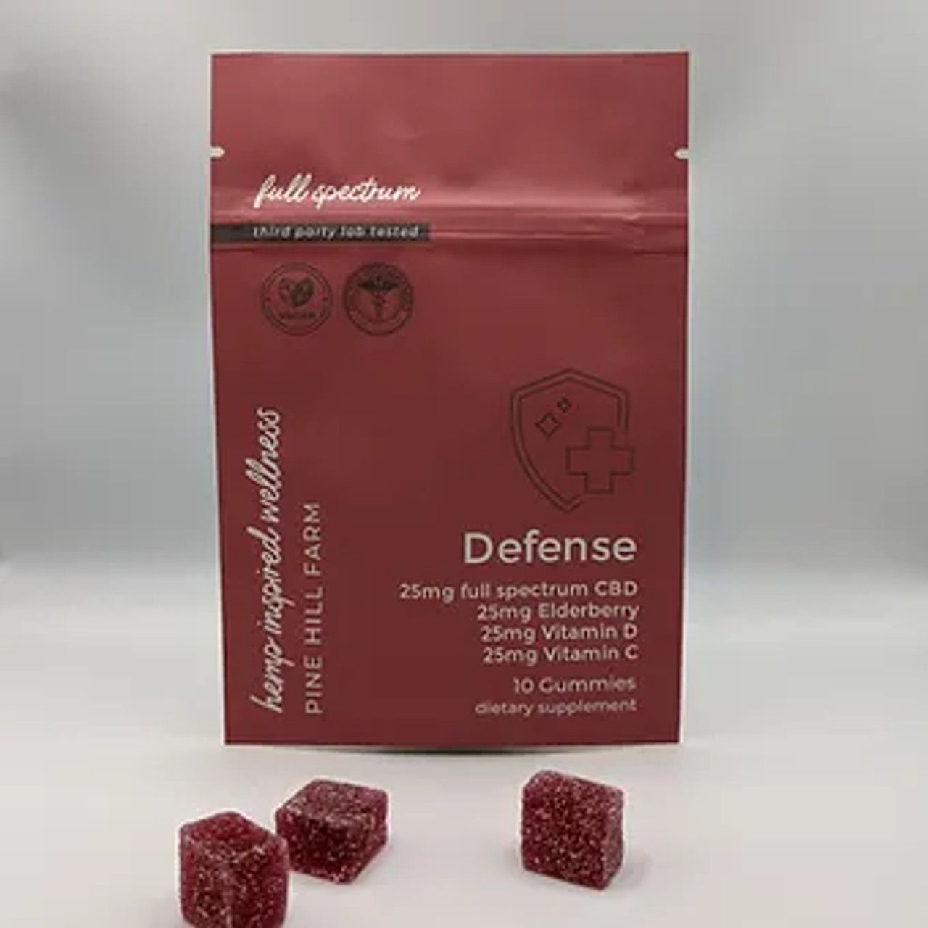

**Defense Gummies**

Achieve ultimate relief along with immune supporting supplements for any season!

25mg Full Spectrum Hemp Extract, 25mg Elderberry, 25mg Vitamin D, 25mg Vitamin C

* 1. Will help boost the immune system. Can be used as a daily supplement, or when you are feel like you are coming down with an illness.

Suggested use, adults: take 1-2 gummies daily or as recommended by a health provider. Store in a cool, dry place away from light.

*\*\*CBDA is a lessor processed version of CBD which means it is stronger than CBD. This is why some people may look at our relief gummies and think it is a low dose, or they have had stronger gummies. However, CBDA is stronger than CBD so we can get away with a lower dose.*

*It also has more of a “earthy” flavor than CBD, so the gummies with CBDA taste stronger than traditional CBD gummies.*

**Wonder Lotion**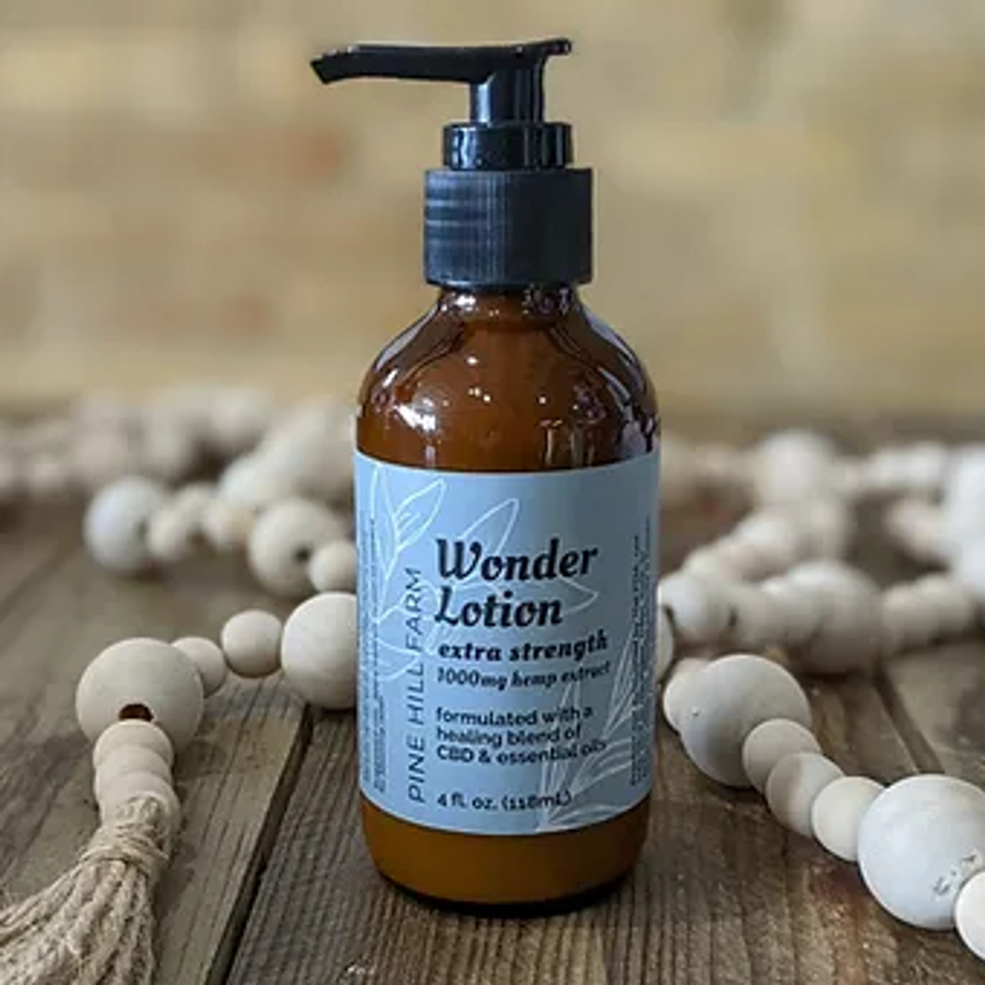

Infused with 1,000mg of organic hemp extract and an invigorating blend of spearmint, lavender, and lemon essential oils-- this lotion will leave your skin feeling silky and luxurious!

This product is for everyone and truly wonderful! 4oz glass bottle.

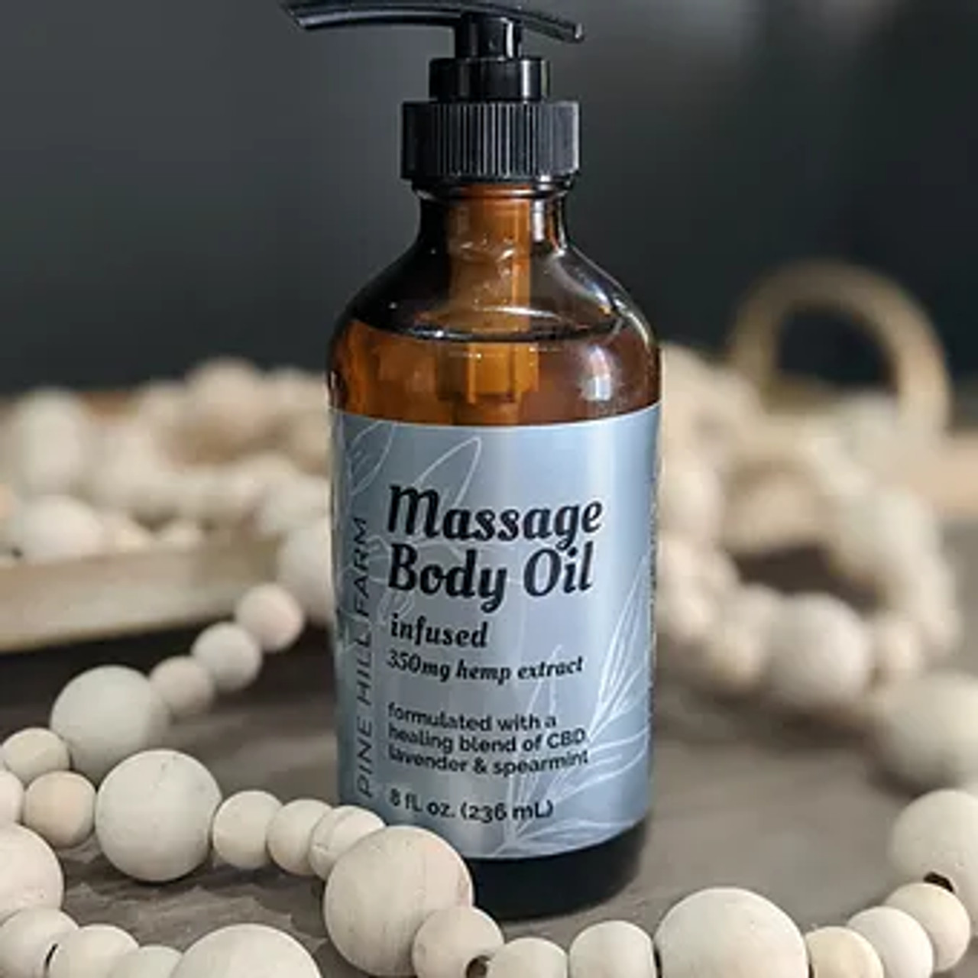

**Massage Body Oil**

Indulge your body with 350mg hemp extract-infused body oil, ultra-moisturizing and allergy-friendly rice bran oil, and a refreshing, spa scent with lavender, spearmint, and a hint of lemon.

**Room Spray/Pillow Mist**

Formulated to support relaxation and mind balance, spritz lightly around room or over pillow.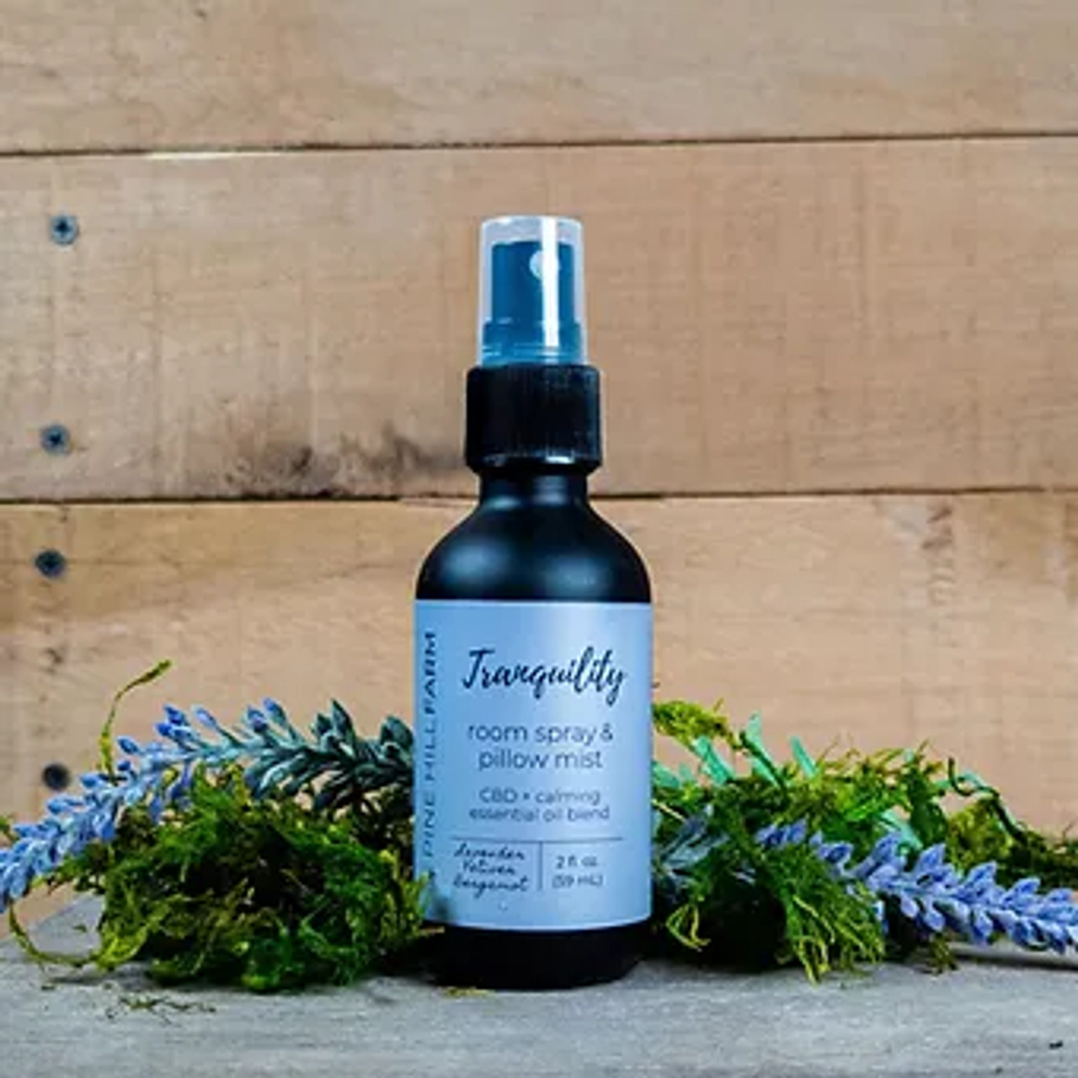

Choose from a tranquil blend of vetiver, lavender, and bergamot essential oils to help you achieve your inner zen, or a balancing blend of patchouli, clary sage, and lavender for a more floral and earthy aroma.

2 oz glass, reusable spray bottle

* Made with organic ingredients
* Crafted in small batches for highest quality

Ingredients: witch hazel, distilled water, organic CBD infused MCT/coconut oil, blend of essential oils

**Everything Balm**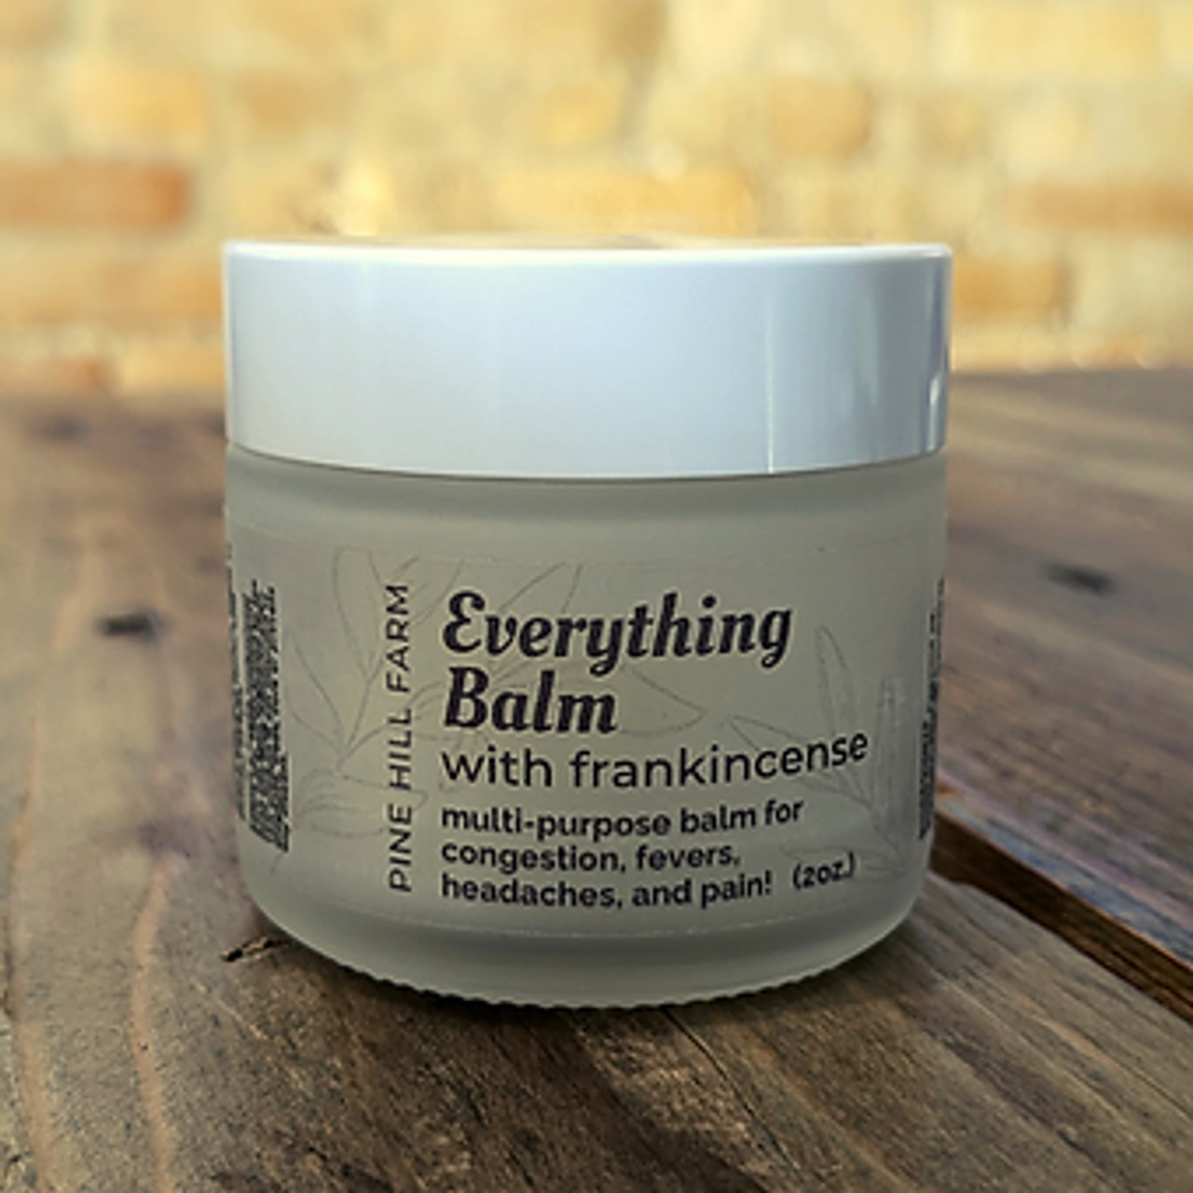

***\*Does not contain CBD***

Multi-purpose balm that is a natural medicine cabinet MUST HAVE!

Supports efforts for pain relief, fever reduction, chest and sinus congestion, aches & pains, and more!

Directions for use: use on chest, back, or other parts of body needing relief. For fevers, rub along neck and spine.

Ingredients: coconut oil, cocobutter, beeswax, essential oils of frankincense, pine, eucalyptus, cinnamon, and tea tree.

**Facial Renewal Serum**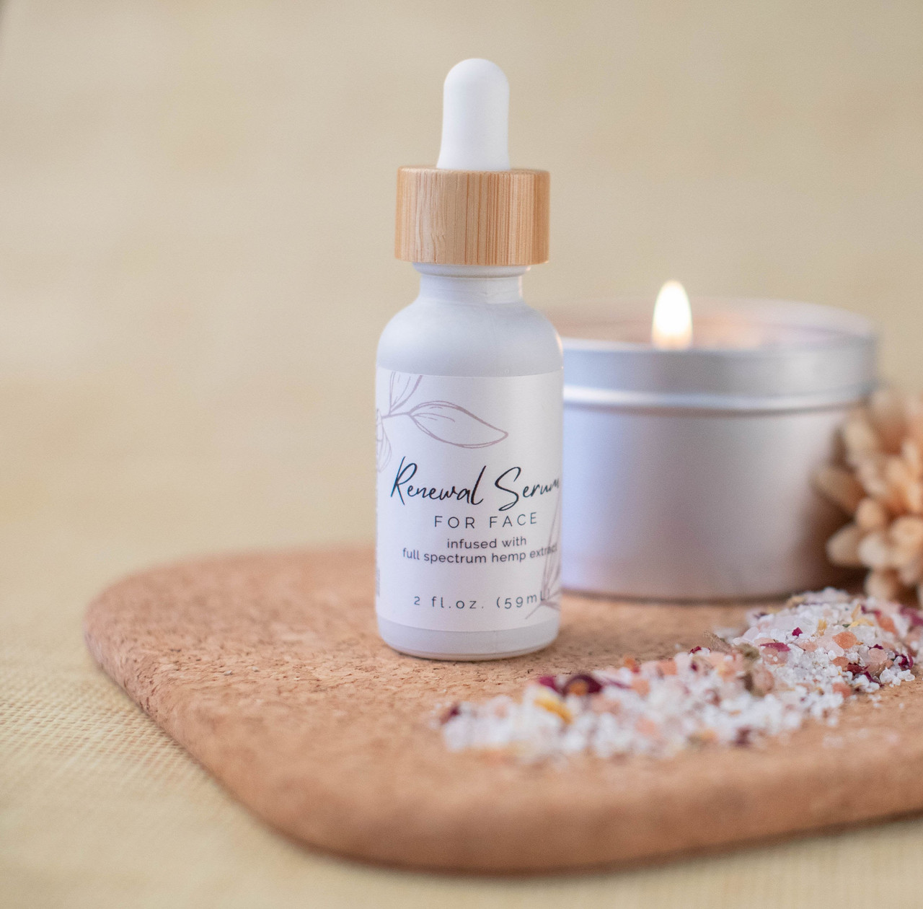

Nourish your skin with this carefully formulated, simply amazing CBD infused facial serum! Allow the organic ingredients to offer the following skin benefits:

* Argan Oil: Skin protectant, diminish fine lines & wrinkles
* Rosehip Oil: antibacterial, reduce blemishes & age spots
* Hemp Seed Oil: reduce redness & inflammation
* Jojoba Oil: amazing moisturizer & skin protectant
* Carrot Seed Oil: reduce lines & wrinkles, anti-aging
* Frankincense Oil: anti-aging, anti-bacterial, astringent
* Cedarwood Oil: reduce irritation, prevent breakouts
* Lavender Oil: anti-fungal, even skin tone

Size: 15mL & 2oz

USE: Can be used as facial moisturizer, or for selected areas such as around eye, temples, and mouth.

Fractionated coconut oil (MCT), hemp extract, argan oil, rosehip seed oil, hemp seed oil, jojoba oil, vitamin E oil, carrot seed oil, essential oil blend.

**Herbal Ear Oil**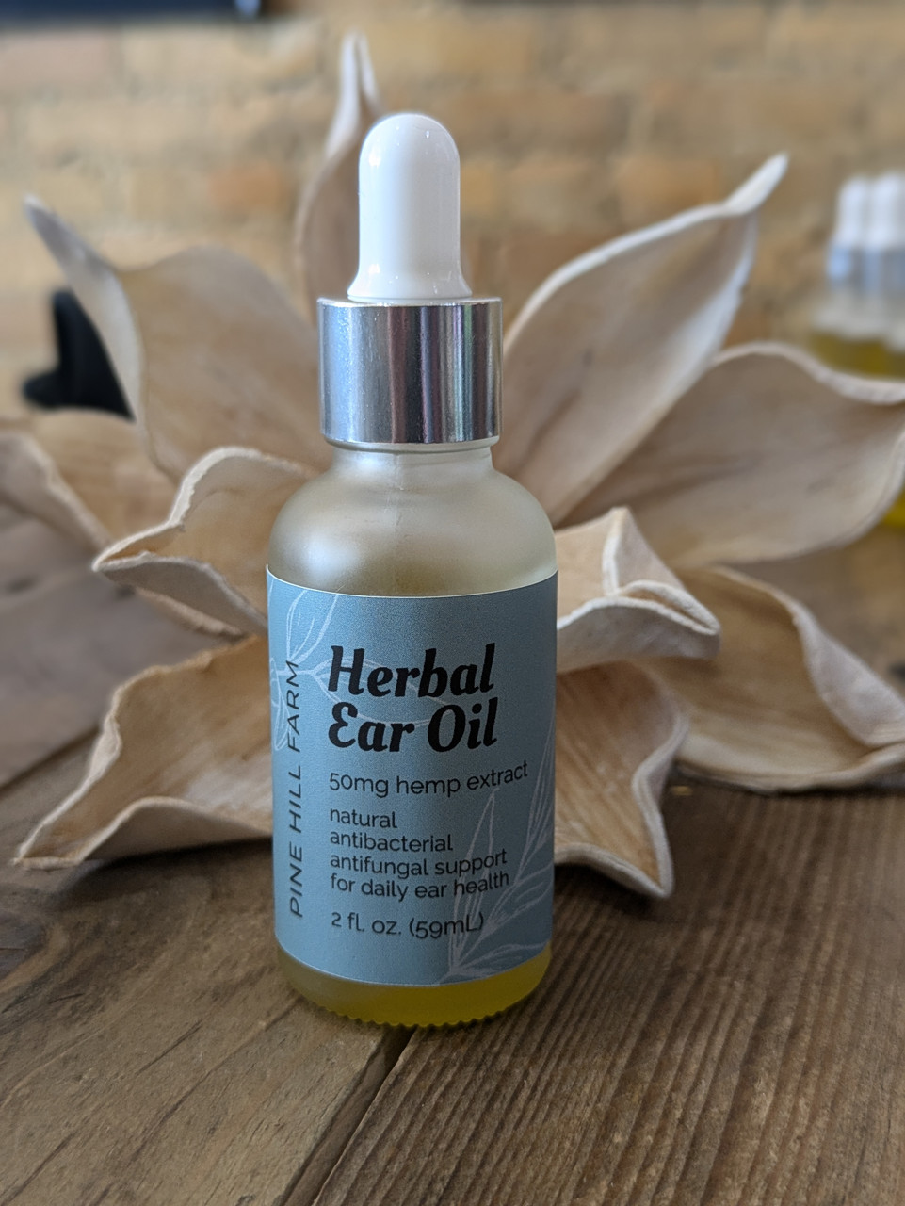

Organic hemp extract herbal ear oil, naturally antibacterial and antifungal, excellent support for daily ear health!

Ingredients: olive oil, mullein oil, garlic infused oil, calendula flower, lavender flower, St John's wort, tea tree oil, hemp extract, MCT coconut oil.

Suggested use: shake well and place 1 to 4 drops in ear, massage front of ear to circulate oil within the ear. Use daily to maintain your health, or 2 to 3 dimes per day for relief of symptoms.

*not suggested for use if you present with a bursted eardrum.

Wild essentials

By Pine Hill

**Calming Chews**

These soft chews are as good for your dog as they are delicious, free from harmful synthetics and preservatives. With nature-based ingredients proven to promote calm, you can rest assured you are helping them live their best life! Great to help their dogs with stress associated with traveling, thunderstorms, trips to the Veterinarian or Groomer, and similar situations that may cause anxiousness. 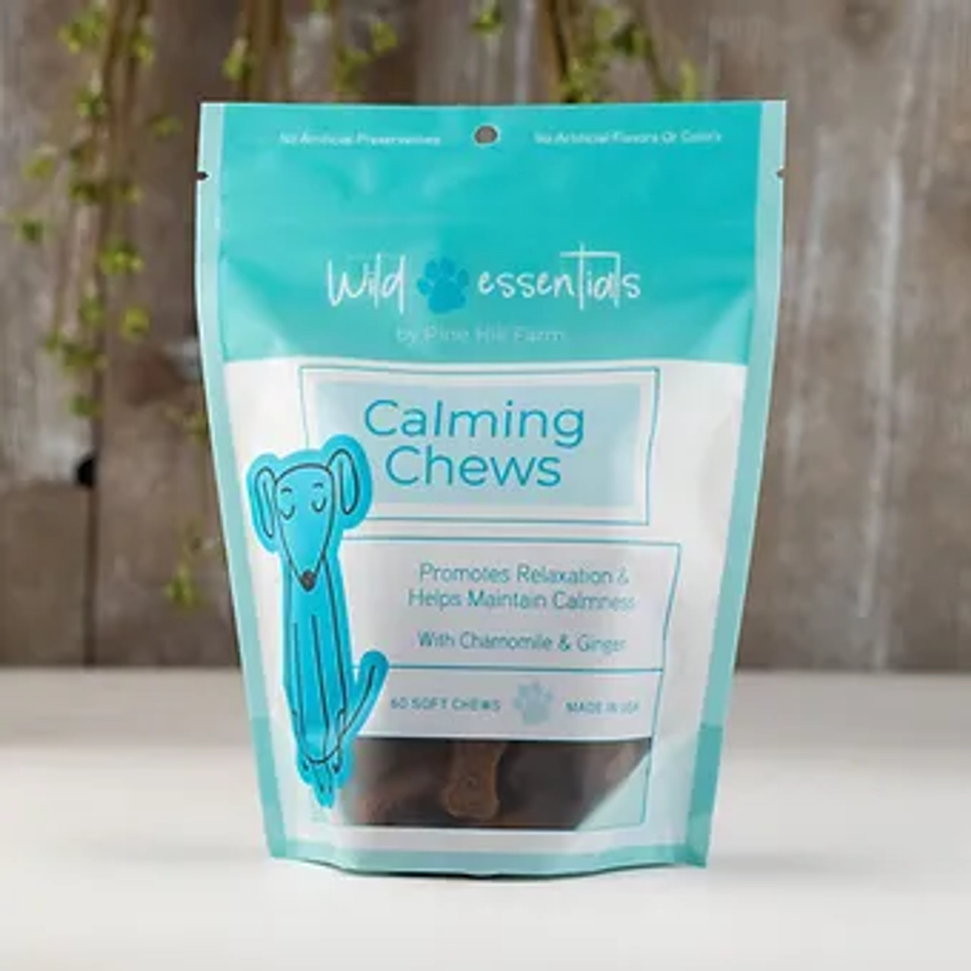

Ingredients: Thiamine, L-Tryptophan, Chamomile, Passionflower, Ginger, L-Theanine, Lemon Balm, Magnesium

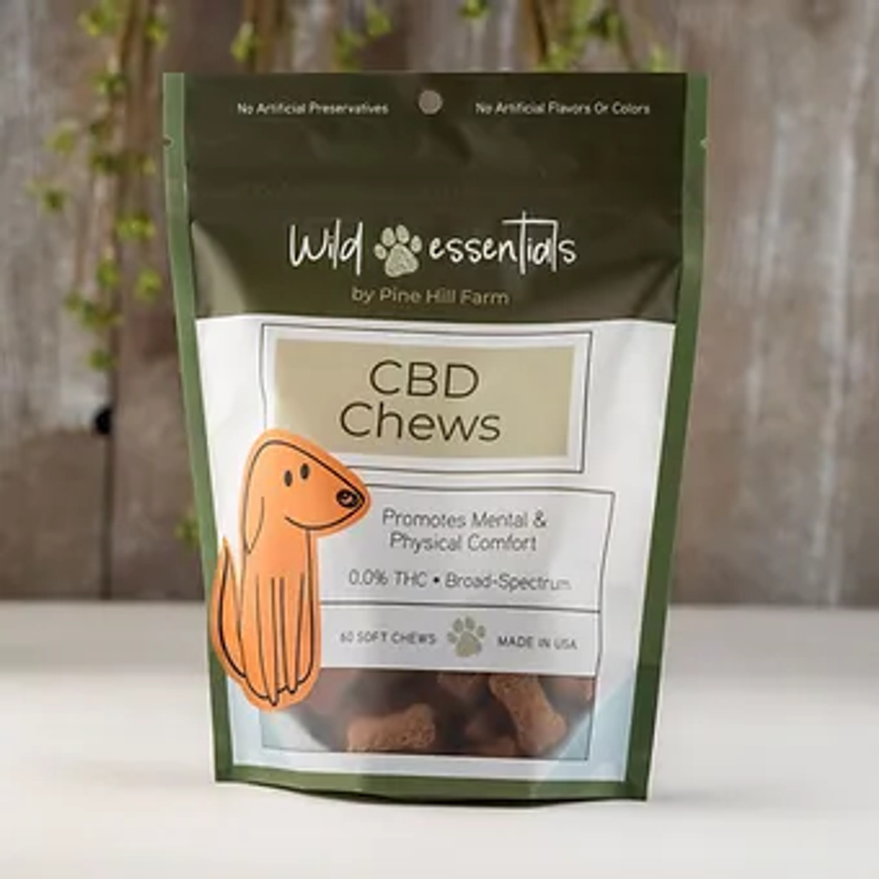

**CBD Chews**

These soft chews are as good for your dog as they are delicious, free from harmful synthetics and preservatives. With nature-based ingredients formulated to ensure your dog's mental and physical comfort, you can rest assured you are helping them live their best life!

Ingredients: Broad Spectrum Hemp Extract Oil (contains cannabidiol, 5mg per chew)

**Dental Sticks**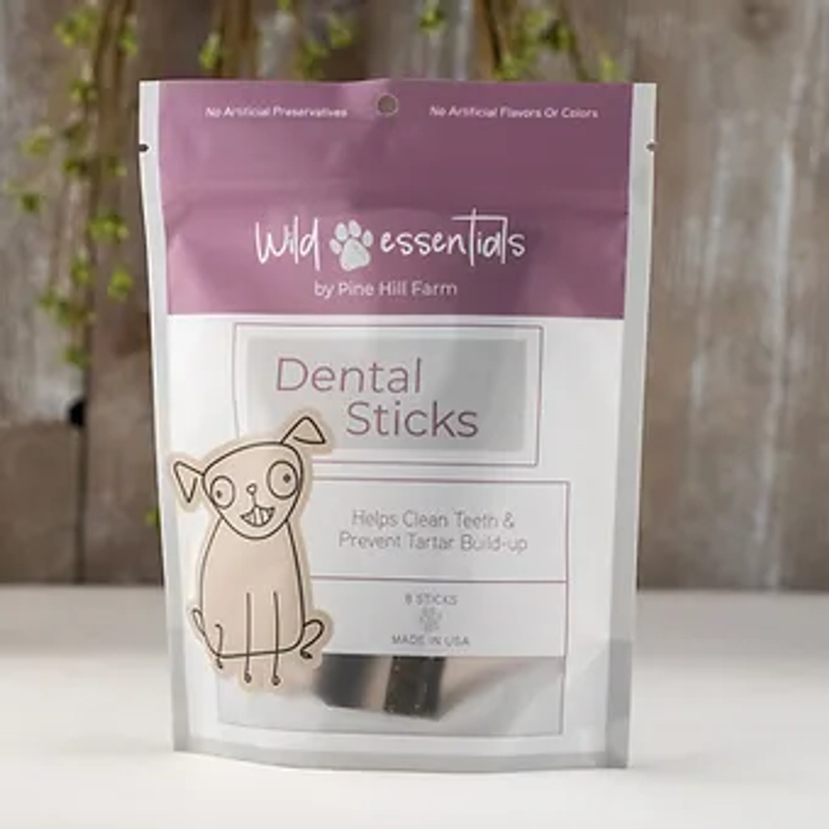

These dental sticks are as good for your dog as they are delicious, free from harmful synthetics and preservatives. With nature-based ingredients proven to help clean teeth and remove tartar, they will help keep your dog's breath fresh!

Ingredients: apple powder, brewers' yeast, chickpea, citric acid, coconut, glycerin, lactic acid, parsley, pea fiber, peppermint oil, rosemary, spirulina, tapioca flour, turmeric, vitamin E

**Digestive Chews**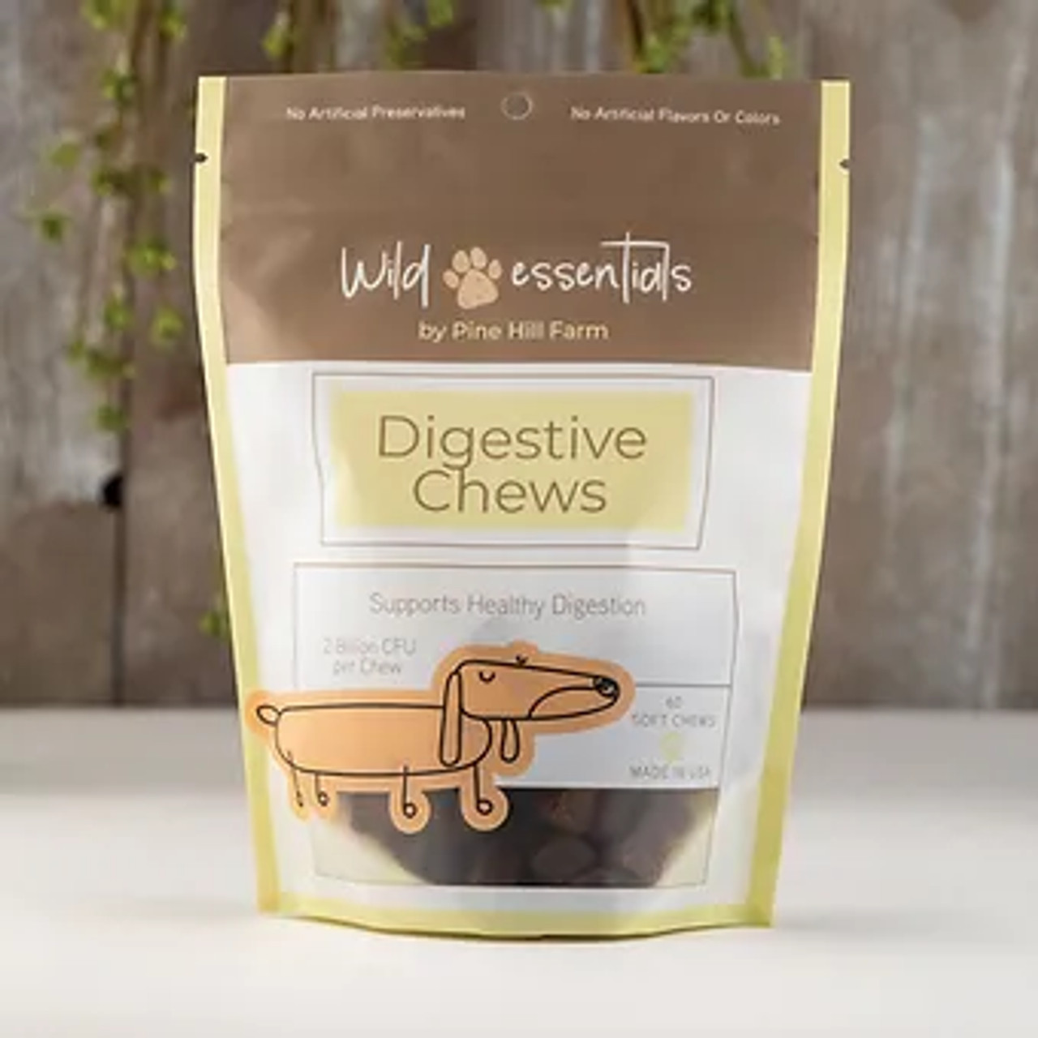

These soft chews are as good for your dog as they are delicious, free from harmful synthetics and preservatives. With nature-based ingredients proven to help gut health and improve digestion, you can rest assured you are helping them live their best life!

Ingredients: Bacillus coagulans, FOS, Vitamin C, Bromelain, Pectinase, Celluase, Amylase, Protease, Lipase

**Hip & Joint Chews**

These soft chews are as good for your dog as they are delicious, free from harmful synthetics and preservatives, artificial preservatives, flavors or colors.Our proprietary no-heat production process ensures the full integrity of every ingredient. Our Hip & Joint Pet Supplement is packed full of beneficial ingredients to help maintain overall joint mobility. Our joint care formulation is one of the most comprehensive soft chew formulas for dogs available. It is also one of the most concentrated.With nature-based ingredients proven to help support healthy joint function, you can rest assured you are helping them live their best life!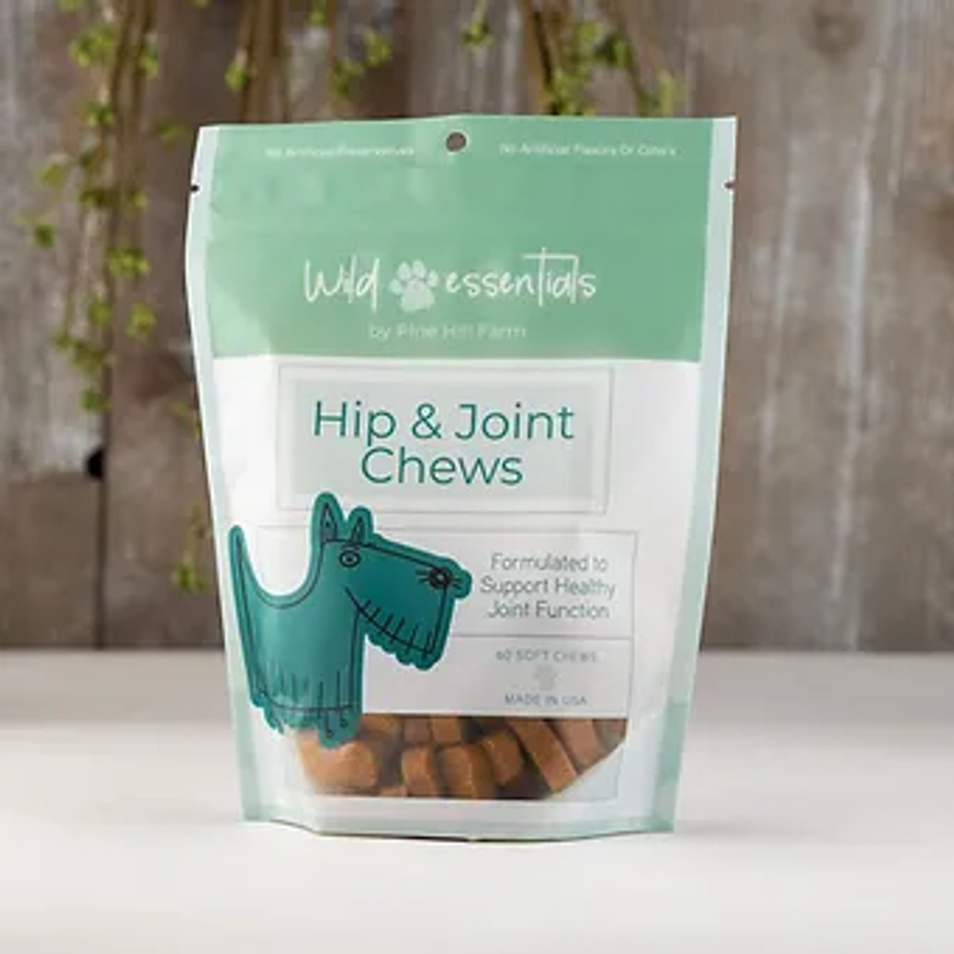

*This is a very potent product with effective levels of glucosamine and turmeric. If your pet has a distaste for turmeric, feel free to cover the treat in peanut butter or other tasty coating.

Ingredients: Glucosamine HCI, chondroitin sulfate, methylsulfonylmethane MSM, green lipped mussel, type 1 chicken collagen, boswellia serrate extract, turmeric, black pepper, zinc, hyaluronic acid, manganese.

**Skin & Coat Chews**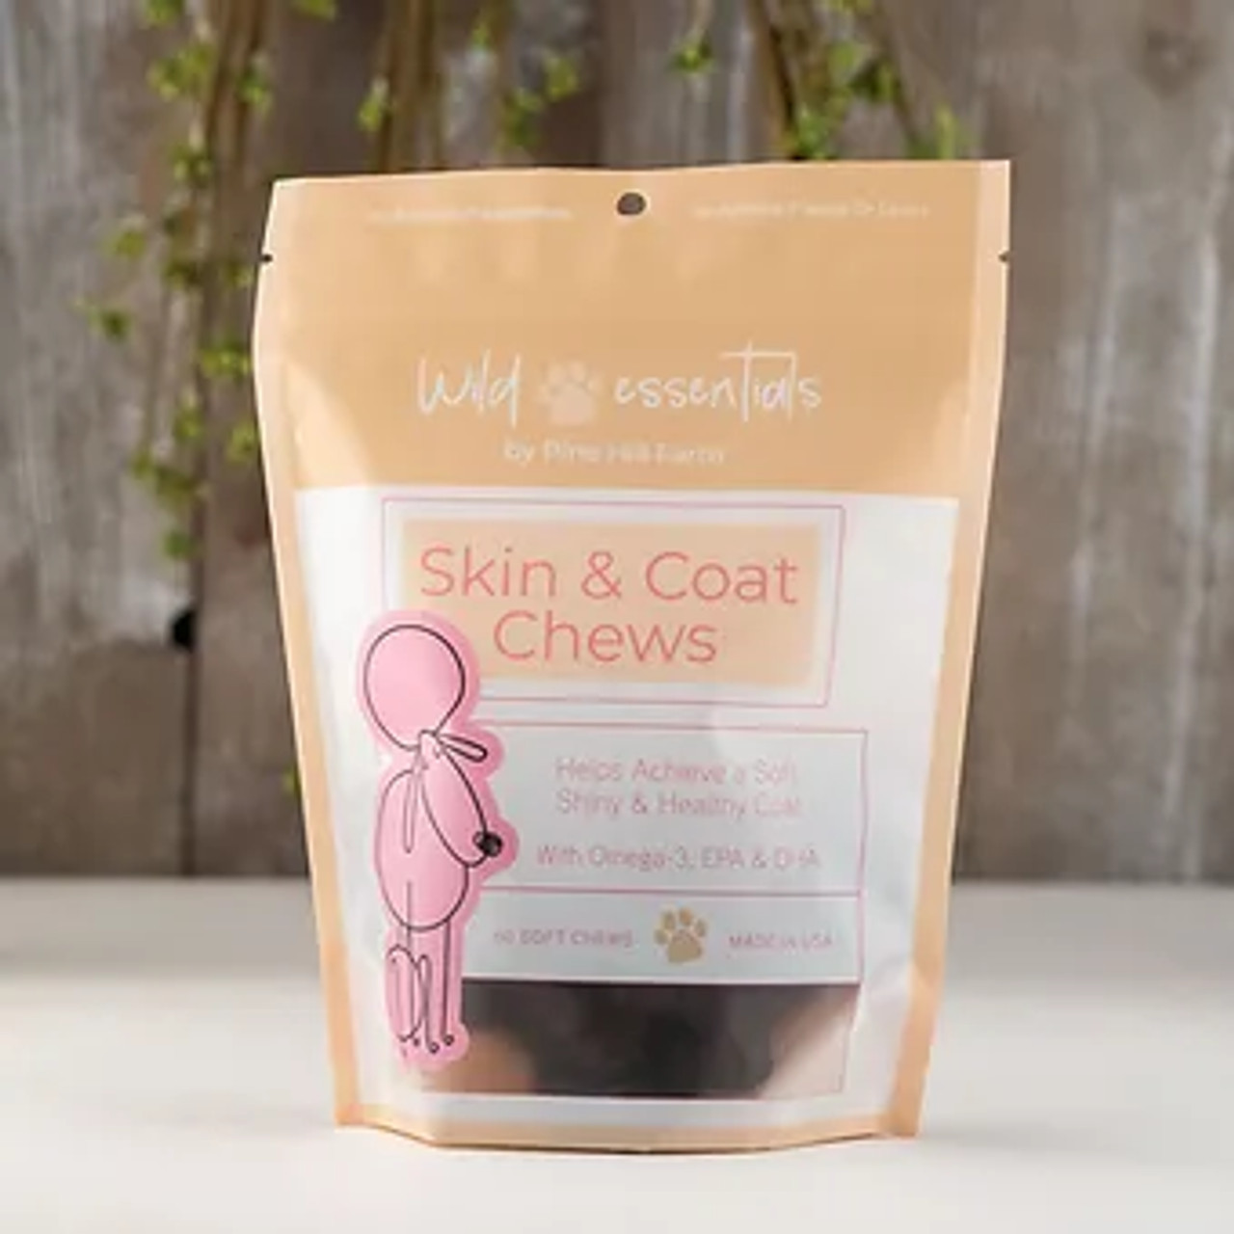

These soft chews are as good for your dog as they are delicious, free from harmful synthetics and preservatives. With nature-based ingredients proven to help achieve a soft and shiny coat, you can rest assured you are helping them live their best life!

Ingredients: Omega-3 fatty acid, alpha-linolenic acid, EPA, DHA, ascorbic acid (vit C), vitamin E